Electrician Cover goes here

ELECTRICIAN
Activity Plans

Electrician

Table of Contents

Acknowledgements . . . . . . . . . . . . . . . . . . . . . . . . . . . . . . . . . . 3
Overview of the Electrical Trade . . . . . . . . . . . . . . . . . . . . . . . . . . . 7
How to Become an Electrician . . . . . . . . . . . . . . . . . . . . . . . . . . . . 19
Introduction to Electrical Theory . . . . . . . . . . . . . . . . . . . . . . . . . . . 27
Electrical Hazards, Safety and Code . . . . . . . . . . . . . . . . . . . . . . . . . 37 Electricial Equipment and Terminology . . . . . . . . . . . . . . . . . . . . . . . . 45 Circuit Concepts . . . . . . . . . . . . . . . . . . . . . . . . . . . . . . . . . . . 55 Circuit Drawings and Writing Diagrams . . . . . . . . . . . . . . . . . . . . . . . . 61 Wiring Methods and Use of Hand Tools . . . . . . . . . . . . . . . . . . . . . . . 73 Connecting Wires . . . . . . . . . . . . . . . . . . . . . . . . . . . . . . . . . . . 87
Wire Devices . . . . . . . . . . . . . . . . . . . . . . . . . . . . . . . . . . . . . 95
Wiring a Wall Section . . . . . . . . . . . . . . . . . . . . . . . . . . . . . . . . 117 Fishing a Receptacle into a Wall Section . . . . . . . . . . . . . . . . . . . . . . 133 Assemble an Extension Cord . . . . . . . . . . . . . . . . . . . . . . . . . . . . 143

Youth Explore Trades Skills

Acknowledgments and Third Party Copyright

Youth Explore Trades Skills Learning Resources Development
Open School BC, the Custom Programs work unit of the BC Ministry of Education, and SkilledTradesBC are grateful to the following individuals and organizations for their contributions to the Youth Explore Trades Skills Learning Resources Development Project.

Carpenter, Electrician and Plumber

Resource Development Planning Session (July 11–12, 2013)
Dick Brouwer, SD 63 (Saanich) Jeff Dickson, SD 35 (Langley) Brad Edmondson, SD 36 (Surrey)
Adrian Hill, Project Manager, Open School BC
Mike Howard, President, BC Technology Education Association, SD 19 (Revelstoke) Martin Lim, Vice-President, BC Technology Education Association, SD 36 (Surrey) David Olsen, SD 69 (Qualicum)
Stu Rhodes, SD 63 (Saanich)
Chris Teskey, Project Manager, Open School BC
Cory Williams, Manager, Program Standards, SkilledTradesBC

Electrician

Writing
Brad Edmondson, SD 36 (Surrey)

Review
Donald Zaklan, British Columbia Institute of Technology

2013 Curriculum Advisory Committee
Brian Campbell, District Principal, Careers and International Education, SD 60 (Peace River North)
Larry Espe, Superintendent of Trades and Student Transitions, BC Ministry of Education Colleen Hannah, Aboriginal Agreements Coordinator, BC Ministry of Education
Rodger Hargreaves, Career Programs, SD 62 (Sooke)
Mike Howard, President, BC Technology Education Association, SD 19 (Revelstoke) Erin Johnston, Manager, Labour Supply Initiatives, SkilledTradesBC Eleanor Liddy, Director, Open School BC

This work is licensed under a Creative Commons Attribution-NonCommercial-ShareAlike 4.0 International License unless otherwise indicated.

Acknowledgments and Third Party Copyright

Eric MacNeil, President, BC Culinary Arts Specialist Association
Jim Pelton, former Director, Training Delivery, SkilledTradesBC
Glenn Rowan, Education Officer, Graduation, Dual Credit, Industry Training, BC Ministry of Education
Tim Winkelmans, Lead, Graduation Standards, Educational Technologies, Learning Alternatives, BC Ministry of Education

2013 Resource Development Planning Session (July 10, Victoria BC)
Dick Brouwer, SD 63 (Saanich) Jeff Dickson, SD 35 (Langley) Brad Edmondson, SD 36 (Surrey)
Adrian Hill, Project Manager, Open School BC
Mike Howard, President, BC Technology Education Association, SD 19 (Revelstoke) Tom Hoyme, SD 42 (Maple Ridge-Pitt Meadows)
Eleanor Liddy, Director, Open School BC
Erin Johnston, Manager, Labour Supply Initiatives, SkilledTradesBC Ken Jorgensen, SD 57 (Prince George)
Karen Larsen, Career Programs Coordinator, SD 39 (Vancouver)
Martin Lim, Vice-President, BC Technology Education Association, SD 36 (Surrey) David Olsen, SD 69 (Qualicum)
Stu Rhodes, SD 63 (Saanich)
Glenn Rowan, Education Officer, Graduation, Dual Credit, Industry Training, BC Ministry of Education
Rhonda Stangeland, SD 38 (Richmond)
Chris Teskey, Project Manager, Open School BC
Cory Williams, Manager, Program Standards, SkilledTradesBC

Open School BC Production Team
Copyright: Shannon Sangster Editing: Keith Learmonth
Graphics: Max Licht (http://www.maxlicht.com) Graphics Coordination: Christine Ramkeesoon Photography: Dennis Evans
Project Managers: Adrian Hill, Tracey Peever, Chris Teskey
Project Supervision: Monique Brewer (Director), Jennifer Riddel (Manager, Instructional Services)

Production Technicians: Beverly Hooks, Brian Glover Website Construction and Design: Christine Ramkeesoon

Third Party Copyright
Every effort has been made to contact copyright holders for third party works included in the Youth Explore Trades Skills learning resources. If you have any questions or concerns, please contact openschoolinfo@gov.bc.ca

Electrician

Introduction to Electrical Theory
Ohm’s Law Problems, question #3. The image and accompanying caption on page five are from the publication Working Safely Around Electricity and cannot be reproduced without written permission from WorkSafeBC. For more free information on this and other safety topics, go to www.worksafebc.com.

Fishing a Receptacle into a Wall Section
Figure 7—Loomex 2 ¼” rework device box. Use by permission, courtesy of Thomas & Betts Corporation.
Figure 10—2 ½”deep Loomex device box. Used by permission, courtesy of Thomas & Betts Corporation.
Figure 11—Rework device box supports: used by permission, courtesy of Hubbell.

Youth Explore Trades Skills 5

Acknowledgments and Third Party Copyright

Overview of the Electrical Trade

Description
There are two types of electrical trade qualifications people may attain in British Columbia: construction electricians and industrial electricians. Both share a common training for the first two levels of their technical training. For the third and fourth levels of technical training, construction and industrial electrical apprentices must meet different learning outcomes. For both types of apprenticeships, there is also on-the-job electrical training where apprentices develop their workplace competencies.
Typically an apprenticeship is a four-year process. Eighty percent of the training is spent on the job, and 20% is spent conducting technical training in school. Students must register
and become employed with an electrical contractor to become an apprentice, either by direct registration and/or employment with an electrical contractor, or by completing an electrical foundations course and then becoming registered and/or employed. If students cannot connect with an electrical contractor, they will never become an apprentice or journeyperson. For more information, see How to Become an Electrician.
Again, construction and industrial apprentices learn different skills. The activities written for Youth Explore Skills Trades will concentrate on the basic skills of all electricians, although much of the material is specifically suited for construction electrician training.

Lesson Outcomes
The student will be able to:
- Understand the main duties of construction electricians
- Know the difference between construction and industrial electricians
- Be aware of the working conditions of an electrician

Assumptions
The student will:
- Have little or no knowledge about the electrical trade.
- Have an interest in gaining knowledge about the electrical trade.

Terminology
Construction electrician: an electrician who works on all electrical systems in a wide variety of buildings and facilities—everything from lighting and plugs to electrical panels, power distribution, climate control systems, fire alarms, and communications equipment. An electrician is designated as a construction electrician under the Interprovincial Standards Red Seal Program. An electrician’s work involves assembling, installing, commissioning, testing, maintaining, servicing, and operating electrical systems and equipment.

This work is licensed under a Creative Commons Attribution-NonCommercial-ShareAlike 4.0 International License unless otherwise indicated. 7

Electrical contractor: an employer or sponsor of electrical apprentices who provides work- based training for electrical apprentices. An electrical contractor is a business person or firm that performs specialized construction work related to the design, installation, and maintenance of electrical systems.
Industrial electrician: an electrician who is typically employed on staff, working at operational large-scale industrial facilities such as pulp mills, hydroelectric dams, and mining and smelting operations maintaining and modifying functioning systems and facilities.
SkilledTradesBC: the organization responsible for leading and coordinating the skilled trades training and credentialing system for the province of BC. SkilledTradesBC provides strategic leadership, policy support, and customer services to help apprentices, employers, and industry. SkilledTradesBC sets program standards, maintains credential records, and issues the highly regarded Interprovincial Red Seal (IP) and BC Certificate of Qualification (CofQ) credentials.
Interprovincial Red Seal and BC Certificate of Qualification: Through the Red Seal
Program, certified tradespeople can obtain a “Red Seal” endorsement on their BC Certificates of Qualification. The Red Seal allows qualified tradespeople to practise their trade in any province or territory in Canada where the trade is designated, without having to write further examinations. See www.red-seal.ca for additional information on the Red Seal Program. The Certificate of Qualification is only recognized in the province where it is obtained.
National Occupational Classification (NOC): a standardized description of the work performed by Canadians in the labour market. It gives statisticians, labour market analysts, career counsellors, employers, and individual job seekers a consistent way to collect data and describe and understand the nature of work.
Technical training: training for the electrical trade that is conducted in school.
Working conditions: the conditions in which an individual works, including environment, noise levels, degree of safety, physical environment, wages, and hours of work.

Estimated Time
1–4 hours

Recommended Number of Students
20, based on BC Technology Educators’ Best Practice Guide

Facilities
Classroom or computer lab

Tools
Projector with computer and speakers, Internet access

Materials
none

Recommended
Introducing this activity plan would be a great opportunity to invite an electrical contractor in as a guest speaker to talk about the electrical trade. The person could speak to the students
about duties performed by an electrician and working conditions. The speaker could also share experiential stories about the trade as well as their experiences as an apprentice.

Resources

Skills Canada 2008—Electrical Wiring
Keewatin Career Development Corporation (KCDC) video. Each skill competition video demonstrates a trade in action, performed during the Skills Canada Competition 2008 in Calgary.
http://www.youtube.com/watch?v=WjwrTAPJ2IY

BCIT construction electrician video
http://cdl-prod.bcit.ca/ltc/download/media/apprenticeship/electrical_full.wmv

Jennifer Geddes: Electrician
https://www.youtube.com/watch?v=0Z0av57vgDo

SkilledTradesBC Industrial electrician information
See page 8 of the program outline for a graphical representation of the path to become an industrial electrician.
https://skilledtradesbc.ca/electrician-industrial

SkilledTradesBC construction electrician information
See the program outline for a graphical representation of the path to become a construction electrician (page 10 of the pdf).
https://skilledtradesbc.ca/electrician-construction

National Occupation Classification (NOC)
Search for 7241 (Construction Electrician) and 7242 (Industrial Electrician) http://noc.esdc.gc.ca/English/home.aspx

Activity

Option 1: Guest Speaker: Electrical Contractor
The following activity would be optimal prior to an electrician coming in to speak to students:
  - The teacher shows video clips listed under the Resources section, including the video of an industrial electrician’s duties so students know the difference between the two different types of electricians.
  - The teacher leads a discussion and provides an overview of the electrical trade, explaining the NOC and main duties of electricians.

Option 2: No Guest Speaker (Class Discussion)
  - Show one or both video clips as a starting point to the activity.

  - Give an overview of the electrical trade, explaining the NOC and main duties of electricians. Lead a class discussion.
  - Show a video of an industrial electrician’s duties (see Resources section) so students know the difference between the two different types of electricians.
Note: This video is from Alberta, where some requirements are different from those in British Columbia, such as educational requirements.

Option 3: No Guest Speaker (Class Activity)
  - Show one or both video clips as a starting point to the activity.

  - Give an overview of the electrical trade, explaining the NOC and main duties of electricians. Lead a class discussion.
Show a video of an industrial electrician’s duties (see Resources section) so students know the difference between the two different types of electricians.
Note: This video is from Alberta, where some requirements are different from those in British Columbia, such as educational requirements.

Venn diagram
The following hands-on activity involves students placing slips of paper—each containing details of industrial and construction electrician duties and descriptions—onto chart paper with a pre-drawn Venn diagram (see Figure 1).

Industrial
Electrician
Both
Construction
Electrician

Figure 1—Venn diagram

The teacher would have to print off two copies of the duties and descriptions for each student or group of students working on this activity. The teacher or the students could then cut each item into a discrete object.
Hand out the slips of paper with duties and descriptions of industrial and construction electricians (see the resource at the end of this activity plan). Students must decide whether the papers fit construction electricians, industrial electricians, or both. Have them lay the papers down on a table with construction on the left, both in the middle, and industrial on the right (a Venn diagram format with two overlapping circles). The list of duties and descriptions is included at the end of this activity plan.
An alternative activity would be to have students simply indicate which tasks pertain to construction electricians and industrial electricians by filling in the table.

Background Information

NOC # 7241 Construction Electrician
Construction electricians lay out, assemble, install, test, troubleshoot, and repair electrical wiring, fixtures, control devices, and related equipment in buildings and other structures. They construct electrical systems in the following facilities:
  - Residential: single family, townhouse, condominium, and high rise apartments
  - Commercial: office buildings, shopping malls
  - Institutional: schools, hospitals, jails
  - Industrial: manufacturing facilities, sawmills, mines

Construction electricians are employed by electrical contractors and maintenance departments of buildings and other establishments, or they may be self-employed.

Main duties
Electricians in this unit group perform some or all of the following duties:
  - Read and interpret drawings, circuit diagrams, and electrical code specifications to determine wiring layouts for new or existing installations.
  - Install conduits, tubing, and cable trays for wires and cables.

  - Pull wire through conduits and cables through holes in walls and floors.

  - Install brackets and hangers to support electrical equipment.

  - Install, replace, and repair lighting fixtures and electrical control and distribution equipment, such as switches, relays, and circuit breaker panels.
  - Splice, join, and connect wire to fixtures and components to form circuits.

  - Test continuity of circuits using test equipment to ensure compatibility and safety of the system, following installation, replacement, or repair.
  - Troubleshoot and isolate faults in electrical and electronic systems and remove and replace faulty components.
  - Connect electrical power to audio and visual communication equipment, signalling devices, and heating and cooling systems.
  - Conduct preventive maintenance programs and keep maintenance records.

NOC # 7242 Industrial Electricians
Industrial electricians install, maintain, test, troubleshoot, modify and repair industrial electrical equipment and associated electrical and electronic controls. They are employed by electrical contractors and maintenance departments of factories, plants, mines, shipyards, and other industrial establishments.

Main duties
Industrial electricians perform some or all of the following duties:
- Read and interpret drawings, blueprints, schematics, and electrical code specifications to determine layout of industrial electrical equipment installations.
- Install, examine, replace, or repair electrical wiring, receptacles, switch boxes, conduits, feeders, fibre-optic and coaxial cable assemblies, lighting fixtures, and other electrical components.
- Test electrical and electronic equipment and components for continuity, current, voltage, and resistance.
- Maintain, repair, install, and test switchgear, transformers, switchboard meters, regulators, and reactors.
- Maintain, repair, test, and install electrical motors, generators, alternators, industrial storage batteries, and hydraulic and pneumatic electrical control systems.
- Troubleshoot, maintain, and repair industrial, electrical, and electronic control systems, and other related devices.
- Operate and program PLCs ( programmable logic computers).

- Conduct preventive maintenance programs and keep maintenance records.

- May install, maintain, and calibrate industrial instrumentation and related devices.

Evaluation Guidelines
The student:
  - Participates in class discussion
  - Understands the difference between construction and industrial electricians
  - Displays an understanding of the main duties of a construction electrician

Duties and Descriptions of Construction and Industrial Electricians for Class Activity

Duty | Construction Electrician | Industrial Electrician
Includes occupational titles such as mill electrician or mine electrician
Maintain, repair, test, and install electrical motors, generators, alternators, industrial storage batteries, and hydraulic and pneumatic electrical control systems
Read and interpret drawings, circuit diagrams, and electrical code specifications to determine wiring layouts for new or existing installations
Troubleshoot, maintain, and repair industrial, electrical, and electronic control systems and other related devices
Operate and program PLCs (programmable logic computers)
Install, examine, replace, or repair electrical wiring, receptacles, switch boxes, conduits, feeders, fibre-optic and coaxial cable assemblies, lighting fixtures, and other electrical components
Conduct preventive maintenance programs and keep maintenance records
May install, maintain, and calibrate industrial instrument- ation and related devices
Install conduits, tubing, and cable trays for wires and cables
Maintain, repair, install, and test switchgear, transformers,
switchboard meters, regulators, and reactors

Duty | Construction Electrician | Industrial Electrician
Install brackets and hangers to support electrical equipment
Install, replace, and repair lighting fixtures and electrical control and distribution equipment, such as switches, relays, and circuit breaker panels
Splice, join, and connect wire to fixtures and components to form circuits
Troubleshoot and isolate faults in electrical and electronic systems and remove and replace faulty components
Connect electrical power to audio and visual communication equipment, signalling devices, and heating and cooling systems

Answer Key
Duties and Descriptions of Construction and Industrial Electricians for Class Activity

Duty | Construction Electrician | Industrial Electrician
Includes occupational titles such as mill electrician or mine electrician | X | X
Maintain, repair, test, and install electrical motors, generators, alternators, industrial storage batteries, and hydraulic and pneumatic electrical control systems |  | X
Read and interpret drawings, circuit diagrams, and electrical code specifications to determine wiring layouts for new or existing installations | X | X
Troubleshoot, maintain, and repair industrial, electrical, and electronic control systems and other related devices |  | X
Operate and program PLCs (programmable logic computers) |  | X
Install, examine, replace, or repair electrical wiring, receptacles, switch boxes, conduits, feeders, fibre-optic and coaxial cable assemblies, lighting fixtures, and other electrical components | X | X
Conduct preventive maintenance programs and keep maintenance records | X | X
May install, maintain, and calibrate industrial instrument- ation and related devices |  | X
Install conduits, tubing, and cable trays for wires and cables | X | X
Maintain, repair, install, and test switchgear, transformers,  switchboard meters, regulators, and reactors |  | X

Duty | Construction Electrician | Industrial Electrician
Install brackets and hangers to support electrical equipment | X | X
Install, replace, and repair lighting fixtures and electrical control and distribution equipment, such as switches, relays, and circuit breaker panels | X | X
Splice, join, and connect wire to fixtures and components to form circuits | X | X
Troubleshoot and isolate faults in electrical and electronic systems and remove and replace faulty components | X | X
Connect electrical power to audio and visual communication equipment, signalling devices, and heating and cooling systems | X | X

How to Become an Electrician

Description
Students who are interested in becoming electricians need to understand the pathways available to them. First, students need an understanding of the apprenticeship process. An electrical apprenticeship is four years long. Each year consists of 10 weeks (20%) of technical training and 1500 hours (80%, or approximately 40 weeks) of on-the-job, practical training.
To begin an apprenticeship, a person must become registered as an apprentice with an electrical contractor. A foundations electrical training course gives students the opportunity to receive Level One technical training, plus practical skills to encourage an electrical contractor to register and hire them as an electrical apprentice. Some school districts in British Columbia offer partnership programs with post-secondary institutions that will allow students to gain their foundation level of training while in high school. Students also need to understand the role that SkilledTradesBC plays in the apprenticeship process.

Lesson Outcomes
The student will be able to:
- Understand the apprenticeship model and work-based training
- Identify the minimum educational requirements to get into the electrical field
- Know the educational strengths needed to succeed as an electrician
- Investigate apprenticeship opportunities within their school district
- Find post-secondary institutions that offer electrical training within their region
- Understand the SkilledTradesBC’s role in the apprenticeship process
- Retrieve information about electricians through website navigation

Assumptions
- Students are interested in investigating a potential career as an electrician.
- Students have access to a computers or tablets for this activity (recommended, but not necessary).

This work is licensed under a Creative Commons Attribution-NonCommercial-ShareAlike 4.0 International License unless otherwise indicated. 19

Terminology
Apprentice: someone who works for a skilled or qualified person in order to learn a trade or profession.
Foundation program: allows students to learn the basic knowledge and skills needed for entry into a trade. It is typically taught in both the classroom and an in-school shop setting. You do not need an employer or sponsor to participate.
SkilledTradesBC: the organization responsible for leading and coordinating the skilled trades training and credentialing system for the province of BC. SkilledTradesBC provides strategic leadership, policy support, and customer services to help apprentices, employers, and industry. SkilledTradesBC sets program standards, maintains credential records, and issues the highly regarded Interprovincial Red Seal (IP) and BC Certificate of Qualification (CofQ) credentials.
Interprovincial Red Seal and BC Certificate of Qualification: Through the Red Seal Program, certified tradespeople can obtain a “Red Seal” endorsement on their BC Certificates of Qualification. The Red Seal allows qualified tradespeople to practise their trade in any province or territory in Canada where the trade is designated, without having to write further examinations. See www.red-seal.ca for additional information on the Red Seal Program.
Training providers: institutions that offer technical training. They must be approved by SkilledTradesBC as a SkilledTradesBC-Recognized Training Provider, if the training is to be counted toward an apprenticeship.
Work-based training: on-the-job training that requires specific learning outcomes.
Electrical contractor: an employer or sponsor of electrical apprentices who provides work- based training for electrical apprentices. An electrical contractor is a business person or firm that performs specialized construction work related to the design, installation, and maintenance of electrical systems.

Estimated Time
2–3 hours

Recommended Number of Students
20, based on BC Technology Educators’ Best Practice Guide

Facilities
Computer lab with access to the internet or class set of tablets Teacher: Projector with computer and speakers, Internet access

Tools
Pen, pencil

Materials
Printed question sheet

Optional
If a class set of computers is not available, the teacher could lead a discussion about how to become an electrician using projector and laptop to navigate through websites and explain them. This could also be an opportunity to go on a field trip to a training provider and tour an electrical training facility.

Resources

7 Steps to Success: SkilledTradesBC
https://skilledtradesbc.ca/sponsor-employers#section--accordion--607

SkilledTradesBC: Home Page
https://skilledtradesbc.ca/

WorkBC
http://www.workbc.ca

Career Trek BC
http://www.careertrekbc.ca/

Apprenticeship Basics: SkilledTradesBC
https://skilledtradesbc.ca/about-the-trades

Teacher-led Activity

Use a projector with computer to show the SkilledTradesBC website and explain the apprenticeship model:
- Explain the apprenticeship process so students understand the apprenticeship model. See the “Apprenticeship Basics” link in the Resources section. The Red Seal Program is also explained on this page.
- Go to the Youth in Trades section and then the Programs tab. This section explains the
Youth Train in Trades and Youth Work in Trades programs.

- Go to Trade Programs, find Electrician, Construction, and select it. Select Download Profile, which explains the apprenticeship pathway and educational requirements to become a construction electrician.
- Find Our Trades Training System section and select Training Providers. This section shows all public and private training providers for trade programs.

Student Activity

Option 1: Informal activity: class set of computers or tablets is available
In this informal activity, the teacher uses the “How to Become an Electrician” worksheet (on the next page) to ask students questions, while the students navigate through the WorkBC website to find answers.

Option 2: Class set of computers or tablets is not available
The teacher uses a projector and laptop to navigate through websites and leads a discussion about how to become an electrician. Students complete the “How to Become an Electrician” worksheet (on the next page) as the teacher moves through the sites.

Option 3: “How to Become an Electrician” worksheet
Students navigate through the WorkBC website and answer questions regarding the electrical trade using the “How to Become an Electrician” worksheet (on the next page).

Evaluation Guidelines
The student:
- Actively participates in the activity (for Option 1 only)
- Accurately completes the answer sheet (for Options 1 and 2 only)
- Participates in class discussion
- Participates in the optional extension activity

Worksheet: How to Become an Electrician

Find out some facts about electricians. Use the website www.workbc.ca It’s time to do some Career Exploration.
- Find the Career Profile for an electrician. The NOC (National Occupation Classification) number you are looking for is 7241.
  - List the three main duties of an electrician.

  - List five facts about electricians’ working conditions.

  - How many weeks in total will an apprentice spend getting their educational training?

- Answer the following two questions concerned with demographic information.
  - What is the average full-time salary of a full-time electrician in the current workforce?

  - What is the expected increase in employment in your region from 2010 to 2020?

- Find the employment outlook in your region.
What is the expected number of job openings in your region in the electrical trades and telecommunication occupations from 2010 to 2020?

- Watch the Career Trek Video, episode 27, Electrician (link is at the bottom of the WorkBC page).
  - What is the top wage per year made by electricians according to the video?

- What five skills are required to be an electrician?

- Are there opportunities in your district for an electrical apprenticeship via partnership programs with post-secondary training institutions?
Hint: Career educators or counsellors should be able to help with this question.

Optional extension activity: Go to www.mytelus.com and search for two electrical contractors in your area. List them on this sheet.

Answers

1. | a. | Electricians perform some or all of the following duties:  interpret drawings, circuit diagrams, and electrical code specifications for wiring layouts; pull wire through walls and floors; install brackets and hangers to support electrical equipment; install or repair various pieces of electrical equipment; splice, join, and connect wires to fixtures and components; test the continuity of circuits to ensure that an electrical system is safe and compatible; troubleshoot and repair faults in electrical systems; run preventive maintenance programs and keep maintenance records. See more at: http://www.workbc.ca/Job-Seekers/Career-Profiles/7241#section-duties
 | b. | Working conditions:  Electricians typically work 40 hours per week and may occasionally work overtime. Workers are usually indoors, though the work area can often be noisy and dirty. Work may take place at heights or in confined spaces, and may require lifting of heavy objects. Safety is a big concern and precautions are followed to reduce the risks of injury from accidental electric shocks and falls from heights. See more at: http://www.workbc.ca/ Job-Seekers/Career-Profiles/7241#section-environment
 | c. | Educational training is typically 40 weeks.
2. | a. | Average salary  $44,000–$53,000, or $26.00 per hour
 | b. | Answers will vary depending on the region.
- Answers will vary depending on region.

- a. $53,000 per year

- Numerical ability, motor coordination, manual dexterity, spatial perception, detail-oriented

Introduction to Electrical Theory

Description
Working as an electrician requires many skills. The physical demands of the job are one important part of the skills needed to succeed. Reading and communication skills are other aspects one must develop and improve to be a successful worker in the electrical field. Electrical theory is a basic building block that every potential electrician must understand from the start.
Electricity makes no sound, doesn’t have an odour, and can’t be seen, so understanding the power you’re dealing with in theory, helps to make you and others safe. Electrical theory is important to understand the function and operation of electrical equipment to ensure proper installation and to complete tasks such as troubleshooting electrical systems and equipment. Much has to be learned to fully understand electrical theory, and it takes years to master. This activity plan will cover the basics, and it should be understood that students will need to continue to develop their math and science proficiencies if they intend to become an electrician.

Lesson Outcomes
The student will be able to:
- Understand a basic electric circuit
- Know how to use Ohm’s law in basic circuit calculations
- Understand the difference between direct current and alternating current
- Understand how a multimeter is safely used to test readings of an AC circuit
- Understand basic series and parallel circuit

Assumptions
- Students will have little or no knowledge of Ohm’s law and electric circuits.

Terminology
Alternating current (AC): an electric current that reverses direction and magnitude in a circuit at regular intervals.
Closed circuit: a closed path or circuit capable of being followed by an electric current.
Conductor: a material or object that allows current to flow through it. Copper and aluminum are common conductors in electrical systems.
Current: the amount of electrons flowing past a specified circuit point per unit time, expressed in amperes, or amps.
Direct current: an electric current flowing in one direction only.
Insulator: a substance or device that does not readily conduct electricity.

This work is licensed under a Creative Commons Attribution-NonCommercial-ShareAlike 4.0 International License unless otherwise indicated. 27

Multimeter: an electrical test instrument that can measure several values, usually voltage, current, and resistance.
Ohm’s law: a law in electricity that states that the current (amps expressed as I) in a circuit is proportional to the potential difference (voltage, expressed as E) divided by the resistance of the

circuit (ohms, expressed as R), I = E
R
or E = I×R orR = E
I

Open circuit: an open path preventing the flow of current.
Parallel circuit: electrical components or circuits connected to common points at each end, rather than one to another in sequence. More than one path for current to flow.
Resistance: the opposition of a body or substance to current passing through it, resulting in a change of electrical energy into another form of energy commonly heat or light.
Series circuit: electrical circuits or components arranged so that the current passes through each successively. One path for current flow.
Short circuit: a path of low resistance allowing a high current to flow.
Voltage: electromotive force or potential difference, expressed in voltage or volts. Electrical pressure.
Watt: the SI unit of power, equivalent to 1 joule per second, corresponding to the power in an electric circuit in which the potential difference is 1 volt and the current 1 ampere.
Power formula, P (watts) = E×I or P = I2 ×R

Estimated Time
2–3 hours

Recommended Number of Students
20, based on BC Technology Educators’ Best Practice Guide
Small groups of 2–4 based on equipment available

Facilities
Technology education shop with benches

Tools
  - AC circuit
  - teacher demonstration:
    - multimeter
    - scientific calculator

Materials
- Battery holders (2)
- 1.5-volt batteries (2)
- 3-volt light boards or connecting wires
- Light bulbs
- Alligator clips

Optional
Scientific calculators

Resources

Basic Theory & Ohm’s Law
http://www.youtube.com/watch?v=b3XS4lAxvrc

An Analogy for Ohm’s Law
http://www.allaboutcircuits.com/vol_1/chpt_2/2.html

Sample Curriculum: Current Electricity
http://www.mst.edu/~pringle/Phys302/Handouts/current.pdf

How to Draw Simple Electric Circuits Lesson
http://www.youtube.com/watch?v=52JoONLGl2s

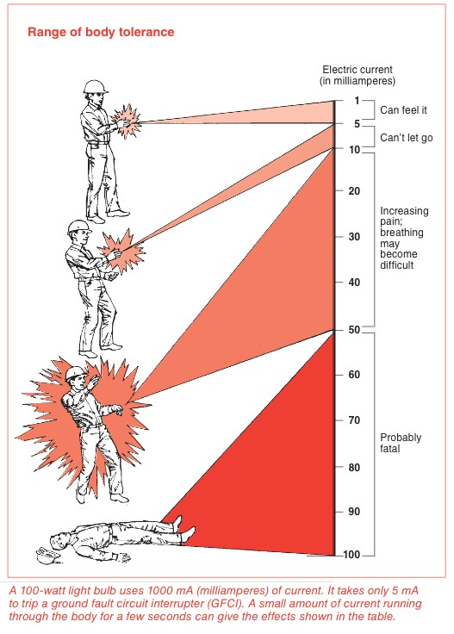

©WorkSafeBC. Used with permission from the publication ”Working Safely Around Electricity.”

Activity: Current Electricity Experiment

How this activity is sequenced is to be determined by the teacher. There are some resources to help explain Ohm’s law, and the teacher might want to start with a small “theory of Ohm’s law” lesson, or complete the lesson after the activity. The depth of this activity is based on students’ prior level of knowledge. Students will do a review of a few simple DC circuits that likely will have been covered in Science 9. These experiments should help students understand how resistive sources react when placed in series and parallel circuits.

Optional Activity
If DC circuit materials are not readily available, the teacher may show the Basic Theory & Ohm’s Law video (see the Resources section) to refresh students’ knowledge of a basic electric circuit and Ohm’s law. The video could also supplement the DC circuit activity. The “Analogy for Ohm’s law” link (see the Resources section) could also be useful to help explain Ohm’s law to students having difficulty understanding the concept. The worksheet provided will allow students to practise calculating basic Ohm’s law problems.

Evaluation Guidelines
The student:
- Works safely
- Follows instructions
- Demonstrates knowledge and understanding
- Answers questions correctly

Ohm’s Law Problems

Show your work.

  - 3 volts is applied across a 6-ohm resistor. What is the current flowing?

  - A 1.2-ohm resistor passes a current of 0.2 amps. What is the voltage across it?

  - What is the voltage of a circuit with a resistance of 250 ohms and a current of 0.95 amps?

  - A small electrical pump is labelled with a rating of 3 amps and a resistance of 40 ohms. At what voltage is it designed to operate?

  - A 9-volt battery is hooked up to a light bulb with a rating of 3 ohms. How much current passes through the light?

  - A lamp is plugged into the wall outlet, which is providing 110 volts. An ammeter attached
to the lamp shows 2 amps flowing through the circuit. How many ohms of resistance is the lamp providing?

  - If your skin has a resistance of 10,000 ohms and you touch a 9-volt battery, what current will flow through you?

  - What current will flow through your body with a skin resistance of 10,000 ohms, if you touch 120-volt house potential?

  - When you are soaked in seawater, your resistance is lowered to 1000 ohms. Now how much current will flow through you if you touch the 9-volt battery?

  - When you are soaked in seawater, what current will flow through you if you touch the 120- volt house potential?

  - How much current flowing through your body is considered fatal?

Answers

E = 9 I = ? R = 3
1. 3 volts is applied across a 6-ohm resistor. What is the current flowing?  E = IR  E = 3 volts I = ?  R = 6  I = E  R  I = 3 | 2. A 1.2-ohm resistor passes a current of  0.2 amps. What is the voltage across it? E = IR  E = ?  I = 0.2  R = 1.2 E = IR  E = 0.2×1.2  E = 0.24
6  I = 0.5 A  3. What is the voltage of a circuit with a resistance of 250 ohms and a current of  0.95 amps?  E = IR E = ?  I = 0.95  R = 250 | E = 0.24 V  4. A small electrical pump is labelled with a rating of 3 amps and a resistance of 40 ohms. At what voltage is it designed to operate?  E = IR E = ? I = 3  R = 40
E = IR  E = 0.95×250  E = 237.5 V  5. A 9-volt battery is hooked up to a light bulb with a rating of 3 ohms. How much current passes through the light?  E = IR | E = IR  E = 3× 40  E = 120 V  6. A lamp is plugged into the wall outlet, which is providing 110 volts. An ammeter attached to the lamp shows 2 amps flowing through the circuit. How many ohms of resistance is the lamp providing?

E = IR E = 110
I = 2

I = I R
I = 9
3
I = 3 A
R = ? R = E
I
R = 110
2
R = 55

7. If your skin has a resistance of 10,000 ohms and you touch a 9-volt battery, what current will flow through you?  E = IR E = 9 I = ?  R = 10,000  I = E | 8. What current will flow through your body with a skin resistance of 10,000 ohms, if you touch 120-volt house potential?  E = IR E = 120 I = ?  R = 10,000  I = E
R  I = 9  10,000  I = 0.0009 A  9. When you are soaked in seawater, your resistance is lowered to 1000 ohms. Now how much current will flow through you if you touch the 9-volt battery? | R  I = 120  10,000  I = 0.12 A  10. When you are soaked in seawater, what current will flow through you if you touch the 120-volt house potential?

E = IR E = 9 I = ?
R = 1000
I = E
R
I = 9
1000
I = 0.009 A
E = IR E = 120 I = ?
R = 1000
I = E
R
I = 120
1000
I = 0.12 A

11. How much current flowing through your body is considered fatal?

0.05 A, or 50 mA

Electrical Hazards, Safety, Ladders, Fall Protection, and Code

Description
Electricians work in many dangerous environments. Electric shock, burns, and falls are among the most common injuries suffered by electrical workers. Working safely and understanding hazards in the workplace are key factors in minimizing potential accidents. Developing and maintaining safe work habits, and ensuring work is done to the WorkSafe standards are essential for people starting work in the electrical trade. Many trades have safety hazards
that are part of the job; however, the electrical trade can be among the most dangerous. One mistake could cause serious injury or death, so workers must always be conscientious and understand the potential for accidents. As an electrician, you are responsible for your safety and the safety of others. If the work practices are not up to standard and a mistake is made, other people could be injured or killed because of it.
The Canadian Electrical Code (CEC) sets the standards for electrical work in Canada. The main purpose of the CEC is to establish safety standards for the installation and maintenance of electrical equipment.

Lesson Outcomes
The student will be able to:
- Understand the new terminology introduced in this Activity Plan
- Identify some of the main electrocution and shock hazards in electrical work
- Understand general hazards and the importance of PPE (Personal Protective Equipment)
- Understand the importance of safe work habits in the electrical trade
- Demonstrate understanding of fall protection and ladder safety
- Have an understanding of the purpose of the CEC

Assumptions
The student will have:
- Little knowledge of electrical safety hazards but will be interested to learn about them

- Little knowledge of ladder safety, fall protection, and PPE

- No knowledge of electrical code requirements

This work is licensed under a Creative Commons Attribution-NonCommercial-ShareAlike 4.0 International License unless otherwise indicated. 37

Terminology
Arc flash: an undesired electric discharge that travels through the air between conductors or from a conductor to a ground. The resulting explosion can cause fires and serious harm to equipment and people.
Canadian Electrical Code (CEC): the national standard for safe electrical installation and maintenance practices of electrical systems in all buildings, structures, and residences.
Consideration has been given to the prevention of fire and shock hazards.
Canadian Electrical Code Simplified, BC Book 1, House Wiring Guide: a simplified book designed for residential homeowners to understand house wiring. It provides regulations to pass local inspection.
Electric shock: a current of electricity going through the body.
Electrical overload: happens when more amperage is put across an electrical wire or load than it is rated for or can handle—a common electrical fire hazard.
Electrocution: to cause death by passing electricity through someone’s body.
Fall arrest: a system that stops your fall before you hit the surface below: a full body harnesses connected by lanyards or lifelines to secure anchors, safety nets.
Fall restraint/protection: systems that prevent falling: safety belts, harnesses, guard rails.
High voltage: a voltage over 750 volts.
Low voltage: 31 volts to 750 volts.
Personal Protective Equipment (PPE): specialized clothing or equipment worn by workers for protection against health and safety hazards. PPE is designed to protect many parts of the body; i.e., eyes, head, face, hands, feet, and ears.
Short circuit: a low-resistance connection established by accident or intention between two points in an electric circuit. The current tends to flow through the area of low resistance, bypassing the rest of the circuit.

Estimated Time
4–8 hours

Recommended Number of Students
20, based on BC Technology Educators’ Best Practice Guide

Facilities
Classroom or computer lab, or shop with access to computer with Internet and projector with sound
Shop class or similar for ladder safety and fall protection

Tools
Pens, pencils, lined paper step and extension ladders, safety harness, hoisting system

Materials
Computers or laptops for students, computer and projector with sound for teacher, copies or photocopies of Working Safely Around Electricity from WorksafeBC.

Optional
This would be a good opportunity to have a guest speaker talk about safety. More specifically, an electrical worker with knowledge of electrical safety and/or a WorksafeBC presenter to talk about injuries in the workplace or fall protection and/or ladder safety.

Resources

An Introduction to Personal Fall Protection Equipment (WorkSafeBC)
https://www.worksafebc.com/en/resources/health-safety/books-guides/an-introduction-to- personal-fall-protection-equipment

A Bright Arc: A Video Guide to Powerline Safety
https://www.youtube.com/watch?v=6P3XX5c9LLA

Construction—Toolbox Meeting Guides—Personal Protective Equipment (WorkSafeBC)
https://www.worksafebc.com/en/resources/health-safety/toolbox-meeting-guides/basic-personal- protective-equipment-and-clothing

Ontario Electrical Safety Authority Video Gallery (three videos)
- Your Life Is on the Line
- Electrical Safety Hazards at Home
- 10 Shocking Facts
http://www.esasafe.com/about-esa/campaigns-and-materials/video-gallery

Fall Protection Can Save Your Life: WorkSafeBC
https://www.youtube.com/watch?v=FGYbrok1bHg

Ladder Safety (WorkSafeBC)
https://www.youtube.com/watch?v=BASYh-MVYlo

Safe Ladder Use (WorkSafeBC Construction Safety Series)

https://www.worksafebc.com/en/resources/health-safety/toolbox-meeting-guides/safe-ladder-use

Working Safely Around Electricity (WorkSafeBC)
http://www.worksafebc.com/publications/health_and_safety/by _topic/assets/pdf/electricity.pdf

Activity Background
The activities will cover three areas: electrical hazards and safety, ladder use and fall protection/ arrest, and the Canadian Electrical Code.
Understanding electrical hazards and safety is paramount to electrical work. Safe practices must always be followed to ensure that the chance of accidents is minimized. Personal Protective Equipment (PPE) must always be used to keep workers safe.

Another topic and activity will be ladder safety and fall protection. Electricians must learn how to use ladders safely and understand the importance of fall safety and fall arrest in the workplace. Students will have a chance to practise safe use of ladders and fall protection.

The Canadian Electrical Code is a very large body of work, and students may find this component more difficult to understand. Students should understand that if they continue in the electrical trade and plan to become an apprentice, greater understanding of the electrical
code is a very important part of the process. The intent is not to memorize the code but to have knowledge of the sections and know where to look to find specific details.

There will be many opportunities for class discussion on all of the topics covered during the activities. Specific sections of these topics may be explored in greater detail if the teacher feels they have the knowledge and/or resources to do so.

Activity 1: Electrical Hazards and Safety

This activity could start by students in groups previewing videos about electrical hazards and safety issues. Students should pick out the most important points in the videos. The students could then show their video to the class and lead a discussion or summarize the video.
Alternatively, the teacher could show the electrical hazards and safety videos and discuss as a class. If this option is chosen, it’s important that the teacher previews the videos and takes notes for class discussion.
- Have students pair up and generate 20 questions from “Working Safely Around Electricity.” The teacher will need to print off enough booklets for the groups. Students should cover topics from each section of the document and note the answers on a separate piece of paper. Give students ample time to complete.
- Once complete, have students trade questions with another pair and answer the questions. Give students enough time to answer the questions. The teacher may determine the allotted time for answering questions.
- Once complete, have the groups trade papers back and mark the answers from their answer keys. Another option for this activity would be for the teacher to generate questions from the document and have the students find the answers.

WorkSafeBC has some great toolbox meeting guides designed for employers. The “Construction—Toolbox Meeting Guides—Personal Protective Equipment—Tue Dec 17, 2013” section deals with general PPE like clothing, hearing, eye, face, and respirators.
The “Construction—Toolbox Meeting Guides—Electrical—Tue Dec 17, 2013” section deals with more specific issues around electrical work.
  - Have students pair up and present some important information from their specific topic area. The topics are in PDF format and the students could print off copies or present from the class projector. These are documents that employers use for safety meetings, so it’s a great way for students to see how employees are continually trained to work safely.

Activity 2: Ladder Safety and Fall Protection

- Show students videos on ladder safety and fall protection. See the WorkSafeBC links in the Resources section:
  - Ladder Safety
  - Fall Protection Can Save Your Life

- Discuss issues surrounding the videos such as the difference between fall protection and fall arrest, choosing the correct ladder (performance or access), elevated platforms, and CSA classifications for ladders.

Ladder Safety Activity
- Print copies or project the “Safe Ladder Use” PDF from WorkSafeBC (see the Resources section). As a class, go through the ladder safety document and pay particular attention to stepladder and extension ladder use.
- The teacher should then have students in pairs safely set up and climb step and extension ladders.

Use ladders no higher than 8–10 feet. The teacher should closely supervise this activity.

Fall Protection/Fall Arrest Activity
- Print copies or project the WorkSafeBC PDF, “An Introduction to Personal Fall Protection Equipment” (see the Resources section). As a class, go through the fall protection document.
- Have students individually put on and correctly size the harness. If possible have the students hoist each other off the ground via a pulley system so they can experience the discomfort of a fall protection harness.

Activity 3: Canadian Electrical Code

The teacher should explain to the class the purpose of the Canadian Electrical Code. Students will do a CEC exercise as part of Activity Plan 6: Circuit Concepts. The CEC is published by the Canadian Standards Association and covers the installation and maintenance of electrical
equipment in Canada. The code uses a prescriptive model, outlining in detail the wiring methods that are acceptable. In the current edition, the code recognizes that other methods can be used to ensure safe installations, but these methods must be acceptable to the authority enforcing the code in a particular jurisdiction. Students should be made aware that the CEC is an ongoing tool that all apprentices will have to learn how to use during their training. The Resources section contains a link to a video giving further explanation of the code.

Evaluation Guidelines
The student:
  - Participates in discussions
  - Contributes to group work
  - Demonstrates an understanding of terminology
  - Demonstrates an understanding of electrical safety and hazards
  - Demonstrates an understanding of fall protection and arrest
  - Has some understanding of the Canadian Electrical Code
  - Presents information to the class
  - Generates and answers questions

Extension Activity
Have students find a video showing short circuits and arc flashes, and present it to the class to help them see what happens in these situations.

Electrical Hazards, Safety, Ladders, Fall Protection, and Code
Electrician

Electrical Equipment and Terminology

Description
Understanding the language of the electrical trade and knowing what electrical equipment is named and its purpose are very important. Anyone who is exposed to a new job must not
only learn how to perform the tasks that come with the job, but must also understand specific information that is unique to the job. In electrical construction, knowing the terminology and being able to identify components and equipment are important skills to learn, especially for new workers. Electrical workers will be continually challenged to learn about innovations with equipment, tools, and processes involved with the trade.

Lesson Outcomes
The student will be able to:
  - Identify basic electrical components and equipment
  - Understand key electrical terms

Assumptions
The student:
  - Understands basic electrical theory and safety.
  - Knows the working conditions and duties of an electrician.

Terminology
Ampere (Amp): the unit for the rate of flow of electrons in an electrical circuit. One ampere is the amount of current that will flow through a resistance of 1 ohm under pressure of 1 volt.
Arc-fault circuit interrupter (AFCI): a circuit breaker designed to prevent fires by detecting electrical arcs and disconnecting power before the arc starts a fire, required for all bedroom outlets in new homes.
Bonding: a low-resistance path created by joining together non-current-carrying metal parts so all have the same electrical potential.
Branch circuits: the portion of wiring from the final circuit breaker to the outlet.
Circuit: a path between two or more points along which an electrical current can be carried.

This work is licensed under a Creative Commons Attribution-NonCommercial-ShareAlike 4.0 International License unless otherwise indicated. 45

Circuit breaker: a device designed to open a circuit under an excessive amount of current flow, either an overload or a short circuit.

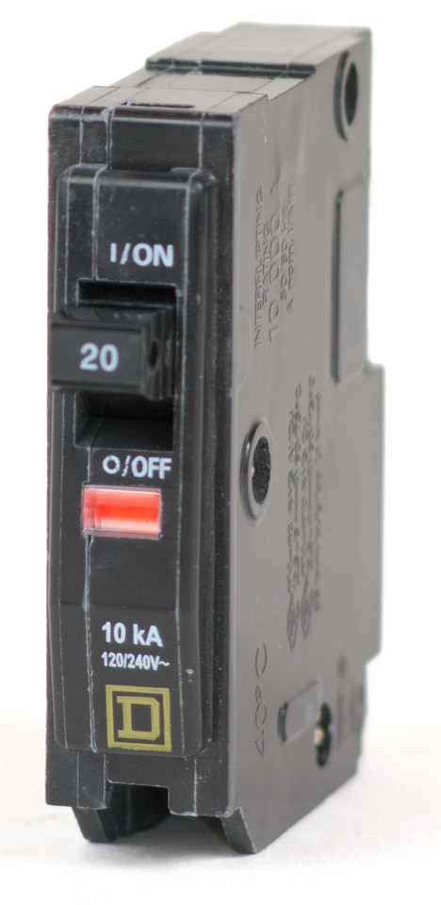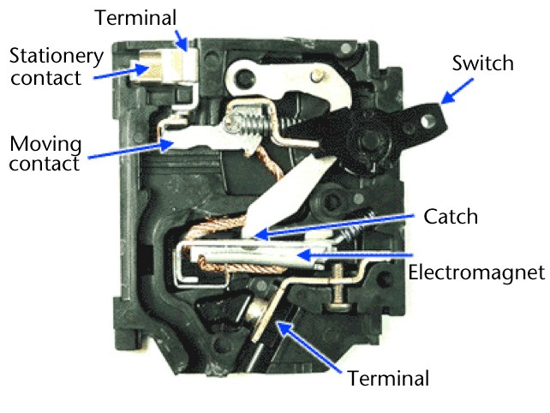
Figure 1—Circuit breaker

Circuit loading: criteria that does not allow you to exceed the designated number of receptacles on a circuit, gauge of wire, or amperage of the circuit breaker.
Conductor: a material that allows an electric current to pass through it easily (e.g., copper, aluminum).
De-energized circuit: a circuit that has no voltage applied to it.
Electrical load: the part of the electrical system that controls the current and actually uses the energy or does the work required.
Electrical equipment: common electrical equipment terms include circuit breaker, electrical meter and meter base, electrical panel, exhaust fan, light fixture, non-metallic sheathed cable (NMSC), receptacle, single pole switch, and three-way switch.
Electric arc: a luminous discharge of current that jumps a gap in a circuit, caused by a high voltage.
Electrical meter and meterbase: a device that measures how much energy a household or business uses so the electric company knows how much to charge is also known simply as an electrical meter.

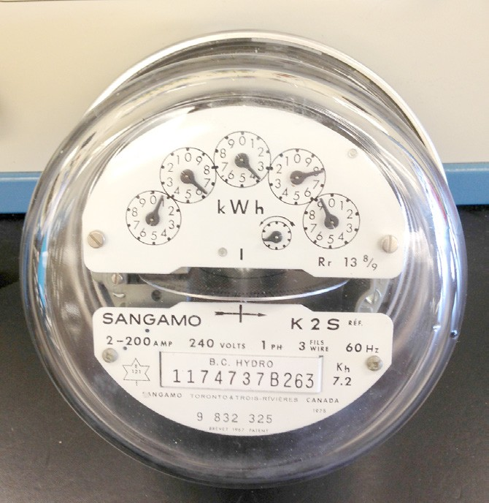

Figure 2—Kilowatt-hour meter

Electrical panel: an insulated panel on which electrical wires are connected to circuit breakers. The panel supplies the branch circuits.

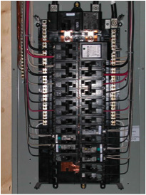

Figure 3—Electrical panel

Electrical safety: recognizing hazards associated with the use of electrical energy and taking precautions so that hazards do not cause injury or death.
Electric hazard: a dangerous condition such that contact or equipment failure can result in electric shock, arc flash burn, thermal burn, or blast.

Exhaust fan: a fan for ventilating an interior space by drawing air from the interior and expelling it outside.

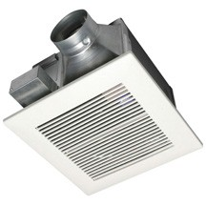
Figure 4—Exhaust fan

Fuse: a device that interrupts excessive current so that overheating or fire does not cause further damage.
Ground fault circuit interrupter (GFCI): a device that stops the flow of electricity by opening or breaking the circuit when a small flow of current to ground is detected. GFCI protection is required for electrical outlets near water sources like sinks and laundry appliances and for bathroom and outdoor outlets.
Grounding: the process of connecting equipment to a common ground, or “earth.” This is done as a safety mechanism in order to prevent equipment from becoming unsafely energized.
High-resistance fault: a fault in an electrical circuit that overheats due to current flowing through a faulty connection.

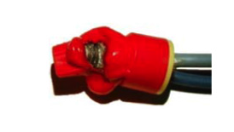
Figure 5—Result of a high-resistance fault.
Loose wire connections create a high resistance point within the electrical system, which can lead to a breakdown in insulation or even a fire.

High-resistance fault

Figure 6—Circuit with high-resistance fault. In this example there is a high-resistance fault between the 2nd and 3rd receptacle.
The voltage drop increased from the 2nd to the 3rd. The high resistance was identified as a poor connection between the two devices.

Light fixture (light fitting): an electrical device used to create artificial light and/or illumination.

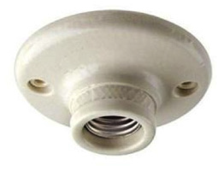
Figure 7—Light fixture

Live conductors: conductors (wires) that have voltage applied to them. The term hot is often used to describe a wire that has voltage on it.
Neutral conductor: the conductor connected to ground in circuit wiring.

Non-metallic sheathed cable NMSC: a common plastic-sheathed cable used for wiring wood frame construction buildings. Also known by trade names Romex (USA) and Loomex (Canada). The most common cable type used in residential wiring is non-metallic dry (NMD) 90 cable. “Dry” refers to the cable’s use in dry areas.

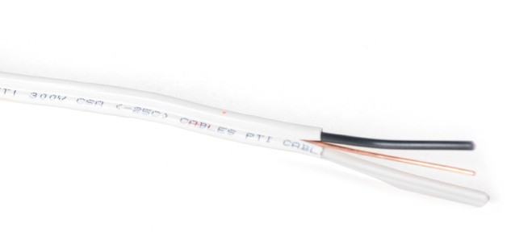

14/2 NMD 90

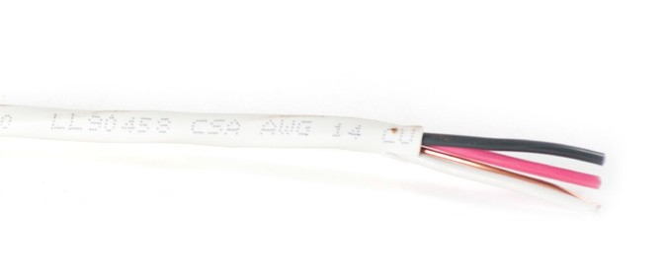

12/3 NMD 90

Figure 8—Non-metallic dry (NMD) cable

Ohm: the unit of measure for electrical resistance. An ohm is the amount of resistance that will allow 1 ampere to flow under a pressure of 1 volt. Symbol is the omega (Ω).
Ohm’s law: the relationship between voltage, current, and resistance, expressed by the equation V (also expressed as E) = IR, where:
    - V(E) is the voltage in volts
    - I is the current in amperes
    - R is the resistance in ohms

Open circuit: an electric circuit in which the normal path of current has been interrupted.
Overcurrent: a condition that exists on an electrical circuit when the normal load current is exceeded. Overcurrents take on two separate characteristics: overloads and short circuits.

Overload: an overcurrent that exceeds the normal current rating of a circuit. This type of overcurrent generally does not leave the normal current-carrying path of the circuit.

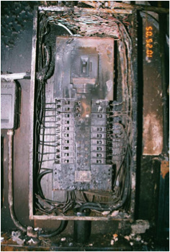
Figure 9—Result of overload in an electrical panel

Receptacle: a contact device, usually installed in an outlet box, that provides the socket for the attachment of a plug to supply electric current to portable power equipment, appliances, and other electrically operated devices. also known as an electrical outlet, duplex receptacle, or plug.

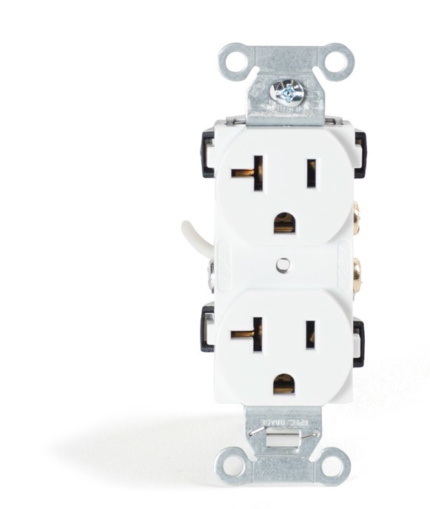
Figure 10—Residential grade 120V/15-20R receptacle

Service equipment: circuit breakers, fuses, electric meter, conduit, and wire associated with the wiring from BC Hydro to the main electric panel.

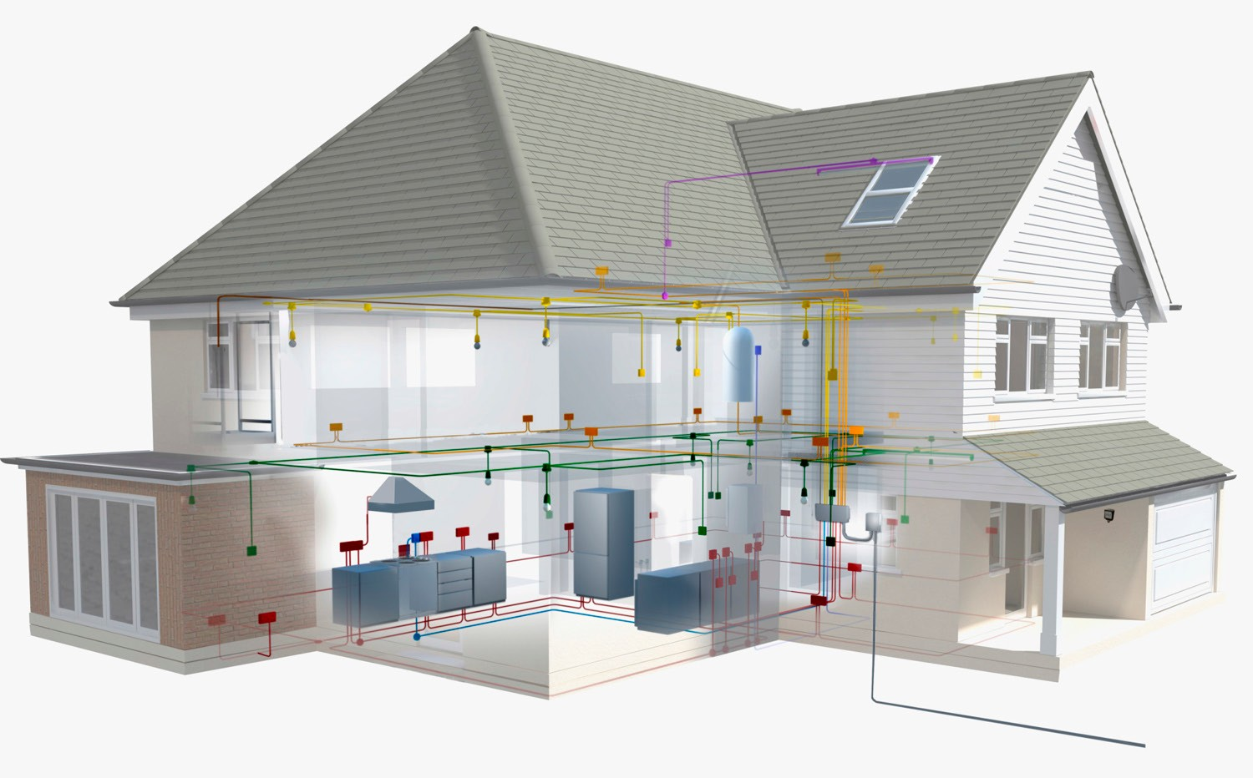

Figure 11—Schematic depicting household wiring dispersion

Short circuit: an overcurrent that exceeds the normal current rating of a circuit by a factor of many tens, hundreds, or thousands of times.

Single-pole switch: a standard on/off wall switch that has two terminals and controls one or more light fixtures from a single location. | Three-way switch: an on/off wall switch that has three terminals. Used to control one or more lights from two different locations.
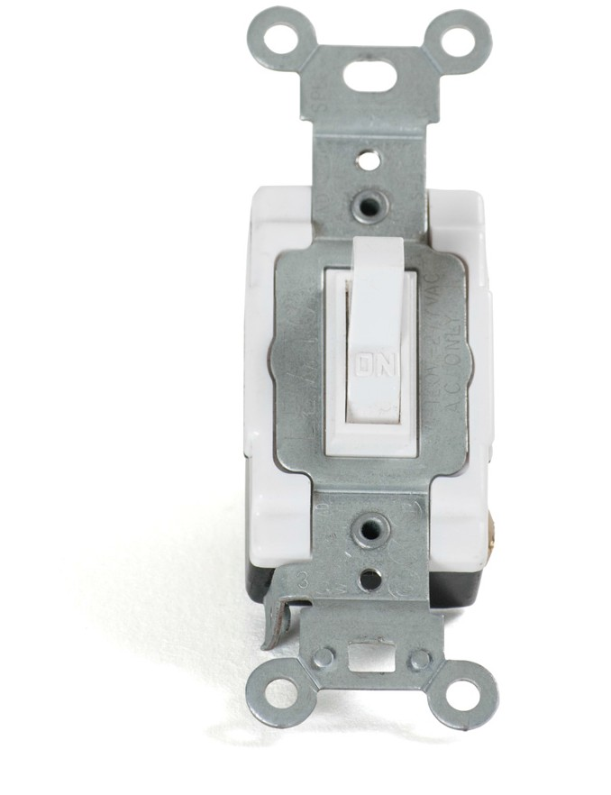  Figure 12—Single-pole toggle switch | 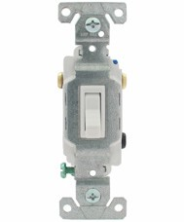  Figure 13—Three-way switch

Volt: the Standard International (SI) unit of electric potential or electromotive force. Electrical pressure applied to electrons in a circuit. Symbol is V.

Estimated Time
2 hours

Recommended Number of Students
20, based on BC Technology Educators’ Best Practice Guide

Facilities
Classroom or computer lab, or shop with access to computer with Internet and projector

Tools
Markers for poster paper, or white board

Materials
Masking tape, pictures printed from electrical equipment sheet, definitions and headings from terminology sheet

Optional
This would be a great opportunity for a field trip to a job site in progress to show students electrical equipment and question their knowledge of some of the terminology. A field trip could be done to add to the activity, and/or add to other activities. It is also an opportunity for an electrician to come in as a guest speaker and bring some electrical equipment to show students, and to help explain some of the terminology.
If none of these options are available, the teacher could lead students on a tour around the school and show them electrical equipment. The teacher could show students the main electrical room. This would allow students to see the main electrical service and help to explain the operation of a working electrical installation.

Resources
All photos used in activity

Activity

- Teacher should photocopy a sheet with all definitions and pictures for each group of students.
- Teacher should view terminology with students and explain and discuss.
- Teacher should view electrical equipment with students and explain and discuss.
- Students break into groups of four or five.
- Each group receives all terminology words and definitions separately and matches them up taped to a board, wall, chart, or poster paper. If samples are available students could attach the definitions to them.
- Have each group present their definitions to the class when complete.
- Teacher may post the electrical equipment photos and have students identify what they are and their use.

Evaluation Guidelines
The student:
  - Correctly identifies terminology and definitions
  - Participates in discussion and presentation of terminology and definitions
  - Contributes to group work
  - Can identify and explain electrical equipment

Extension Activity
Have students use the web to research:
  - additional electrical terminology and definitions
  - various types of electrical equipment, explaining what the equipment does and providing a picture of the equipment
Once students have retrieved this information, they can present and explain their findings to the class.

Circuit Concepts (Residential)

Description
This Activity Plan will allow students to understand how electrical circuits work in a home. Students will also gain knowledge of service panel installation and understanding of how the Canadian Electrical Code (CEC) applies to residential electrical wiring.
According to residential wiring requirements, to safely wire a home electricians must understand the concepts of branch circuit wiring. Many new apprentices spend time wiring homes in order to gain experience. The time spent learning how to rough in a home will help them to understand how to wire a home and learn about the CEC requirements for residential wiring. Residential house wiring also teaches new apprentices about:
- Electrical equipment
- How to read electrical drawings
- Understanding electrical symbols
- Using practical measurement and layout
- Distribution of electrical circuits
- Applying CEC rules to electrical installations

Wiring a home is a small-scale electrical job, but it incorporates many of the skills needed to move on to more complex electrical jobs. The basic skills learned during residential wiring are really the foundational skills needed to advance in the electrical trade.

Lesson Outcomes
The student will be able to:
- Understand how electrical power enters a home and is distributed to branch circuits
- Know some of the CEC requirements for BC
- Learn about safety issues regarding electrical services

Assumptions
The student:
- Has little or no knowledge of residential wiring
- Has knowledge of a basic electrical circuit
- Understands electrical hazards and safety
- Knows what role the Canadian Electrical Code plays in determining standards for electrical installations

This work is licensed under a Creative Commons Attribution-NonCommercial-ShareAlike 4.0 International License unless otherwise indicated. 55

Terminology
Branch circuit: the portion of wiring from the final circuit breaker to the outlet.
Drywall: gypsum wallboard used to cover the interior walls of most homes.
Electrical bonding: the permanent joining together of metal parts to form an electrically conductive path that has the capacity to conduct safely any fault current likely to be imposed on it.
Electrical equipment: equipment such as receptacles (outlets), light fixtures, switches, conductors (wires), circuit breakers, electrical panels, conduit, etc.
Electrical layout: taking information from a blueprint or electrical drawing and transferring it to the actual locations in a room to denote where devices will be installed (e.g., lights, switches, receptacles).
Electrical meter: a device that measures the amount of electrical energy consumed by a residence, business, or electrically powered device.
Grounding: the process of connecting equipment to a common ground, or “earth.” This is done as a safety mechanism in order to avoid the unsafe energizing of equipment.
Main electrical panel: a metal electrical service box that accepts the main power to the home and distributes electrical current and voltage (power) to the various circuits within the home.
The various circuits are protected from over current by the use of circuit breakers or fuses. The electrical panel is also known as a service panel, breaker panel, and fuse box (archaic).
Overload: an overcurrent that exceeds the normal full load current of a circuit. This type of overcurrent characteristically does not leave the normal current-carrying path of the circuit. It flows from the source, through the conductors, through the load, back through the conductors, to the source again.
Rough in: work performed on a building’s electrical system before the interior walls are insulated and finished with drywall.

Estimated Time
1–2 hours

Recommended Number of Students
20, based on BC Technology Educators’ Best Practice Guide

Facilities
Computer lab, classroom, or shop

Tools
Pencils, pens

Materials
- Class copies of or enough for pairs: Electrical Code Simplified, House Wiring Guide. P.S. Knight. ISBN number 978-0-920312-48-3. Available at most home improvement stores.
- Projector and screen
- Computer with Internet access and sound
- Photocopied handouts or overhead projector with transparencies

Optional
This would be a good opportunity for a field trip to a residential construction site to show the electrical system being built. This could also serve as an opportunity to show the carpentry and plumbing trades performing their jobs.

Resources

Understanding Wiring
Video providing information on the electrical panel. http://www.youtube.com/watch?v=Qgtx6Eckovg

Basics of Your Home's Electrical System - The Home Depot
https://www.youtube.com/watch?v=nZVeOgusxqk

Electrical Code Simplified, House Wiring Guide, BC Book 1, published by P.S. Knight. Available at most home improvement stores.

Activity

- As a class, watch the “Understanding Wiring” video (see the Resources section). This video is from the United States, but it gives a good overview of an electrical panel and concepts of branch circuit wiring. It also covers some important safety issues related to house wiring.
- Watch the “Panel Upgrade” video to show students how power comes into an electrical service from the power authority. It will also show and explain to students how a panel is upgraded from a smaller service to a larger service. The electrical portion of this 23:44 video is the first 16:05.
- Discuss these videos as a class and help students understand that electrical wiring in homes is done very similarly across North America, although different areas have different code requirements for electrical work. The teacher should preview these videos and generate some discussion topics and questions to check for student understanding.
- Have students pair up or work individually on the questions on the next page, based on
Electrical Code Simplified, House Wiring Guide, BC Book 1.

Evaluation Guidelines
The student:
  - Participates in discussions about the videos

  - Displays knowledge and understanding of branch circuits through discussion and questioning
  - Demonstrates understanding of some of the safety issues around electrical services and branch circuit wiring
  - Displays knowledge and understanding of the main service of the home through discussion and questioning
  - Answers questions on code requirements correctly

Extension Activity
If there are enough copies of Electrical Code Simplified, students in small groups could draw up a few questions from specific chapters in the book, then trade questions with another group to find the answers from the book. This activity will help students become more familiar with code rules as well as how to find them in the simplified code book.

Electrical Code Questions

All questions are generated of pages 52–53 of Electrical Code Simplified, House Wiring Guide. The images on pages 52–53 lead to a page in the book that has the answer. Provide the code rule as well as the answer to the questions. Wire sizes and ampacities are:
- #14 wire—15 amps
- #12 wire—20 amps
- #10 wire—30 amps
- #8 wire—45 amps
- All wire is NMD90 copper Answer key on the next page.
- What is the maximum amperage and wire size that may be used for a washing machine in a laundry room? What type of receptacle is it?

- What is the maximum size of circuit breaker to be used for an electric water heater?

- How many conductors and what size of wire should be used to supply an electric dryer? What size of circuit breaker should be used?

- In British Columbia is it mandatory for outdoor plug outlets to be controlled by a switch inside the house?

- What is the minimum wire size and ampacity used to supply a fridge? How many conductors should be used? What other load may be supplied by a fridge circuit?

- Is it allowable to install an outlet box behind a baseboard heater?

- How many conductors and what size of wire should be used to supply an electric range outlet? What should the plug receptacle rating be? Is it acceptable to fasten a range receptacle outlet box on one side only?

- What types of receptacles are required in a bedroom? What is their purpose?

Answers
  - Rules 26–710 (e) (i), 26–720 (b): 20 amp #12 copper, 20 amp T slot receptacle 2. 26–750 (4): 20 amps
3. 26–744 (2) & (3): 3 wire #10 copper, 30 amp
- 26–717 (a): No, but recommended by CSA
- 26–720 (a): #14 wire 15 amps, two conductors, clock outlet 6. 12–506, 12–3002 (6): Yes, but not preferred
7. 8–300, 26–744, 26–746: 3 wire #8 copper, 45 amp receptacle rating, 12–3012 (3): No, supported on two or more sides
8. 26–722 (f) & (g): AFCI type, arc fault circuit interrupters, to trip quickly to avoid fire hazards

Youth Explore Trades Skills Electrician

Circuit Drawings and Wiring Diagrams

Description
Successfully performing electrical work requires the ability to read and interpret many different types of drawings and diagrams. Understanding circuit symbols and components is another one of the basic building blocks needed to become an electrician. If an electrician misinterprets a drawing or diagram when wiring a house, devices could be incorrectly installed or even missed altogether. Knowing how to properly take information from an electrical drawing or diagram and apply it to the real world is essential for electricians.

Lesson Outcomes
The student will be able to:
- Know the difference between a circuit drawing and a wiring diagram
- Understand some basic symbols for schematic drawings and wiring diagrams
- Produce a wiring diagram
- Understand the difference between different types of diagrams
- Know how to draw a basic floor plan with electrical symbols

Assumptions
Students will have been introduced to electrical equipment and terminology. In addition, they will understand:
- Basic electrical circuits and theory
- Branch circuit wiring
- A basic top view floor plan

Terminology
Block diagram: a diagram of a system in which the principal parts or functions are represented by blocks connected by lines that show the relationships of the blocks.

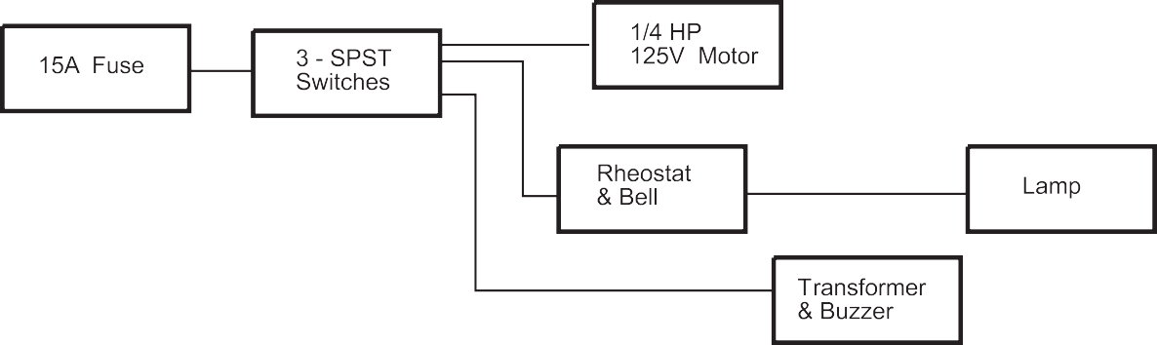
Figure 1—Block diagram

This work is licensed under a Creative Commons Attribution-NonCommercial-ShareAlike 4.0 International License unless otherwise indicated. 61

Circuit drawing (diagram): a simplified conventional graphical representation of an electrical circuit.

12'
10'
21 mm
21 mm
SYMBOL LEGEND
Duplex receptacle
Single-pole switch
1 × 4 fluorescent light fixture
Electrical panel
EMT run
Armoured cable run (B/X)
4x4 junction box

Figure 2—Circuit drawing

Line diagram: a one-line diagram or single-line diagram is a simplified notation for representing an electrical system. The one-line diagram is similar to a block diagram except that electrical elements such as switches, circuit breakers, transformers, and capacitors are shown by standardized schematic symbols.

Figure 3—One-line diagram

Pictorial diagram: a diagram that represents the elements of a system using abstract, graphic drawings or realistic pictures.
Schematic diagram: a diagram that uses lines to represent the wires and symbols to represent components. It is used to show how the circuit functions.

Figure 4—Schematic diagram

Wiring diagram (or pictorial): a simplified conventional pictorial representation of an electrical circuit. It shows the components of the circuit as simplified shapes, and how to make the connections between the devices. A wiring diagram usually gives more information about the relative position and arrangement of devices and terminals on the devices.

Figure 5—Wiring diagram

Estimated Time
2–3 hours

Recommended Number of Students
20, based on BC Technology Educators' Best Practice Guide

Facilities
Classroom, or technology education shop

Tools
Pencils, rulers, erasers

Materials
Blank paper, photocopies of standard floor plans

Optional
Drafting table, T square, 90° triangle

Resources
Attached drawing and wiring diagram

Activity 1: Drawing Circuits

- Using the basic electrical floor plan and the symbol chart on the following pages, explain the electrical symbols to the students.
- Give students a standard photocopy of a floor plan (see the end of this Activity Plan) that includes a kitchen and have them draw one or two 12-device circuits using electrical symbols and paths for circuits as shown in the floor plan drawing (Figure 5).
Note: Page 59 in the Electrical Code Simplified Book will help students to understand how many devices are permitted per circuit and their electrical symbols.
- Have students draw two outlets that require separate circuits for a fridge and a dishwasher that go directly back to panel (homerun shown as a short line directed toward the panel with an arrow on it).
- Have students draw a legend of symbols for their drawing.

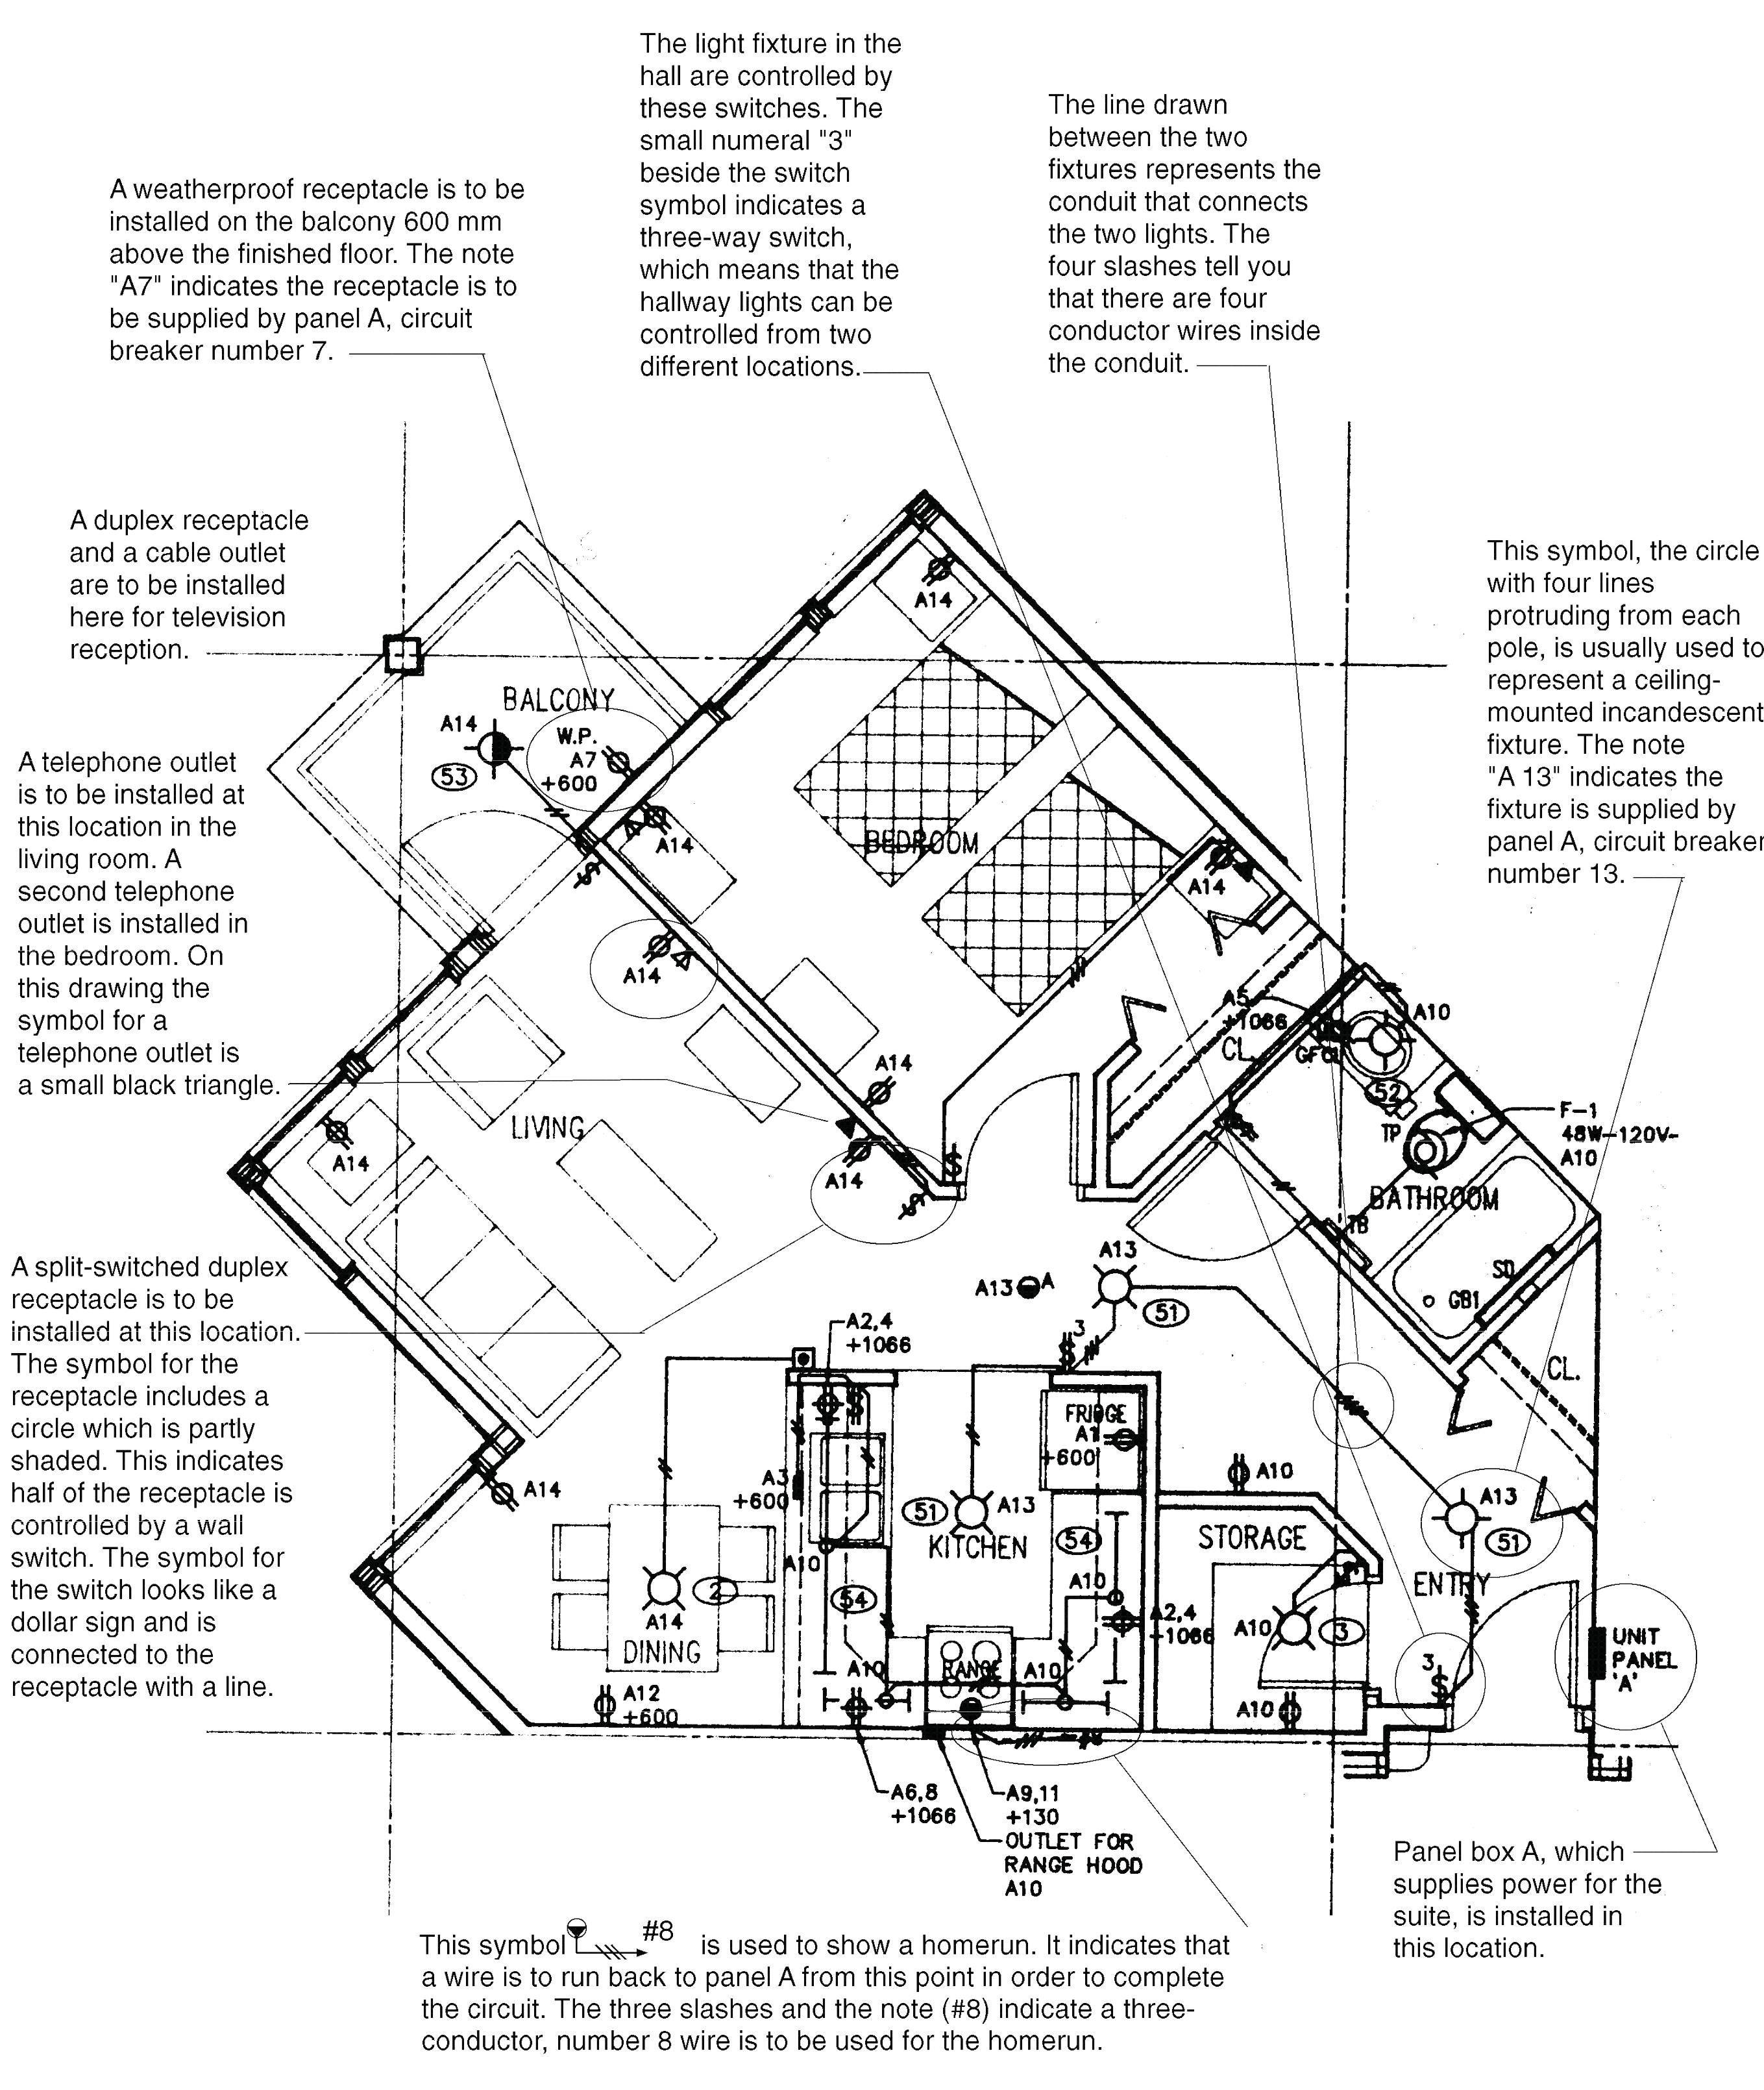
The light fixtures in the
hall are controlled by these switches. The small number “3” beside the switch symbol indicates a three-way switch, which means that the hallway lights can be controlled from two different locations.
This symbol, the circle
with four lines protruding from each pole, is usually used to represent a ceiling- mounted incandescent fixture. The note
“A13” indicates the fixture is supplied by panel A, circuit breaker number 13.
A split-switched duplex
receptacle is to be installed at this location. The symbol for the receptacle includes a circle that is partly shaded. This indicates half of the receptacle is controlled by a wall switch. The symbol for the switch looks like a dollar sign and is connected to the receptacle with a line.

Figure 6—Floor plan of a typical suite showing power and lighting details

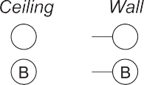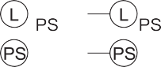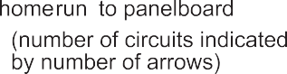

-
-

-
-

Figure 7—Common electrical symbols

Activity 2: Basic Wiring Diagram

  - Have students produce a basic wiring diagram.
  - The wiring diagram will show the circuit students will wire in Wiring Devices and Wiring a Wall Section.
  - The diagram should show incoming power feeding a receptacle.
  - From the receptacle the cable feeds a switch.
  - From the switch the cable feeds a light.

Figure 8—Basic Wiring Diagram

Wire one duplex outlet and one switch controlling one light, fed from the outlet.

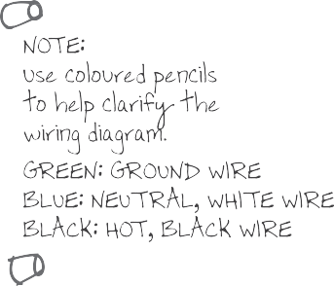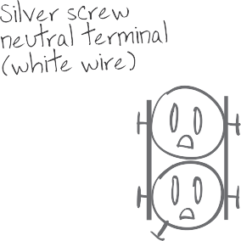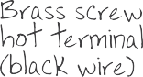

Evaluation Guidelines
The student:
  - Understands basic types of electrical drawings
  - Can produce a floor plan that displays understanding
  - Knows the difference between a circuit drawing and a wiring diagram
  - Draws and understands a wiring diagram

Extension Activity
Draw more wiring diagrams that include more devices in different configurations.

Example: Wiring from a switch box running two lights. The circuit could be more complicated if the student understands the concepts.

BATH
BEDROOM 1
HALL
BEDROOM 2
FRONT PORCH
DINING ROOM
LIVING ROOM
LAUNDRY
KITCHEN

Plan for Main Floor of House
•
BACK PORCH

Circuit Drawings and Wiring Diagrams
Electrician

Use of Hand Tools

Description
Learning a new skill doesn’t always happen easily or quickly, and using hand tools is no different. Some students may have had a lot of exposure and practice using hand tools and are already competent. Many students will be using hand tools in a different way than they may have before. When doing electrical work, manual dexterity is important. Doing electrical work takes thought, but using hand tools takes practice. Having good hand and tool skills makes an
electrician more efficient. Working safely with hand tools in the electrical field is a major skill that must be continually maintained and practised.

Lesson Outcomes
The student will be able to:
- Understand and safely use lineman pliers, wire strippers, and a utility knife
- Cut sheathing off plastic-sheathed cable and extension cord wire
- Identify common hand tools used by electricians
- Use hand tools more competently

Assumptions
- The teacher will know all the common hand tools used by electricians and be able to demonstrate how to safely use pliers, wire strippers, and a utility knife.
- Students will have little knowledge of electrical tools

Terminology
Conductors: the copper or aluminum wires located inside the wire insulation.
Fish tape: a tool for pulling wires or cables through conduits and inaccessible spaces. A fish tape is a very long metal strip with a hook at the end, which can be used to grab a wire or another fish tape, somewhat like catching fish with a hook on a line.

Figure 1—Fish tape

This work is licensed under a Creative Commons Attribution-NonCommercial-ShareAlike 4.0 International License unless otherwise indicated. 73

Hacksaw: a fine-tooth hand saw with a blade held under tension in a frame, used for cutting materials such as metal or plastics.

Figure 2—Hacksaw

Hand tool: any tool that is not a power tool; one powered by hand or manual labour.

Figure 3—Hand tools

Insulation: the material that surrounds the bare conductors.
Lineman pliers: a type of pliers used by electricians and other tradespeople primarily for gripping, twisting, bending, and cutting wire and cable.

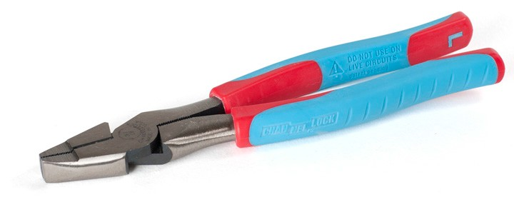

Figure 4—Lineman pliers

Needle-nose pliers: pliers with long, slender jaws used for grasping small or thin objects.

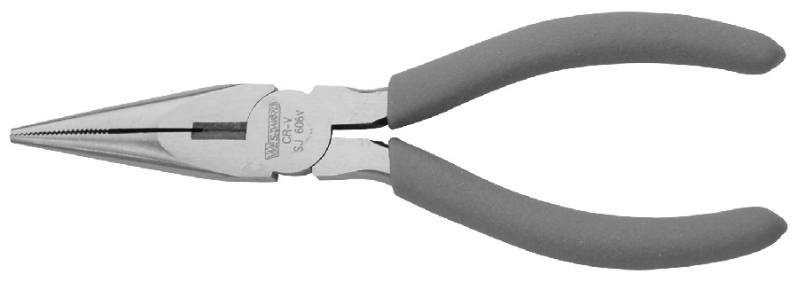

Figure 5—Needle-nose pliers

Non-metallic sheathed cable (NMSC): a common plastic-sheathed cable used for wiring wood frame construction buildings. Known by trade names Loomex (Canada) and Romex (USA). It is available as 2 or 3 conductor and sizes #14 (15 amp), #12 (20 amp), #10 (30 amp), #8 (45 amp), and some larger sizes. The conductor count does not include the uninsulated wire that is used as a ground wire. The outer jacket can be colour-coded to make the wire sizes easier to identify.

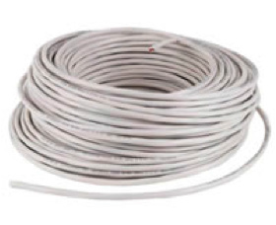

Figure 6—Non-metallic sheathed cable (NMSC)

Screwdriver: a hand tool for turning a screw, consisting of a handle attached to a long, narrow metal shank, and available with a variety of tips. Common types for electricians are Robertson® (square tip) in sizes #1 and #2, slotted (flat tip), and Phillips® (star tip).

Slotted Phillips® Robertson®
Figure 7—Types of screwdrivers

The parts of a screwdriver are the head, handle, ferrule, shank, blade, and tip. The length of the blade indicates the size of a screwdriver. Some screwdrivers may have square shanks that permit turning with a wrench when required for extra torque.

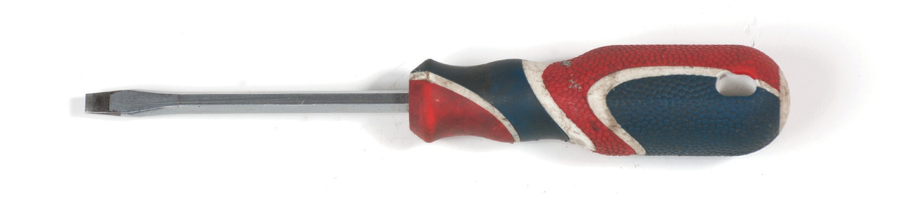
Handle
Shank
Ferrule
Blade
Head
Tip
Size of screwdriver
length of blade
Figure 8—Parts of a screwdriver

The stubby screwdriver is available in all sizes of slot, Robertson®, and Phillips® tips. The blade and handle are very short.

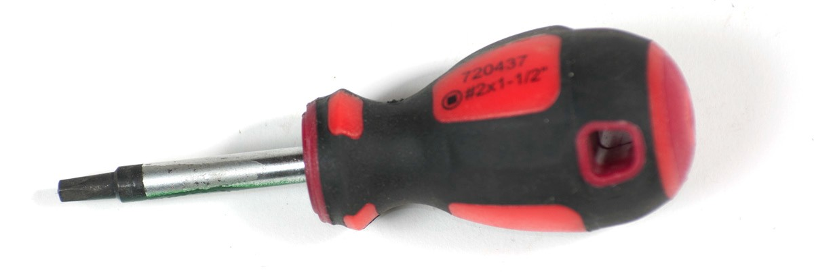

Figure 9—Stubby screwdriver

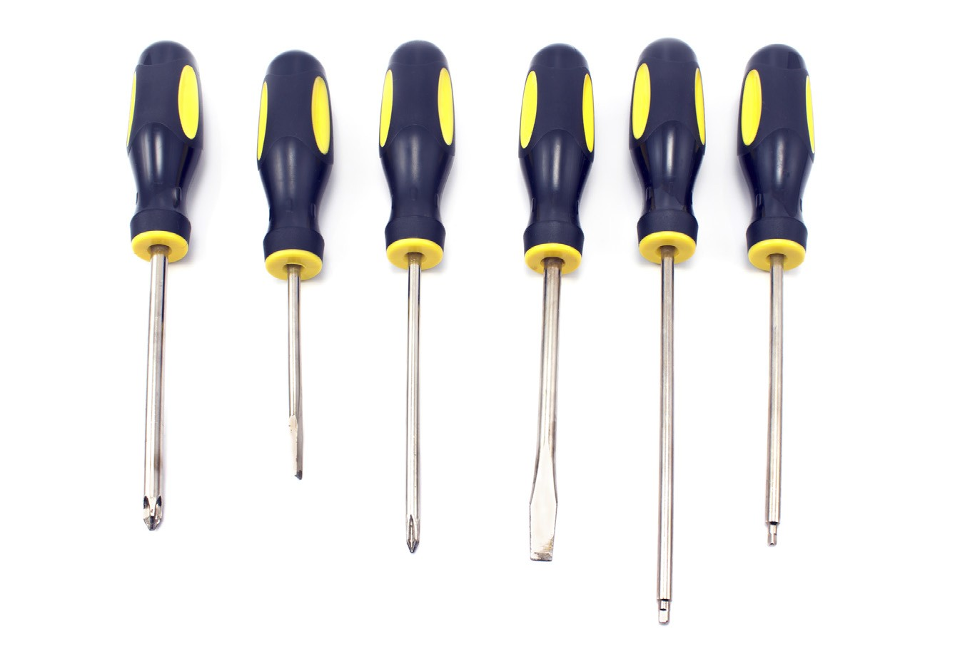

Figure 10—Assorted screwdrivers

Side cutters: general-purpose cutters used to snip light-gauge wire or cable.

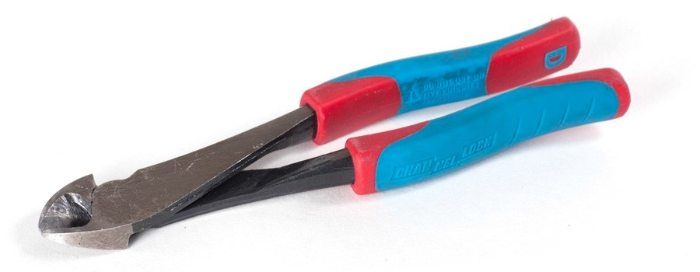

Figure 11—Side cutters

Torpedo level: a spirit level or bubble level is designed to indicate whether a surface is horizontal (level) or vertical (plumb). They commonly have a magnetic edge to attach to metal electrical boxes or conduit.

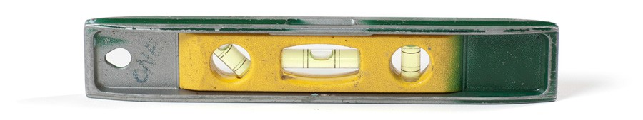

Figure 12—Torpedo level

Utility knife: a knife used for general or utility purposes (see Resource video).

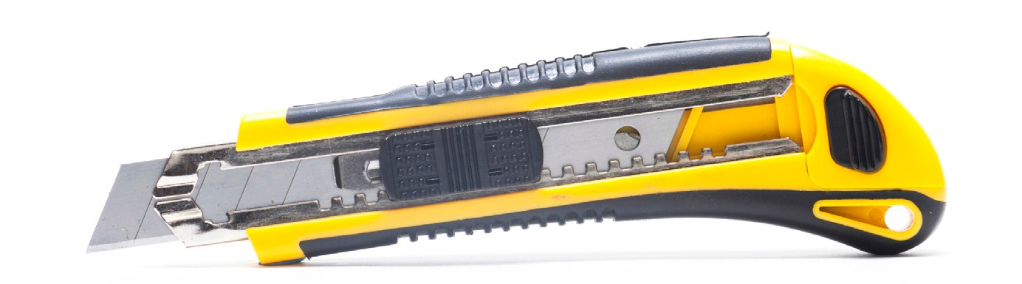
Figure 13—Utility knife

Wire strippers: is a small, hand-held device used to strip electrical insulation from electric wires.

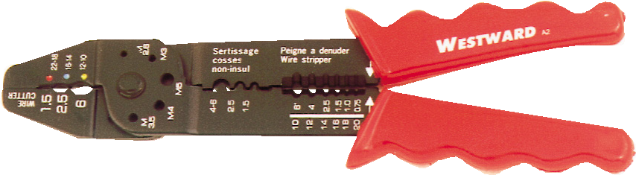
Figure 14—Wire stripper

Estimated Time
1–2 hours
The time required to complete this activity will depend on students’ familiarity with hand tools and on the teacher’s ability to find redundant equipment (old electronics, stereos, old power tools, etc.) for students to “find their hands” and practise using different hand tools.

Recommended Number of Students
20, based on BC Technology Educators' Best Practice Guide
Students may work individually or in pairs, depending on the availability of hand tools.

Facilities
Technology education shop with benches or similar environment

Tools
Lineman pliers, wire strippers, and utility knife at the very least (all other electrical hand tools could be used in this lesson)

Materials
14/2 plastic sheathed wire

Optional
This could be an opportunity to have an electrician come it to speak and bring electrical tools to explain their use.

Resources
Hand tool worksheet

Electrician Tools
http://www.youtube.com/watch?v=SXZXtD60t2g

Activity: Stripping Plastic-sheathed Cable

The teacher should go through all of the electrician’s hand tools and explain their safe use. Always turn off power and test for voltage when working with electrical equipment.
- Demonstrate to students how to strip plastic-sheathed cable (scrap cable is preferred to avoid waste; small offcuts will work fine). This could be done on a bench with scrap wood under the wire.

- Using 14/2 cable, place a short piece (minimum 12") on the surface. Push down on the utility knife in the middle of the sheathing about 6" from the end of the cable until the knife goes through. Gently draw the knife toward the end of the cable, away from the body and not in the path of the other hand.
Note: It is important to cut the middle of the sheathing because that is where the bare ground wire is; if the knife strays to the edges it will cut into the insulation of the current- carrying conductors that run on either side of the bare ground wire. It can be dangerous if wire is installed with nicks or cuts in the insulation.

- When the cut is finished, peel back 6" of the sheathing and cut it off with side cutters or pliers.

- Show students how to use the proper wire gauge notch on the wire strippers to cut insulation from wire.

- Using the #14 gauge stripper hole on #14 wire, strip a piece of insulation about 1" in length from the end of the conductor.

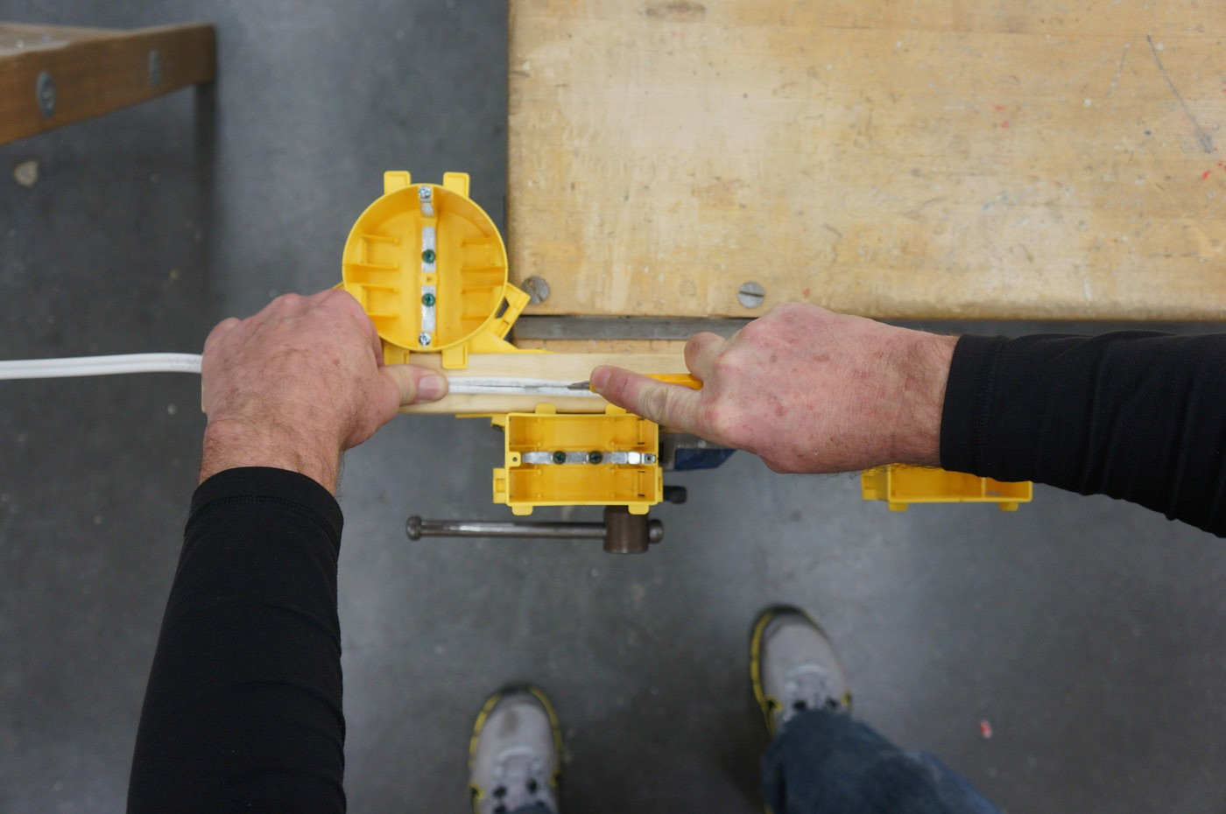

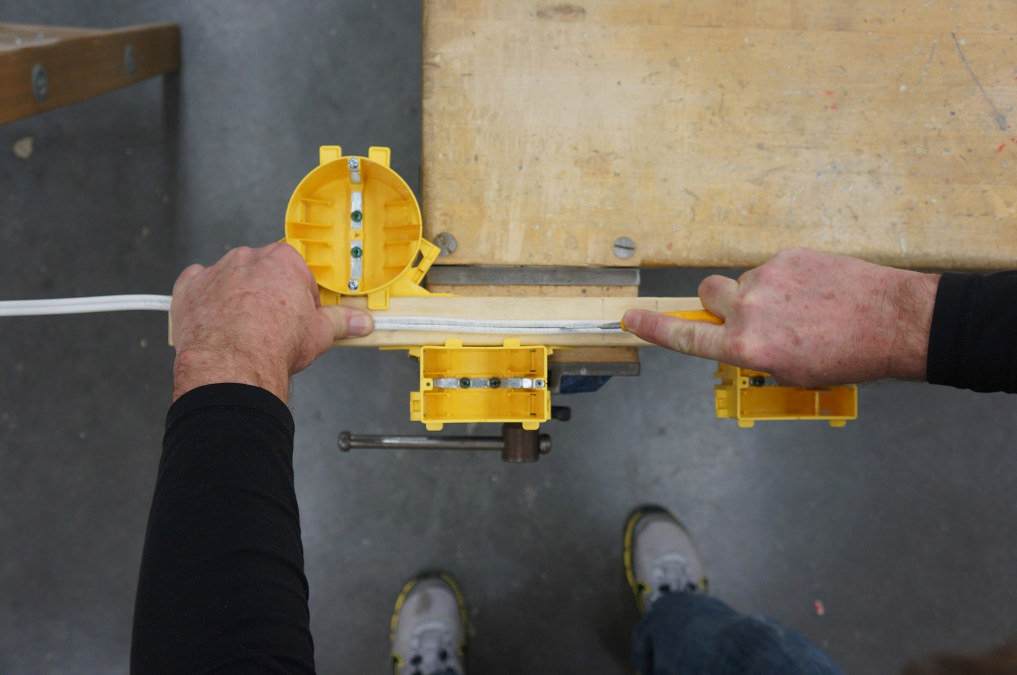

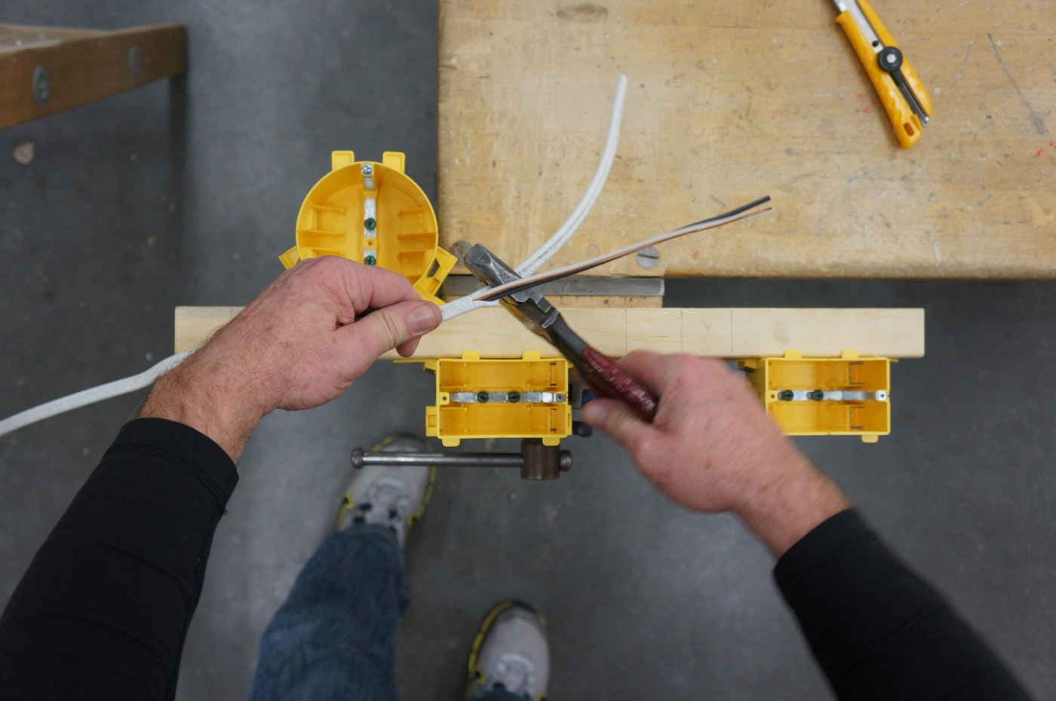

Figure 15a, 15b, 15c—Cutting sheathing and finished cut sheathing

Improper Use
- Strip a piece of insulation about 1" in length using the #16 gauge stripper hole on #14 wire.
- Remove the insulation. The wire will be scored because the strippers will cut into the conductor. A scored wire will break if the wire is bent back and forth a few times.
- Explain how this could be a problem with electrical wires. Scored wire or nicked insulation can create a dangerous situation for high-resistance faults, electrical shorts, or open circuits.

Proper Use
Students should practise cutting sheathing to learn how to do it safely without cutting the insulated cables inside the sheathing.
- Have students strip small lengths of insulation (1") from the conductors from which they have stripped the sheathing to practise and get a feel for the wire strippers.
- Have students strip wire to 1" and practise making some hooks by holding the wire with one hand then using needle-nose pliers to rotate the end of the wire to form a hook.
- Students could also practise using the hole in the wire strippers to make a hook. Insert the tip of the stripped end of the conductor into the hole of the wire strippers. Twist the wire strippers in a rotating motion to make a hook on the stripped end of the conductor. The hook should form a 180° bend in the wire when complete.
Students will benefit greatly by spending as much time as possible using all of the electrician’s hand tools to increase their manual dexterity. Taking apart and reassembling equipment is
an effective way to increase student awareness of electrical tools; it gives them hands-on opportunities to use many of the hand tools.
Note: Students will be making hooks and will be wiring devices in Wiring Devices.

  - Have students complete the hand tool worksheet.

Evaluation Guidelines
Check for nicked conductors after sheathing has been removed. Insulation on the conductors inside the sheathing should not be cut or nicked.
The student:
  - Works safely and responsibly
  - Can remove cable sheath and conductor insulation correctly
  - Matches pictures of tools to names on hand tool worksheet
  - Describes safety tips when using hand tools

Extension Activity
Try to find old electronic equipment, stereos, power tools, or any other type of redundant equipment that could be taken apart and reassembled with precision.
Note: Students will practise stripping an extension cord in Assemble an Extension Cord.

Hand Tools Worksheet

Electrical Tools
Most electrical wiring jobs are relatively easy to handle with a few inexpensive tools.

Circuit tester (Voltage tick): Simple and inexpensive, a circuit tester plugs into a conventional outlet and will tell you whether the circuit is “hot” (charged) or whether it’s properly grounded.

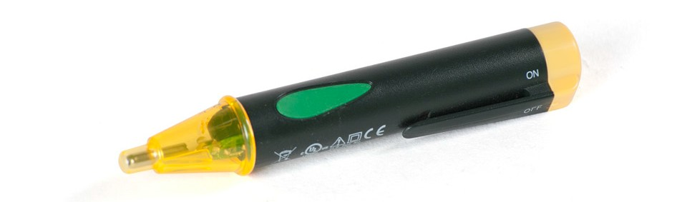

Figure 1—Circuit tester

Continuity tester: A small, battery-operated continuity tester costs less than $10. It can be used to determine whether wiring is broken and whether electrical circuits are complete.

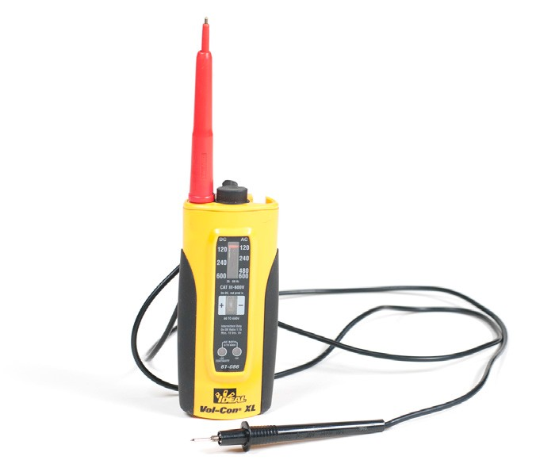

Figure 2—Continuity tester

Lineman’s pliers: A pair of these is the best tool to use for cutting heavy wire or cable and twisting wire ends together. To twist two wires together, hold them side by side with one hand, their stripped ends aligned, and point the blunt end of the pliers in line with them, clamp down, and twist in a clockwise direction.

Figure 3—Lineman pliers

Long-nose pliers: Long-nose pliers are great for bending small loops at wire ends or for cutting off wires (most include a wire-cutting section). Use the pointed end of the pliers to form a smooth,
¾-circle at a wire’s end, designed to circle around a screw terminal (always hook the wire onto the terminal with the end of the bend sweeping clockwise from the wire).

Figure 4—Long-nose pliers

Multi-meter: You’ll want to have a multi-meter on hand for making a variety of continuity checks, checking voltage, and other similar tasks. Read the manufacturer’s instructions for a thorough understanding of techniques. Multi-meters, which do the job of ohm meters, volt meters, and related tools, are sold at consumer electronics stores.

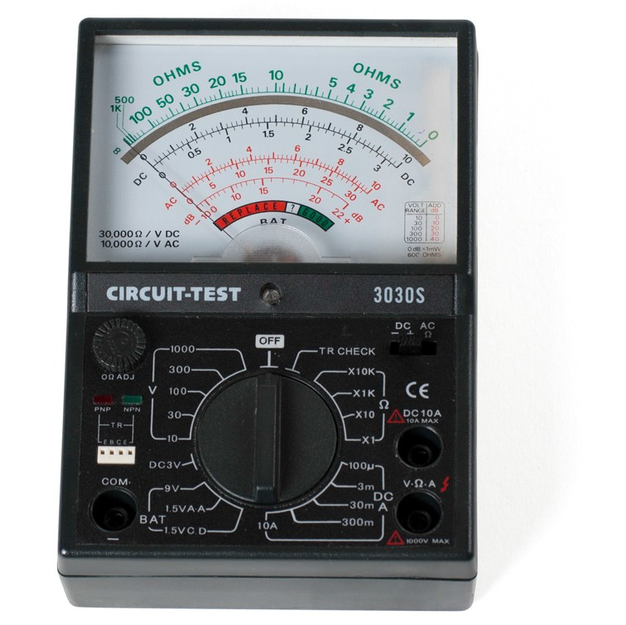

Figure 5—Multi-meter

Neon voltage tester: This helpful little tool can tell you whether wires are “hot” or not. When using it, be sure to hold only the insulated probes—not the bare parts. Touch one probe to what you suspect is a hot wire and the other probe to a neutral wire or grounding wire (or grounded metal electrical box). If the small light glows, the circuit is live.

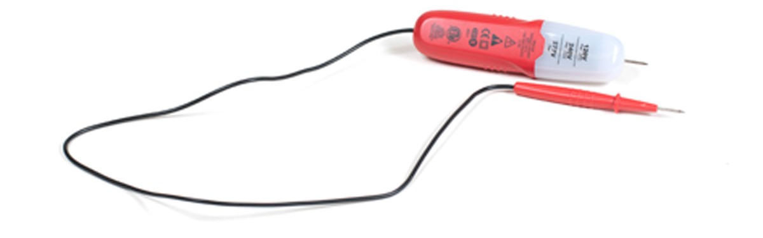

Figure 6—Neon voltage tester

Screwdrivers: You’ll want an assortment of screwdrivers with insulated rubber grips. Be sure to get both flat-bladed and Phillips-head drivers.

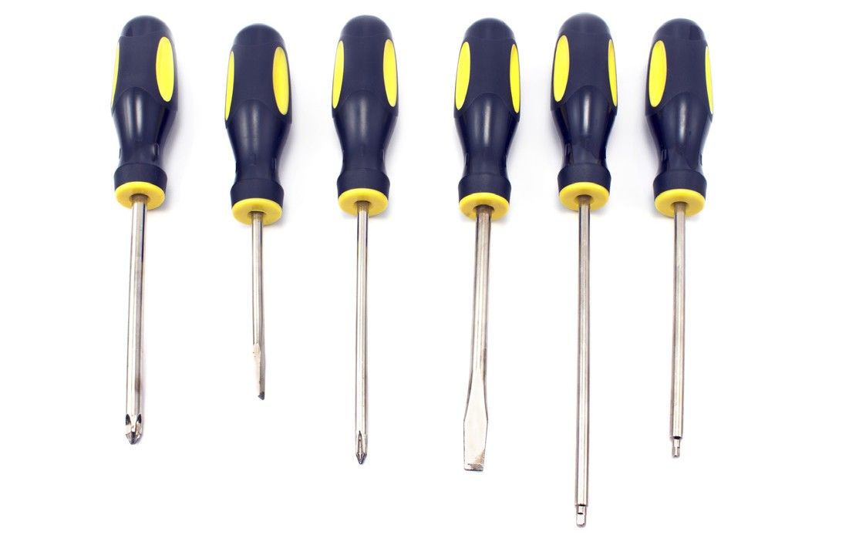
Figure 7—Assorted screwdrivers

Wire stripper: Most electrical wires run inside a sleeve of insulation, a plastic, rubber or paper coating that prevents bare conductors from shorting against each other or shocking you. When splicing wires(connecting two or more wires together) or connecting them to devices, you must remove the insulation, a relatively simple job when you have the right tool—an inexpensive wire stripper.

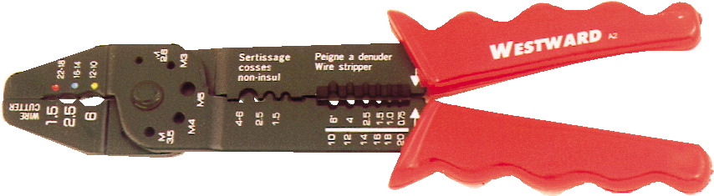
Figure 8—Wire stripper

The stripper should be set so that it cuts the insulation but doesn’t nick the wire (or use the slot that matches the wire conductor’s size). Hold the wire with one hand, bite into the insulation with the stripper, about ½" to ¾" from the wire’s end, rock the stripper back and forth, and pull the
insulation off the end of the wire.

Directions: Write the correct name beside the tool.

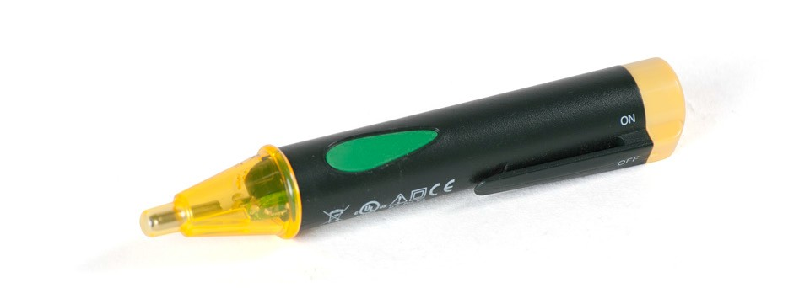 | 1.
 | 2.
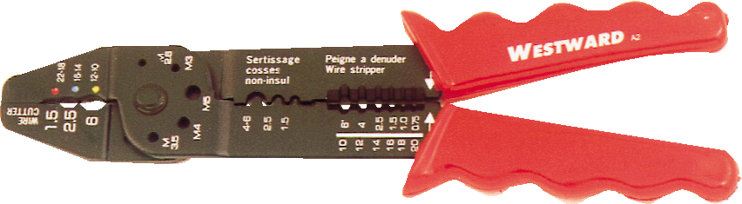 | 3.
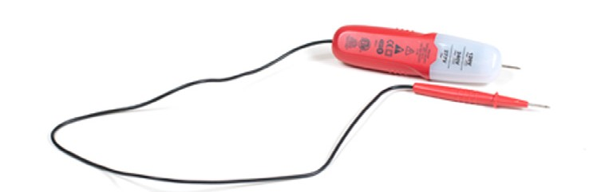 | 4.
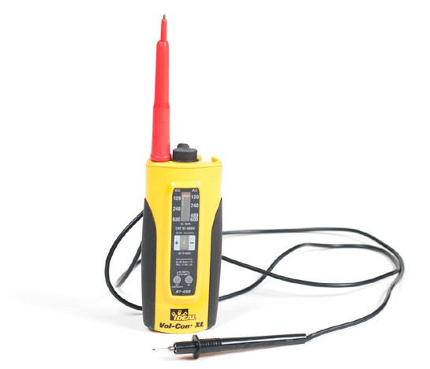 | 5.
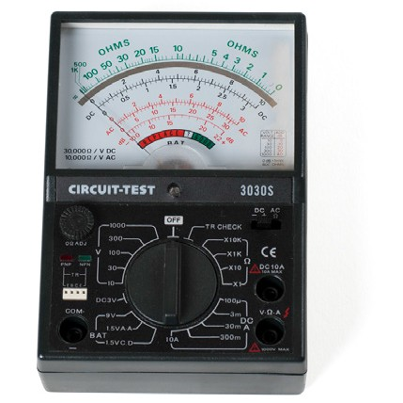 | 6.
 | 7.

Connecting Wires

Description
All lights in a house must have proper wire connections in order to work. Residential electrical work requires electricians to join wires together in junction boxes and electrical outlet boxes. It is very important that wire connections are done properly so that no short circuit, fire, or shock hazards occur.

Lesson Outcomes
The student will be able to:
  - Use proper technique with tools
  - Strip wire and use lineman pliers more proficiently
  - Join wires together with lineman pliers (2 wire, 3 wire)
  - Join wire using wire connectors
  - Select the proper connector for the number of conductors that will be joined together

Assumptions
The students will:
  - Have knowledge and understanding of basic electrical theory
  - Have had an introduction to electrical hazards, safety, and electrical code
  - Understand electrical circuits, drawings, and diagrams
  - Have knowledge of electrical terminology and equipment
  - Have practised stripping wire and using lineman pliers from Use of Hand Tools

Terminology
American Wire Gauge (AWG): a standardized wire gauge system used since 1857 predominantly in the United States and Canada for the diameter of round, solid, non-ferrous, electrically conducting wire.
Braid: to form into a braid; to weave together three or more strands or parts of something.
Conductor: a material or an object that conducts heat, electricity, light, or sound. Insulation: a material that reduces or prevents the transmission of heat, sound, or electricity. Splice: to join ropes, wires, etc., by weaving or twisting them together.
Wire connector: a twist-on cap made of a durable, thermoplastic polymer used to connect two or more aluminum or copper wires together in a box or enclosure. Also known as marrette, wire nut, and marr connectors in North America.

This work is licensed under a Creative Commons Attribution-NonCommercial-ShareAlike 4.0 International License unless otherwise indicated. 87

Estimated Time
1–2 hours

Recommended Number of Students
Individual work

Facilities
Technology education shop with benches

Tools
    - Good insulated lineman pliers
    - Wire strippers
    - Utility knife

Materials
    - #14 gauge wire, could be scrap wire (minimum 6" in length)
    - Yellow, red, and orange wire connectors

Common Wire Connectors and Their Uses

Wire Nuts and Wire Connectors | Colour & Type | Connector Capacity
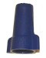 | Large Blue Wire Nut | #14 to #6 AWG  Min. 3 #12  Max. 2 #6 w/ 1 #12
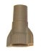 | Large Grey Wire Nut | #18 to #6 AWG  Min. 2 #12  Max. 6 #12
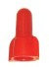 | Red Wire Nut | #18 to #8 AWG  Min. 2 #18  Max. 4 #10
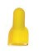 | Yellow Wire Nut | #18 to #10 AWG  Min. 2 #18  Max. 3 #12
 | Orange Wire Nut | #22 to #14 AWG  Min. 1 #18 w/ 1 #20  Max. 4 #16 w/ 1 #20

Note: The most commonly used wire connectors in residential wiring are red, yellow, and orange. The table above shows acceptable wire sizes for wire nuts.

Activity 1: Connect Two Wires Together

The teacher will demonstrate proper technique for stripping insulation from conductors and for twisting wires together before installing wire connectors. Students will practise connecting two wires together using the proper method. Once students become competent, they will practise connecting three wires together.

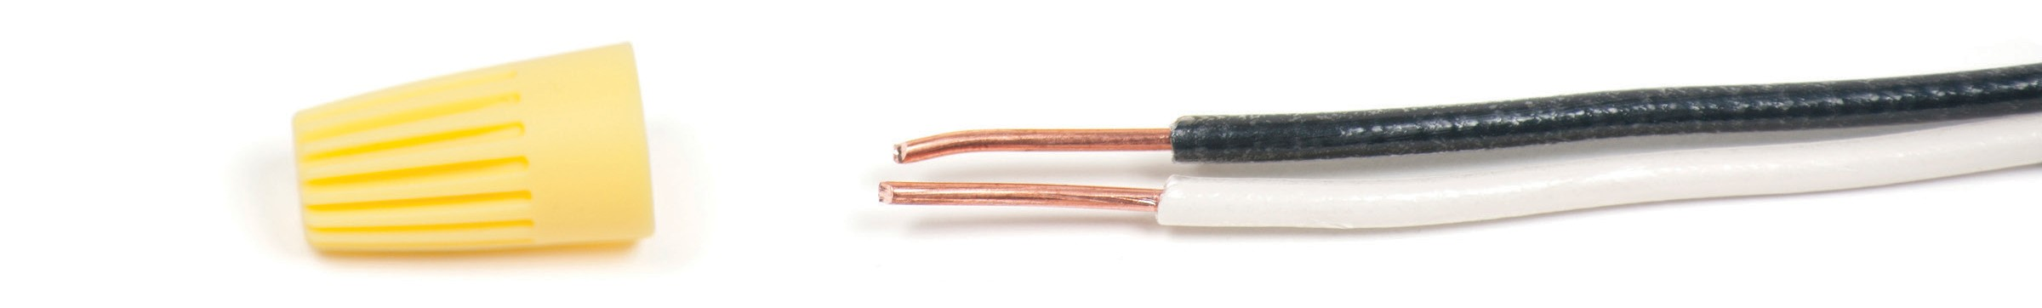

Figure 1—Connector and stripped wire

- Obtain appropriate tools.
- Strip all insulated wires to expose 1" of copper (Figure 1).
- Be sure not to nick or score the conductors.
- Position the black and white wires so the insulations are even.
- Hold the insulation of the two wires firmly.
Note: Insulation is stripped to 1" to allow the student to cut a clean end on the connection at 5⁄8" so the connector will thread on easily and not leave any copper exposed. As students get more practice they might be able to strip the wire to 5⁄8 and get a clean enough end to thread the wire connector on.

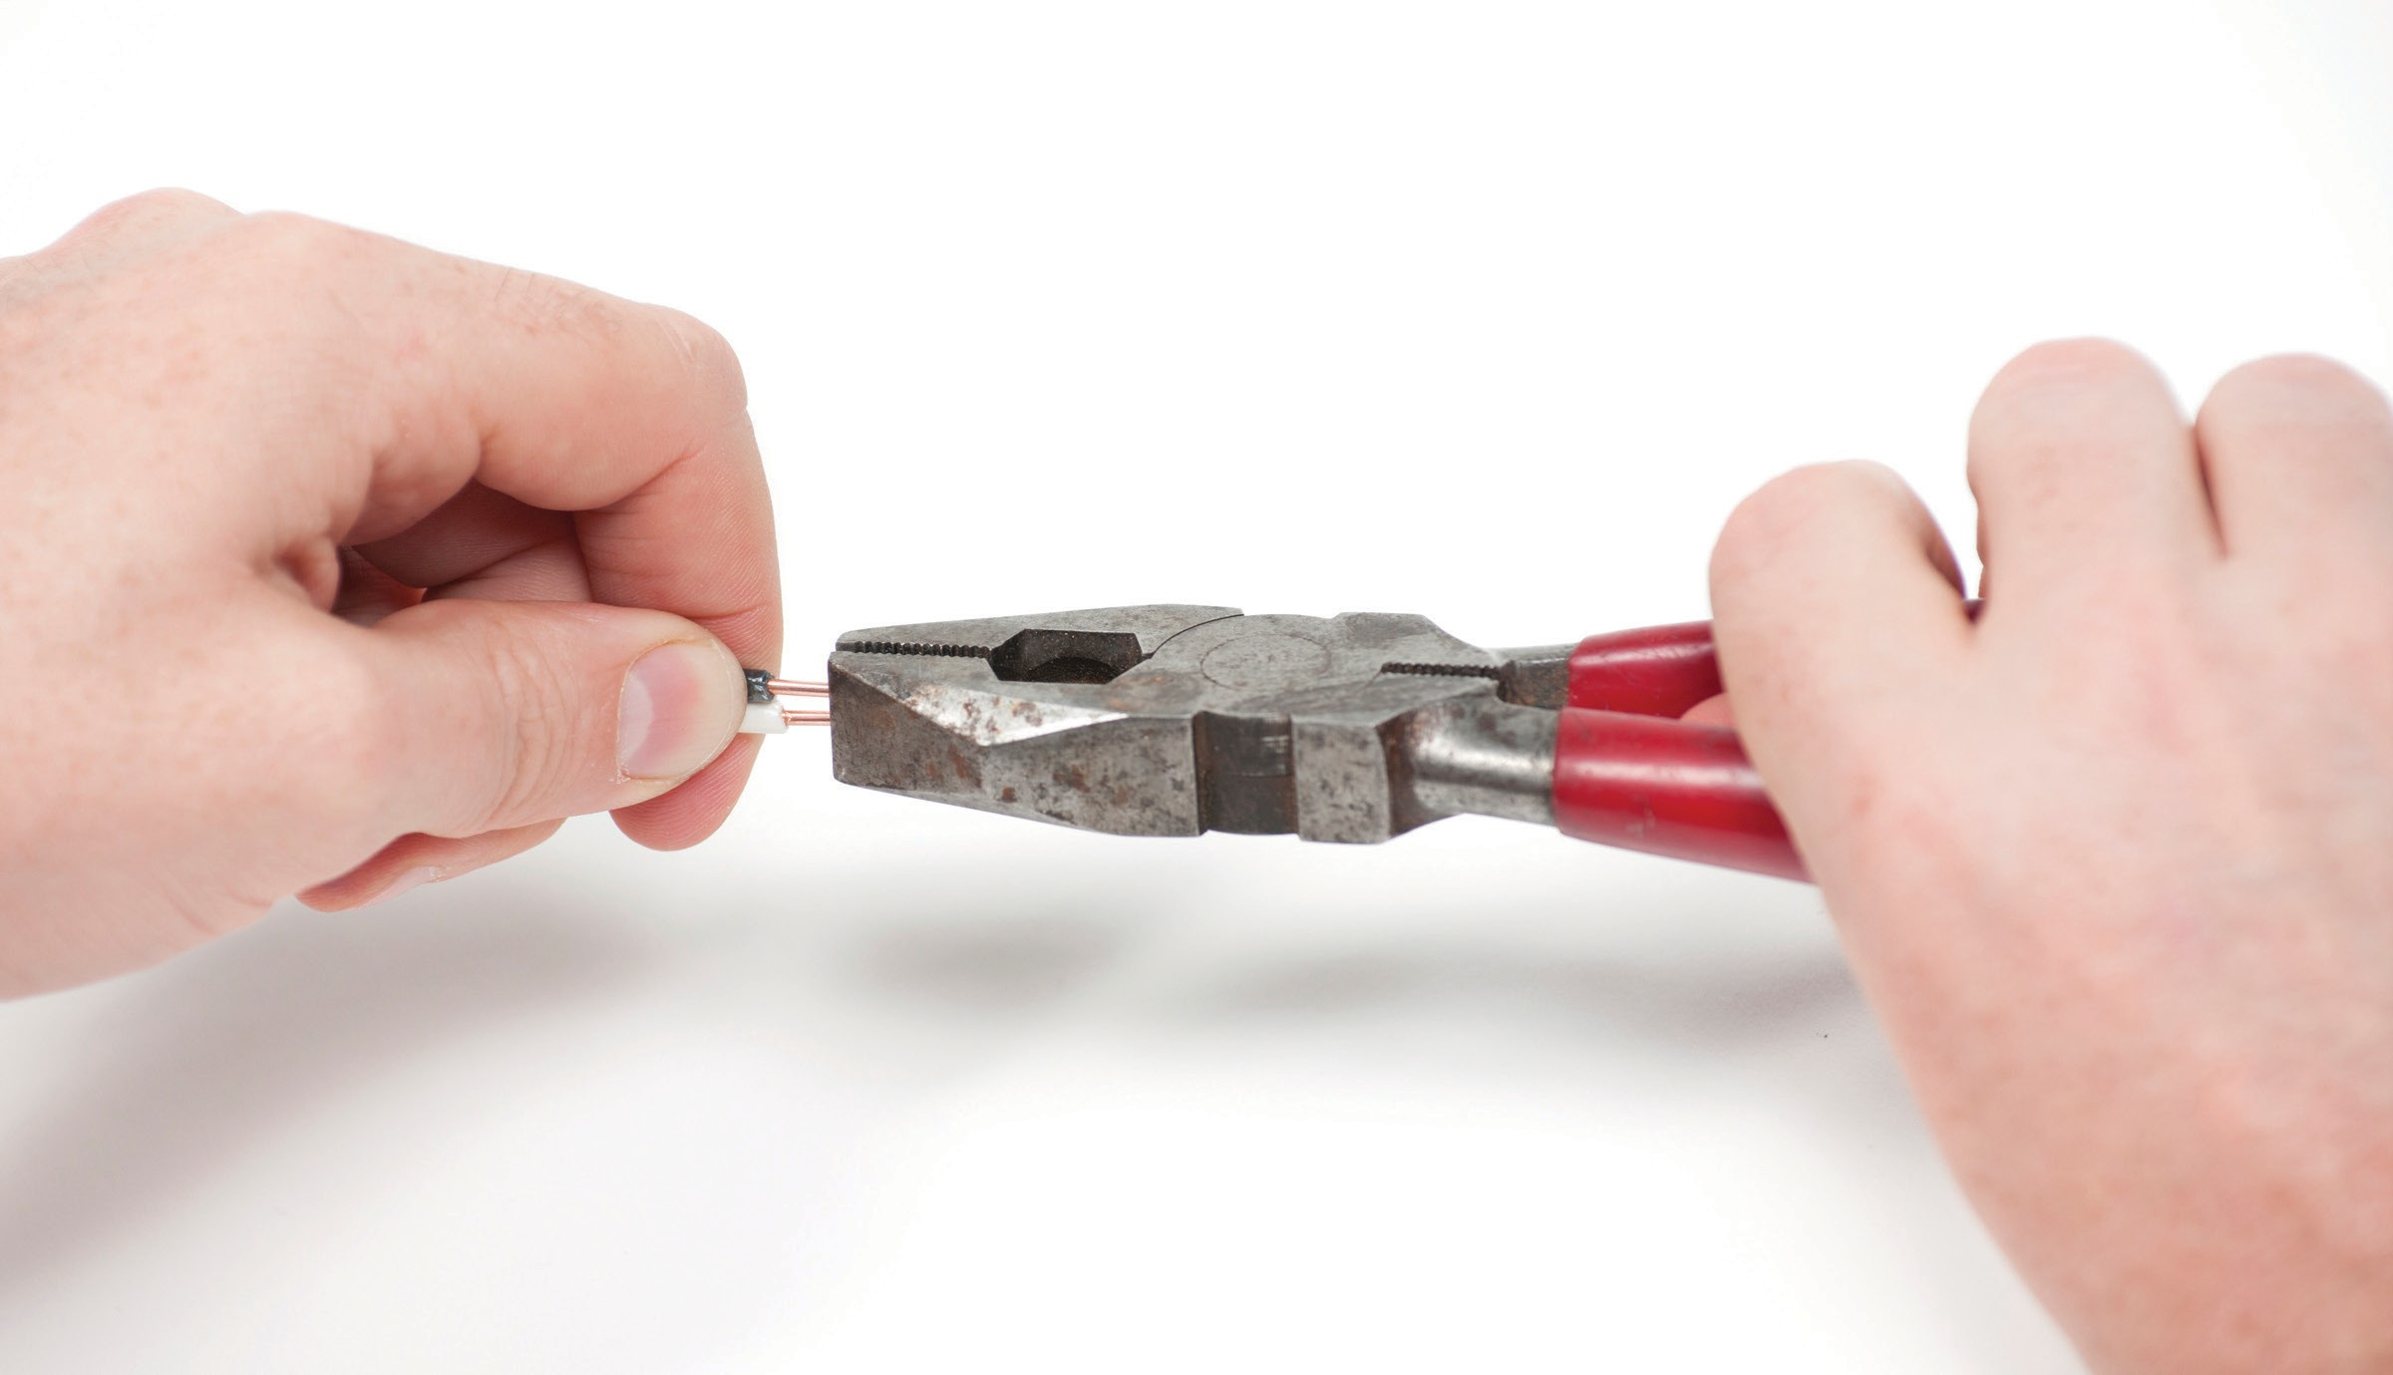

Figure 2—Twist the two wires together

- Grasp the ends of the wires with lineman pliers and twist clockwise to join the wires together.
Note: Pliers should be in line with wires with all wire connections facing them head on and not at 90° (Figure 2).
- Trim the twisted ends of the exposed wires to 5⁄8". (Figure 3).
- Select the appropriate wire connector and twist it on in a clockwise direction (clockwise is commonly used to tighten, counter-clockwise to loosen).

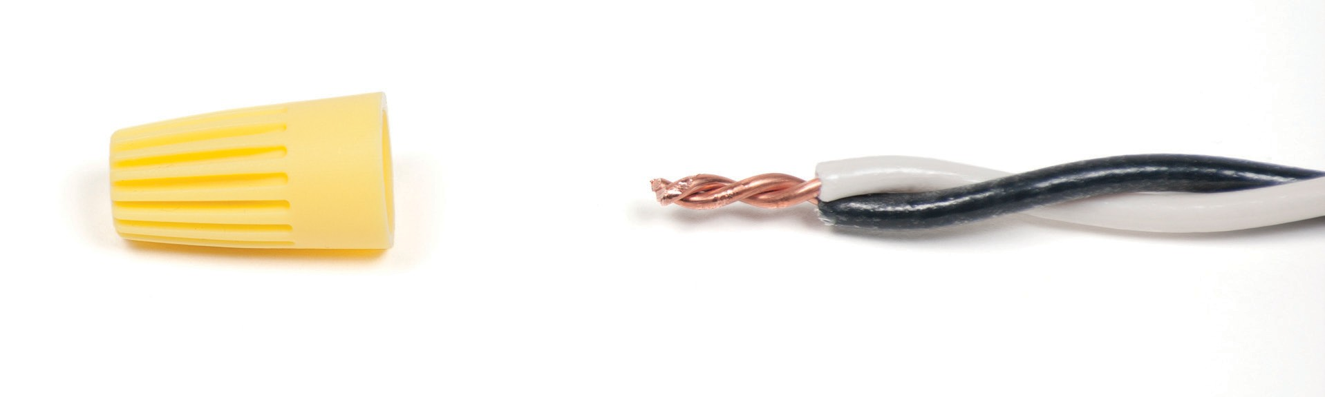
Figure 3—Exposed wires twisted together

- When complete, no copper conductor should be exposed past the wire connector (Figure 4).
- The insulations of the two wires should start to braid together.

Students should do the same procedure again at the opposite end of the two wires.

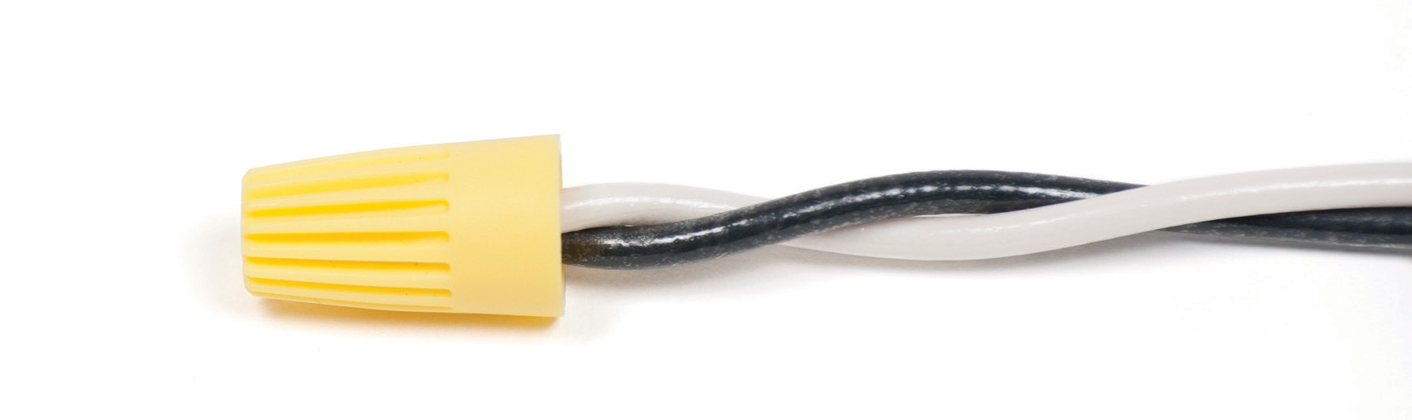
Figure 4—Completed connection

Most Importantly: No bare copper should be exposed at the bottom of the wire connector.
  - Figure 5 shows an example of poorly connected wires.
Note: The insulations are not aligned and the insulation has not started to twist together which makes the connection less stable.

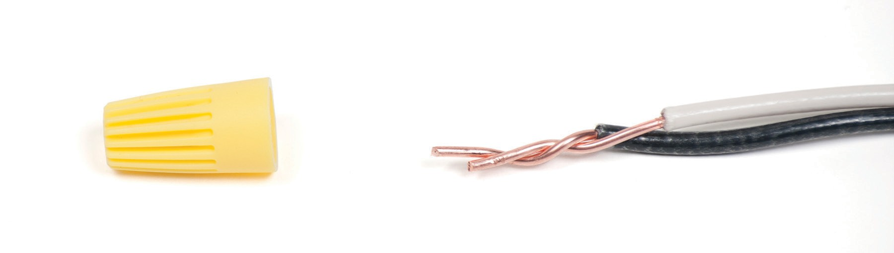

Figure 5—Poorly connected wires

  - Figure 6 shows a wire connector installed on the wires in Figure 5.
Note: The exposed copper conductor makes this VERY DANGEROUS.

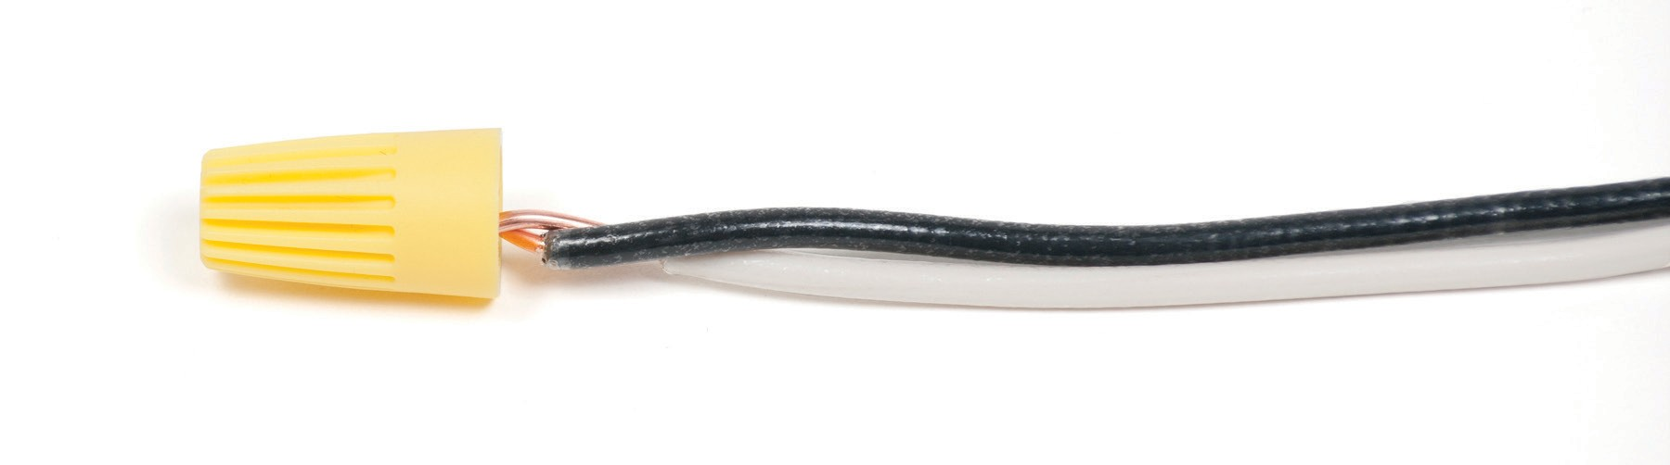

Figure 6—Bare conductors, exposed

Activity 2: Connect Three Wires Together

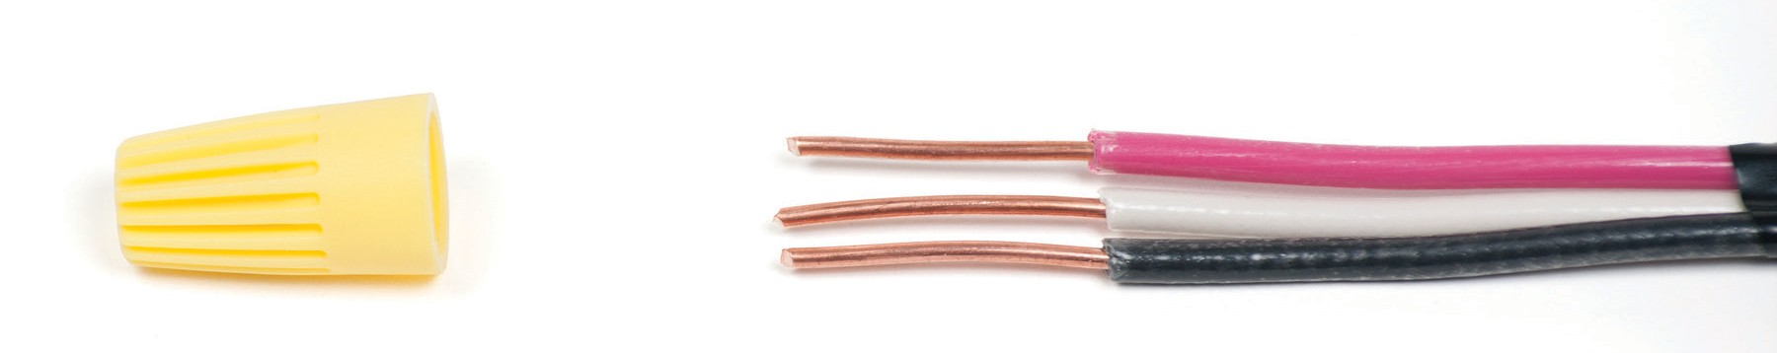

Figure 7—Properly stripped wires ready for connection

- Strip the wires to 1" (Figure 7).
- Grip the insulation firmly with the thumb and finger close to the conductors (about ½").
- Gently squeeze the wires with the pliers while turning the pliers clockwise.
- When the conductors start to braid, increase the pressure on the pliers until tight.
Note: Some students might be more comfortable starting with two wires and adding the third after. Practise both ways.

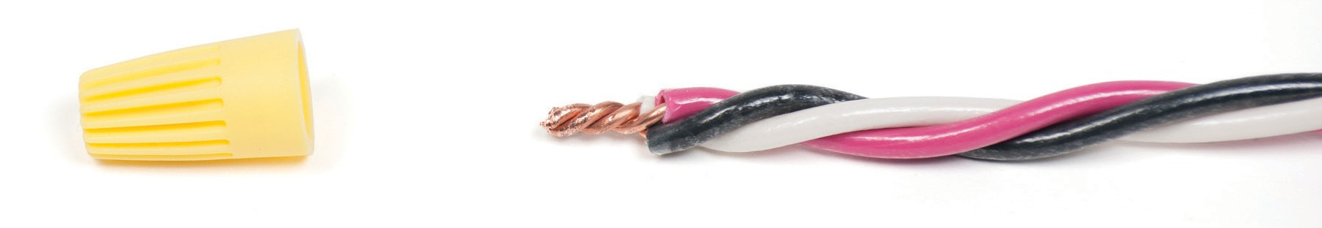

Figure 8—Properly twisted wires

- Cut the exposed part of the wire to 5⁄8".
- Make sure the insulation has started to braid (Figure 8).
- Select the appropriate wire connector and tighten.
- Make sure no exposed conductor is visible past the wire connector (Figure 9). Students should do the same procedure again at the opposite end of the wires.

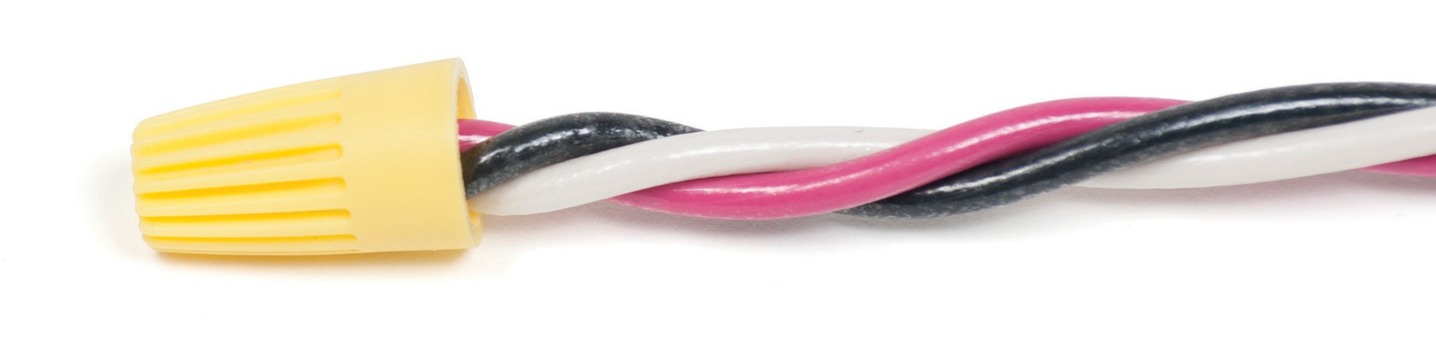
Figure 9—Properly completed connection

Evaluation Guidelines
  - The student uses tools appropriately and safely.
  - The student removes insulation without nicking or scoring the conductor.
  - Wires and insulation are braided together tightly.
  - Wire connector is tight.
  - There is no exposed copper beyond the wire connector.
  - When the teacher removes the wire connector, the connection of the wires should still be stable.
  - Three-wire connections should follow the same guidelines as above.
  - The student is responsible for a tidy work environment.

Note: Three-wire connections are more difficult and should require more time for the students to perfect.

Optional Activities
Practice is key for students to become more proficient with pliers and wire strippers.
  - Have students add more wires to the connection.
  - Start with four wires (all wire from the previous exercises can be reused).
  - Have students experiment by using smaller wire connectors (orange) in a four-wire splice to show them that the wire connector is too small and they must select the appropriate size to make a safe connection.
  - Make a five- or six-wire splice to see if students can still produce quality splices.
  - Have students attempt to strip wires using pliers instead of wire strippers.
  - Many electricians use their pliers to strip wire to be more efficient. Students can practise getting a feel for the pliers by trying this. The students must be aware not to nick or score the wire when stripping insulation. If the wire is nicked or scored it will likely break when connecting it to other wires.

Optional Extension Activity
The teacher could do a class demonstration with a pre-assembled set of device boxes representing a receptacle, a switch, and a light. The teacher could make the appropriate wire connections and turn on the light to show the students a working circuit made possible by connecting wires using the methods from the activity. This activity could also work into the introduction of Wiring Devices.

Wiring Devices

Description
Once a house has been roughed in and has passed an electrical inspection, it’s time for the electricians to do the final job of wiring and installing devices. Most trades have a finishing process to their specific areas in residential construction. Finishing carpenters usually come to add doors, trim, and moulding, plumbers connect fixtures such as taps and sinks, kitchen cabinets get installed, flooring and carpets get installed, and painters finish it all by doing their job. The time it takes from electrical rough in to finishing varies depending on the pace and
timing of all trades. Ultimately, when the electricians arrive to install devices such as switches, receptacles, and light fixtures, all other trades are finishing their areas as well.
Wiring devices is the finishing touch and a chance to test all branch circuits for proper operation. This is the point in a job where if mistakes were made in the rough-in stage, they could be very costly to the contractor, in both time and material. Wiring devices properly is relatively easy
if the rough in is done accurately. If device and wire connections are done poorly during the finishing process, it can create a very real safety hazard. High-resistance faults from poor wire connections in switch, light, and receptacle boxes are the most likely areas for fire hazards, so proper wiring skill and technique at this stage are imperative. Responsibility for people’s safety should be an electrician’s number one priority in all work performed.

Lesson Outcomes
The student will be able to:
- Wire a switch, light, and receptacle
- Produce a wiring diagram for wiring a switch, light, and receptacle
- Correctly strip plastic-sheathed cable and insulated wire inside a device box
- Understand how to make pigtails
- Know how to properly ground a device box and the device within it
- Make proper hooks for terminal connections
- Understand the safety concerns around proper wiring methods regarding short circuits, shock hazards, and high-resistance faults inside device boxes

Assumptions
Students will:
- Understand basic electrical theory
- Know about electrical safety and shock hazards
- Know how to draw a basic wiring diagram
- Have knowledge of electrical terminology and equipment
- Have some practice with electrical hand tools and know how to strip wire and sheathing

This work is licensed under a Creative Commons Attribution-NonCommercial-ShareAlike 4.0 International License unless otherwise indicated. 95

Terminology
Bonding: the permanent joining of metal parts together to form an electrically conductive path that has the capacity to conduct safely any fault current likely to be imposed on it.
Device box: a box that holds a device (e.g., switch, receptacle, or cover) and associated wiring.

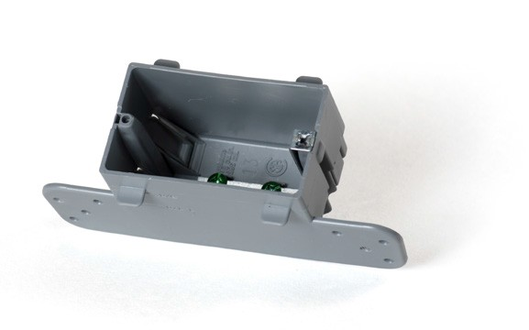 | 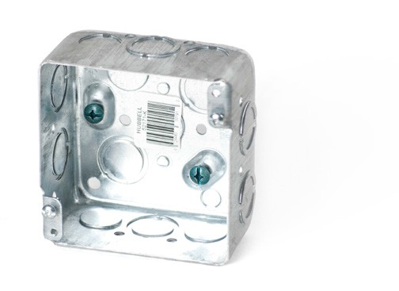 | 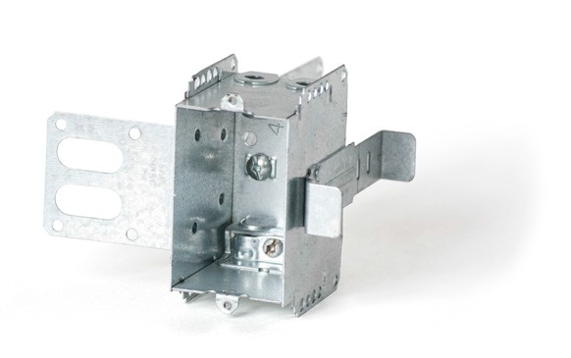
Plastic device box | 4 × 2⅛ sq. box | Metal stud device box
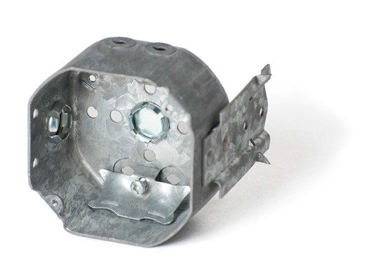 | 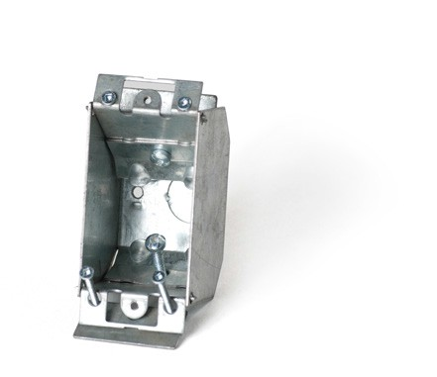 | 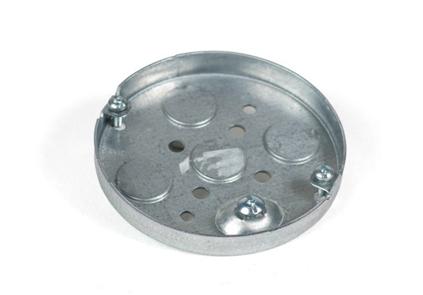
4 × 2⅛ octagon | Finished surface EZ box | 4 × ½ round
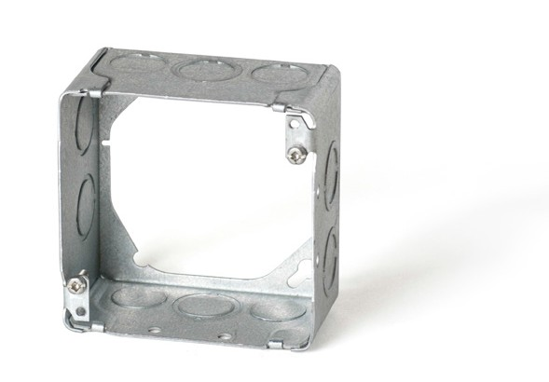 | 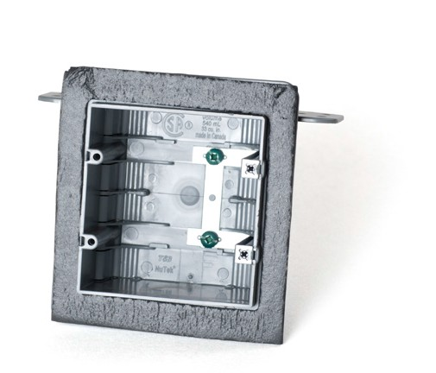 | 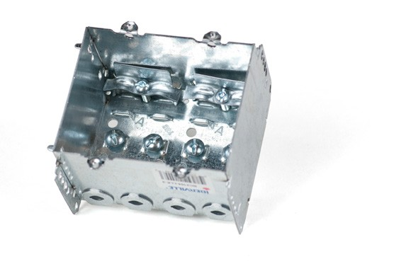
4 × 2⅛ sq. extension ring | Two-gang insulated device box | Two-gang device box

Figure 1—Device boxes

Device connections: line and load refer to the power connections coming into or out of electrical devices in the scheme of an electrical system, commonly a ground fault receptacle. The incoming feed from the supply comes into the line side of a device. It leaves the device from the load side and then feeds the load.
Electrical device: anything that can use electricity to perform a task using electricity, such as a switch or receptacle.
Non-metallic sheathed cable (NMSC): a common plastic-sheathed cable used for wiring wood frame construction buildings. Also known by trade names Romex (USA) and Loomex (Canada). The most common cable type used in residential wiring is non-metallic dry (NMD) 90 cable. “Dry” refers to the cable’s use in dry areas.

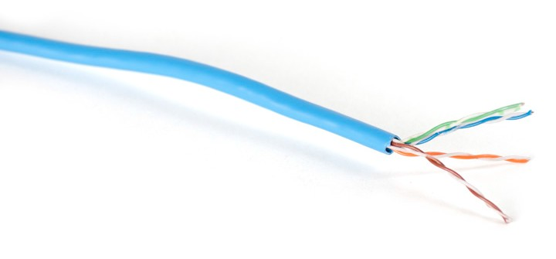 | 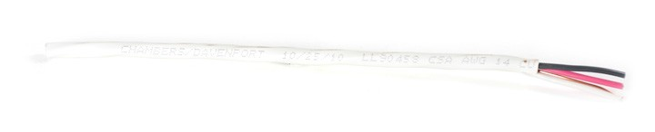
CATSe | 12/3 NMD 90
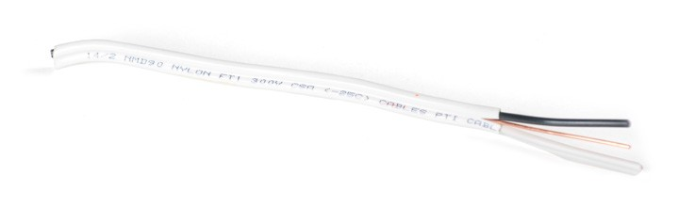
14/2 NMD 90 | LVT

Figure 2—Cable types

Pigtail: a short wire used to connect an outlet or switch to a splice.
Wiring diagram or schematic: a simplified pictorial representation of an electrical circuit. It shows the components of the circuit as simplified shapes, and the wiring connections between the devices. A wiring diagram usually gives more information about the relative position and arrangement of devices and terminals on the devices, to help with installing the wiring.

Figure 3—Wiring diagram

Estimated Time
2–4 hours

Recommended Number of Students
20, based on BC Technology Educators’ Best Practice Guide, working in pairs or larger groups depending on hand tools and material available. Students could carousel through activities if hand tools are scarce. Half the students could do wiring diagrams while the other half wires devices.

Facilities
Technology education shop with benches and vises

Tools
  - Lineman pliers
  - Wire strippers
  - Utility knives
  - Robertson® #1 and #2 screwdrivers
  - Needle-nose pliers
  - Side cutters

Materials
  - 14/2 plastic-sheathed cable (Loomex)
Note: The teacher should purchase a roll of wire 75 or 150 m for all activities based on the number of students. Any leftover wire can be used for future classes.
  - Wire connectors, yellow, 10 per group
  - Device boxes: two single gang and one octagon per group (metal or plastic).
Note: Boxes should �⁄�" offset for drywall as shown.
  - Single-pole switches (one per group) (Figure 4)
  - Duplex receptacle (one per group) (Figure 5)
  - Medium base lamp holder and 40 or 60 W bulb (one each per group) (Figure 6)
  - Wood screws (#8 × 1" or 2.5 cm, 6 per group)
  - Small cuts of 2 × 4" stud roughly 24" (60 cm), not smaller than 18" (45 cm), 1 per group. Note: The lumber is for students to practise attaching boxes to wood and for wiring. Do not cut full lengths of material for this exercise if it is going to be used for framing, etc.; offcuts of material will work for this activity. If using larger pieces of material, group boxes within 24" (60 cm) of each other to save wire.

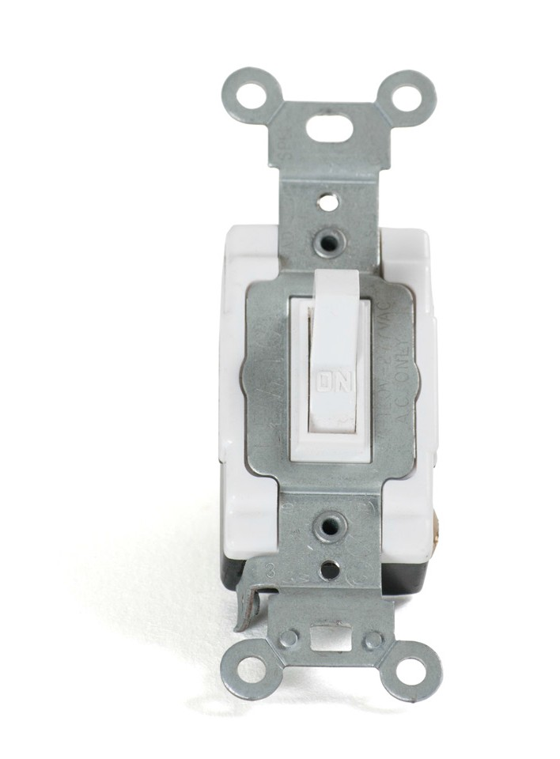
Figure 4—Single-pole toggle switch | Figure 5—Residential grade 120V/15-20R receptacle

Figure 6—Base lamp holder

Optional
Cordless drill with Robertson #1 and #2 bits

Resources

Understanding the wiring in an electrical receptacle
http://www.youtube.com/watch?v=bDhYDY9A4TI
Electrical Code Simplified, House Wiring Guide, BC Book 1. P.S. Knight Co. Ltd. Available at most home improvement stores.

Activity

Students should produce a wiring diagram of the circuit before commencing this activity. The circuit should include a receptacle with a power source feeding a single-pole light switch, which then feeds a light. Students will have produced a wiring diagram for the circuit used in this activity during Circuit Drawings and Wiring Diagrams. They may use this wiring diagram for reference during this activity.
Note: The teacher should make sure the wiring diagram is accurate before commencing this activity.

Wire one duplex outlet and one switch controlling one light, fed from the outlet.

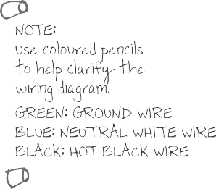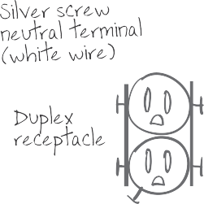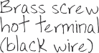

Figure 7—Wiring diagram of circuit

This activity is designed to teach students how to attach device boxes to studs and how to wire devices. How to correctly run and strap wire between device boxes is explained in Wiring a Wall Section.

Mounting Boxes
The teacher should demonstrate how to attach a receptacle, switch, and light device box to a section of 2 × 4" stud (18–24", or 45–60 cm in length) or to a larger piece of material with the boxes spaced closely together to save wire.
- Secure the stud into a bench vise for stability.
- Screw the octagon box close to one end of the stud using 1" (2.5 cm) wood screws.
Note: Make sure the boxes are screwed with tabs flush against the stud to allow for drywall.
- Screw the two single gang boxes spaced evenly below the octagon box.

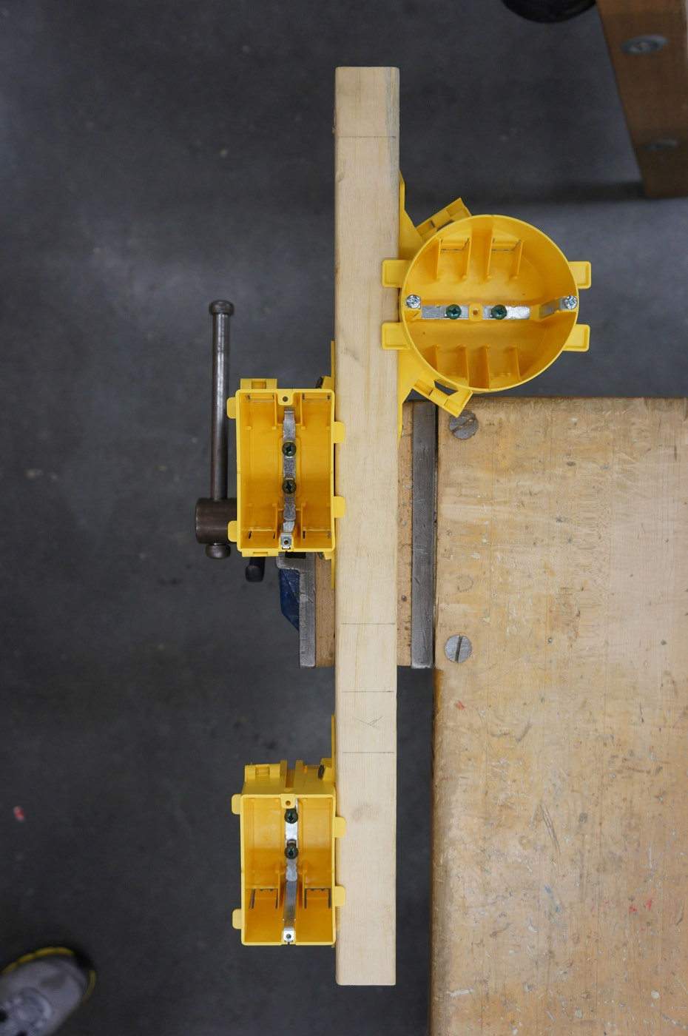

Figure 8—2 × 4" secured in vise with boxes attached

Entering Cables
  - Measure the 14/2 cable to run from the octagon box to the closest single gang box. (Figure 9)
Note: Allow 8" (20 cm) of cable to run past each box to allow for wire length inside the boxes.

Code requires at least 6" (15 cm) of free wire in a box plus enough wire to wrap the ground wire around the ground screw.

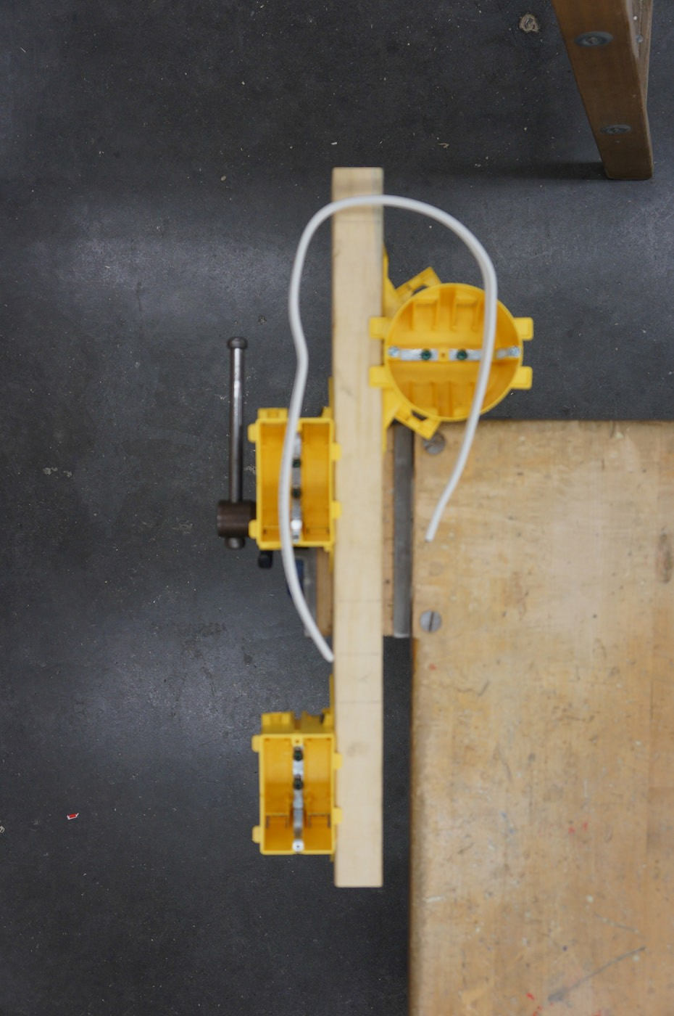

Figure 9—Two boxes showing wire measurement

  - When cutting sheathing, hold the wire firmly and place the blade in the middle of the sheathing. Draw the blade away from your hand to split the sheathing open (Figures 10a and 10b). The reason for placing the blade in the middle of the sheathing is to run the blade beside the ground wire inside, and to not nick the insulation on the two conductors running on the outside of the 14/2 cable.
Safety concern: Make sure hands are clear from the blade.

  - Strip 8" (20 cm) of sheathing (Figure 10c). Push one end of the 14/2 cable into the octagon box and guide the wire out of the box until 6–8" (15–20 cm) of wire is protruding from inside the box (Figure 11). Allow �⁄�" (1 cm) of sheathing to be visible in the box entrance so the conductors do not get damaged. Do the same with the first single gang box.

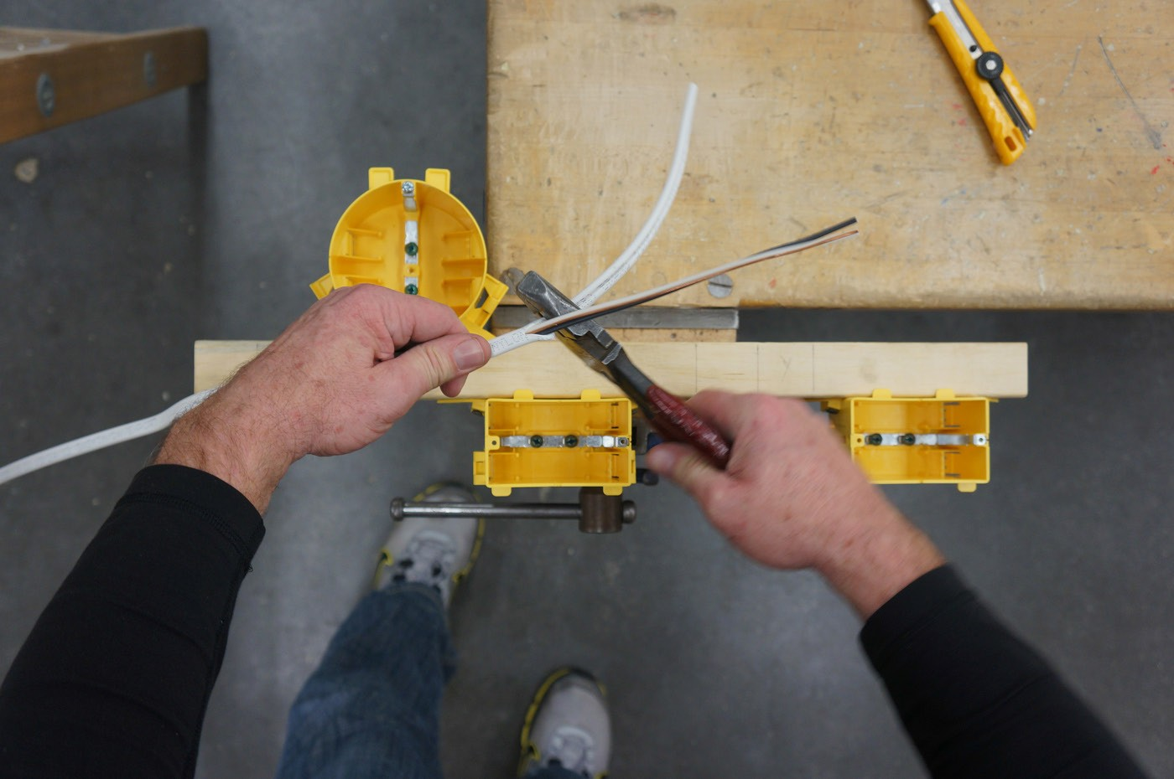

Figures 10a, 10b, 10c—Stripping sheathing

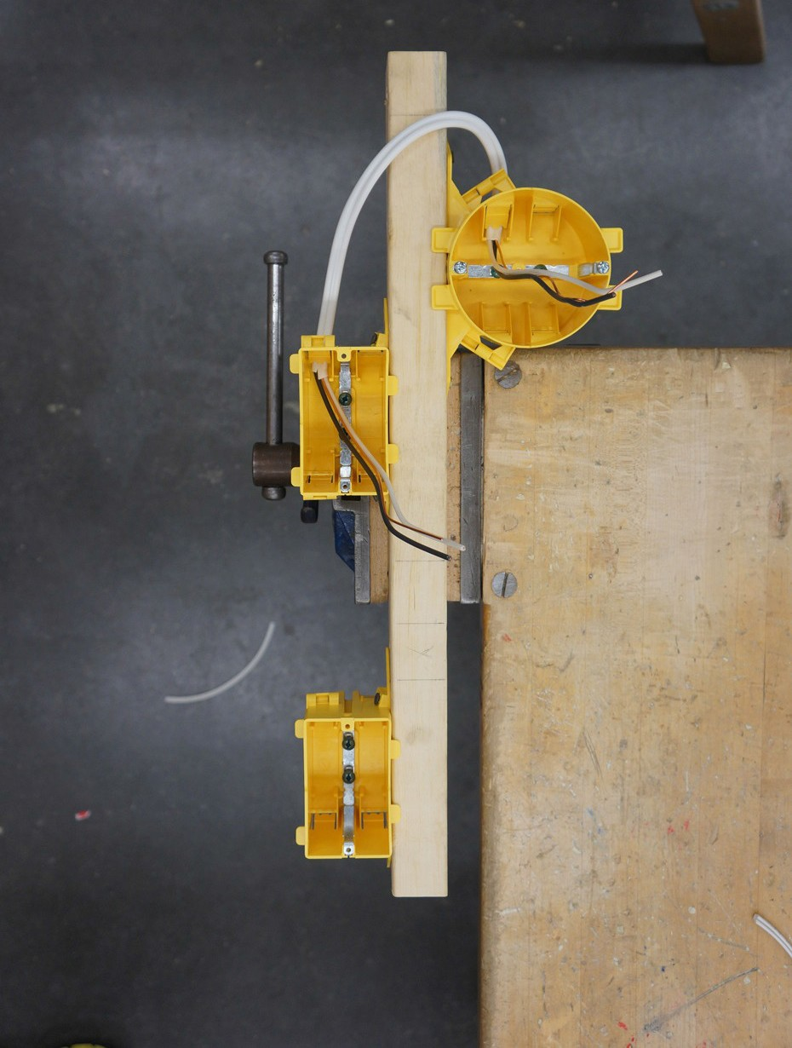

Figure 11—Wire run into boxes

  - Repeat this procedure to run cable between the two single gang boxes (Figures 7 and 12).

  - Cut a piece of 14/2 cable to 12" (30 cm), or use a piece of scrap 14/2, and bring it into the last device box to simulate incoming power. (Figures 7 and 12)

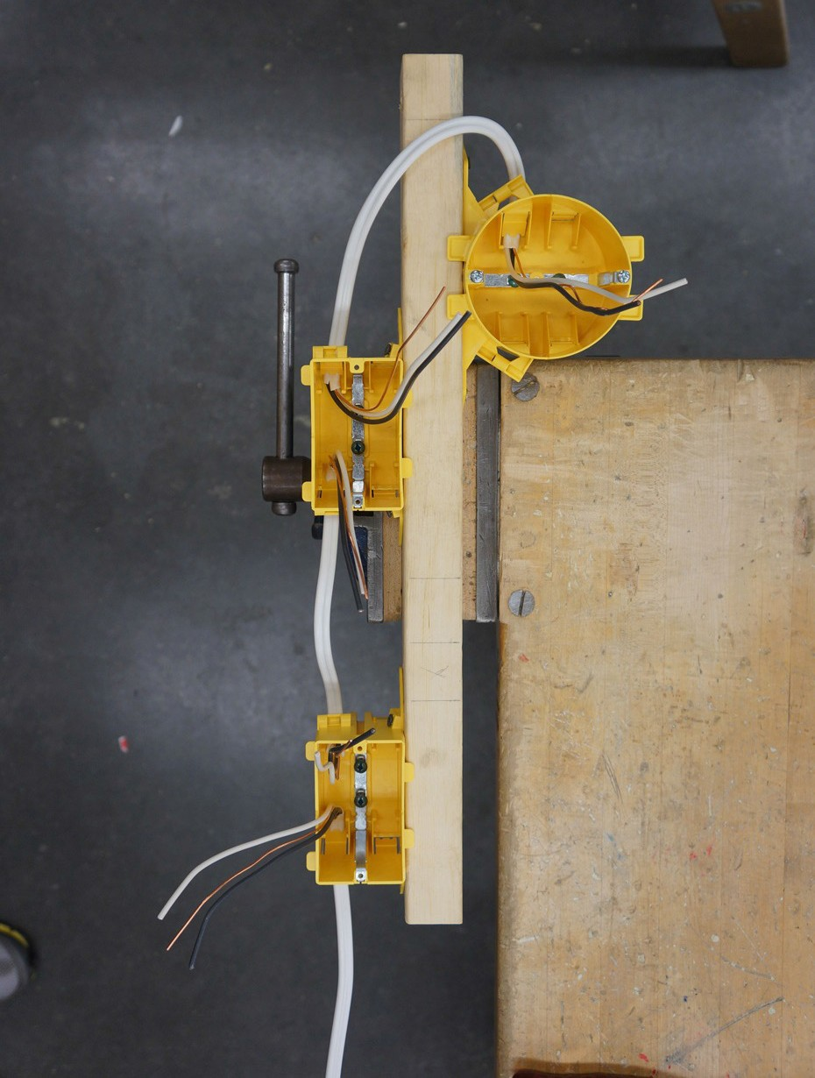

Figure 12—Completed wiring to boxes

Grounding the Boxes
The next step is to bond the boxes to ground, starting at the first single device box.

The first single gang box is going to be a receptacle with incoming power, the second single gang box will be a single-pole switch, and the octagon box will be a light.
- Starting at the receptacle box, loosen the grounding screw in the box (counter-clockwise). Then loop the base of one ground wire around the grounding screw (clockwise) and tighten the screw (Figure 13).

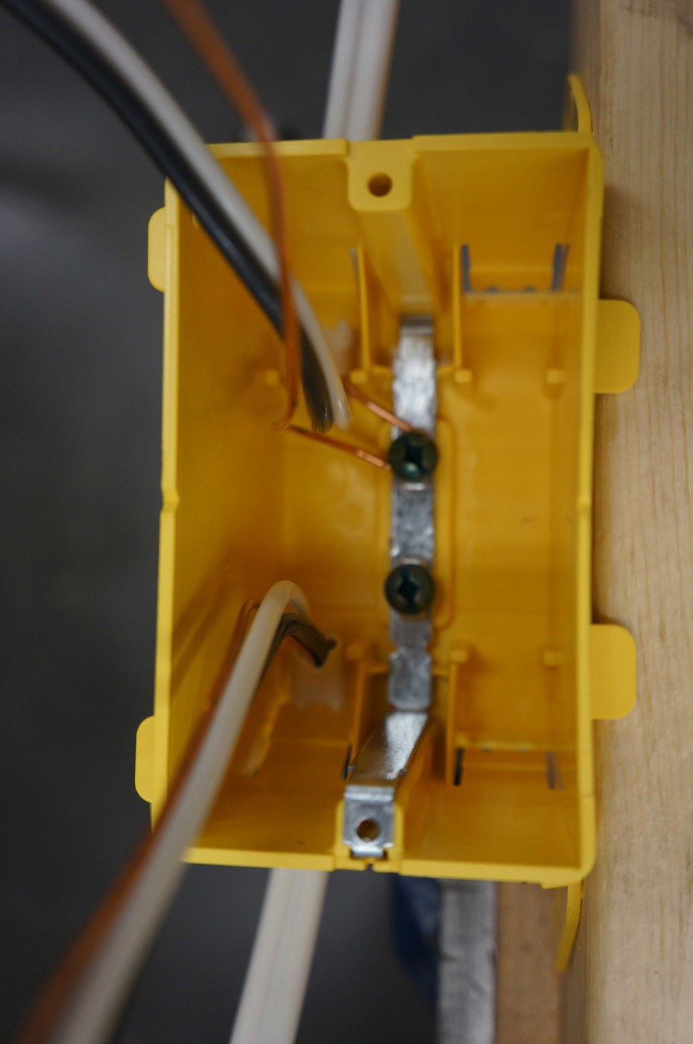 | 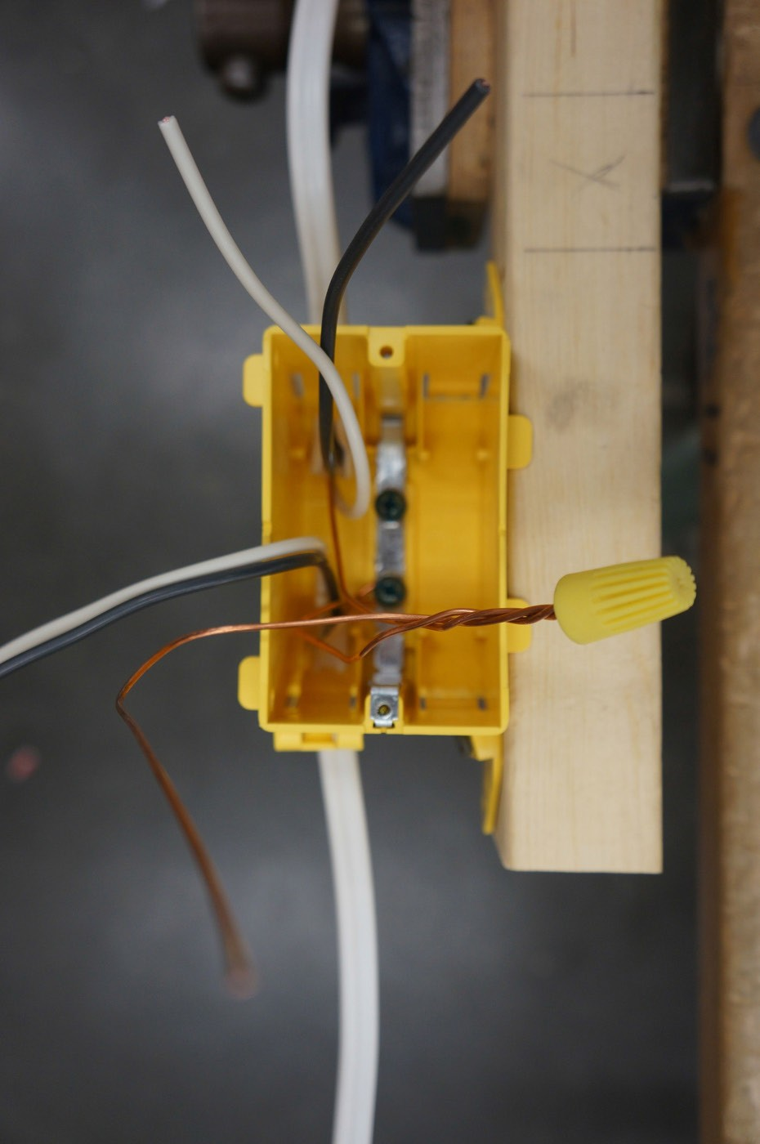
Figure 13—Box showing the ground wire looping around the grounding screw | Figure 14—Ground wire pigtail
- Make black, white, and bare pigtail wires for splicing outlets.
- Cut a piece of 14/2 Loomex 6" (15 cm) long and strip off the jacket. Scrap wire could be used for this task. Save the black and white pigtails for later splicing.
- Join the two ground wires along with a pigtail grounding wire by twisting and putting
a wire connector on them (Figure 14). If the receptacle was the last device in a wiring configuration and there was only one 14/2 entering the box, the ground wire could simply loop from the ground screw to the receptacle without making a pigtail.

- Now run the ground wire around the grounding screw in the single-pole switch box. Switches are not connected to the grounding wires, so join the two grounding wires and put on a wire connector (Figure 15).
Note: The switch will be bonded to the ground when the device is secured to the box.

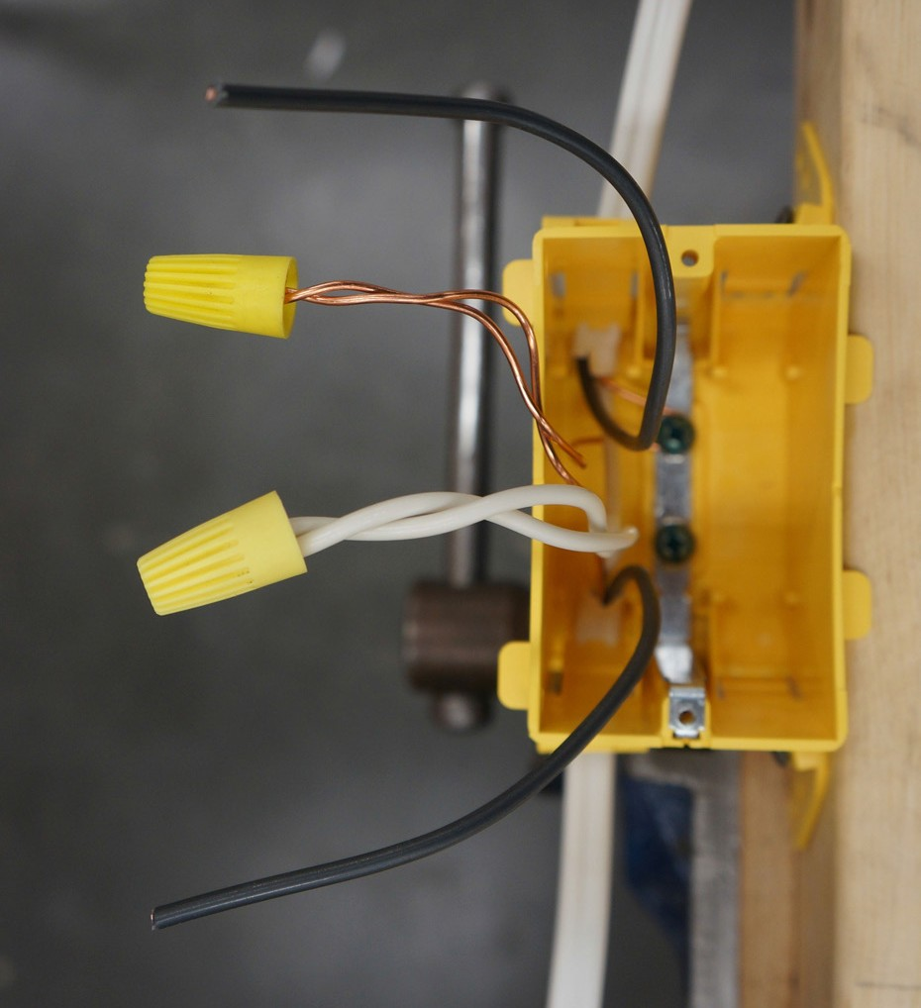

Figure 15—Switch box grounding

- The octagon box has only one 14/2 cable entering it, so in this case the grounding wire gets wrapped around the grounding screw and pushed into the box (Figure 16).
Note: This light fixture has no grounding connection; any light fixtures that do have a green or bare wire would be connected to the bond wire in the octagon box. In this case, the fixture will be bonded to ground when the fixture is attached to the box.

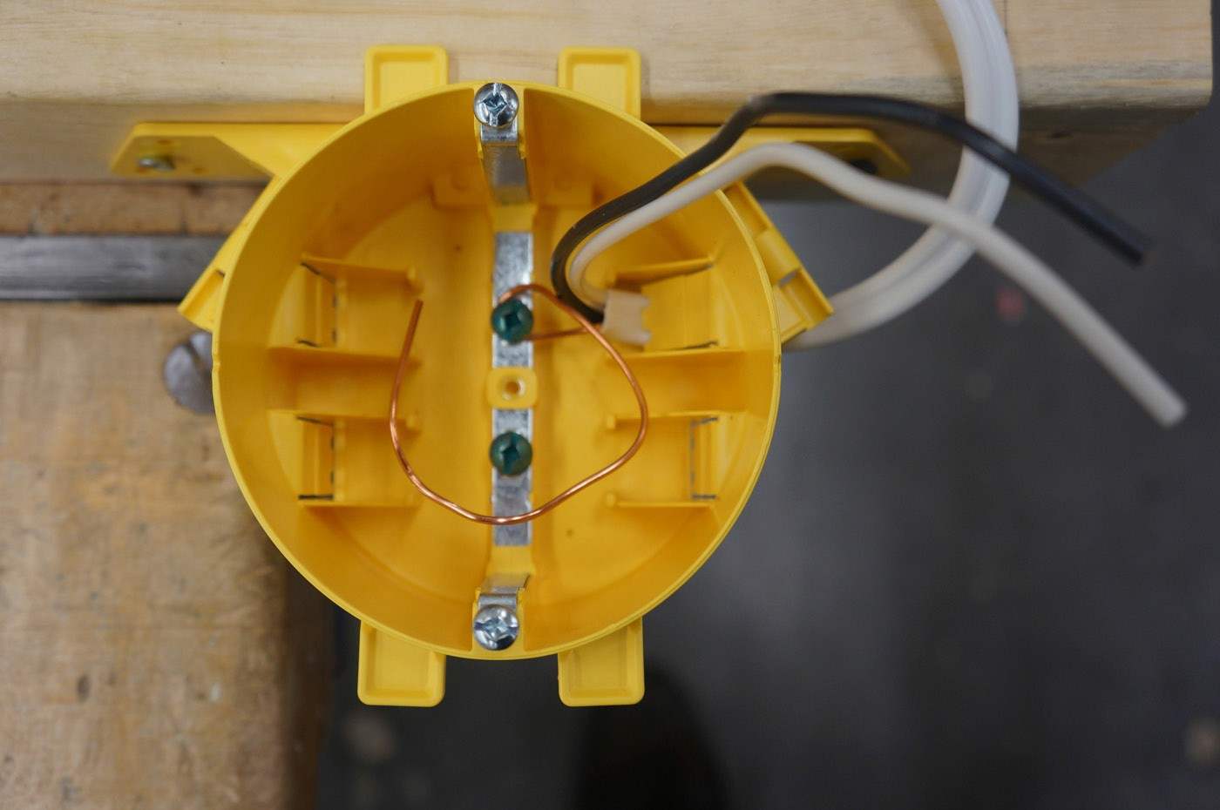

Figure 16—Grounding wire in octagon box

The grounding is now complete.

Splicing and Pigtailing

Outlet Box
- Match up the white (neutral) wires in the box and cut them to the same length. Leave 4" (10 cm) protruding, measured from the front edge of the box.
- Strip the white wires, attach a 4" (10 cm) white pigtail to the other two white wires, twist, and put a wire connector on them (Figure 17).
Note: A pigtail is required by code for the white (neutral) cable with three conductors (14/3, 12/3, etc.), but not for two-wire cables. However, most electricians will use a pigtail for all receptacles and lamp holders as it will reduce the strain on receptacle and lamp holder termination points and a spliced connection will carry current more reliably.
- Cut and strip the black (hot) conductors in the receptacle box and make a pigtail connection for them as was done for the white wires (Figure 17).

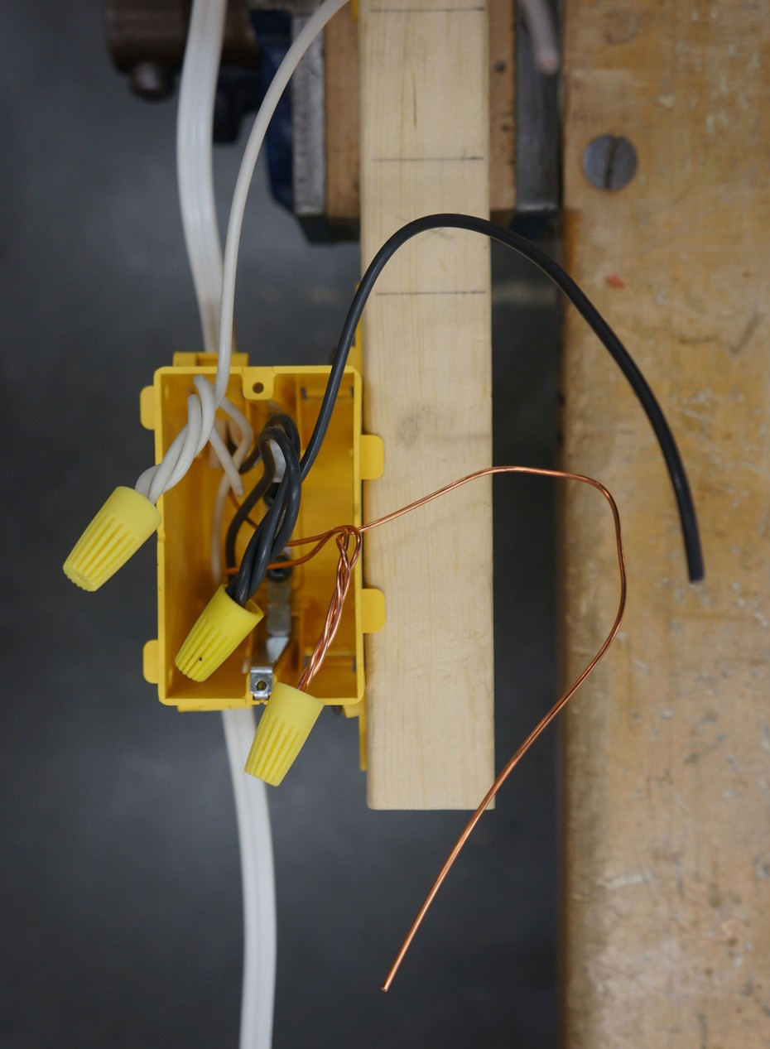

Figure 17—Completed pigtails in receptacle box

Switch Box
  - Cut, strip, and twist the two white conductors and join with a wire connector in the switch box (Figure 18).

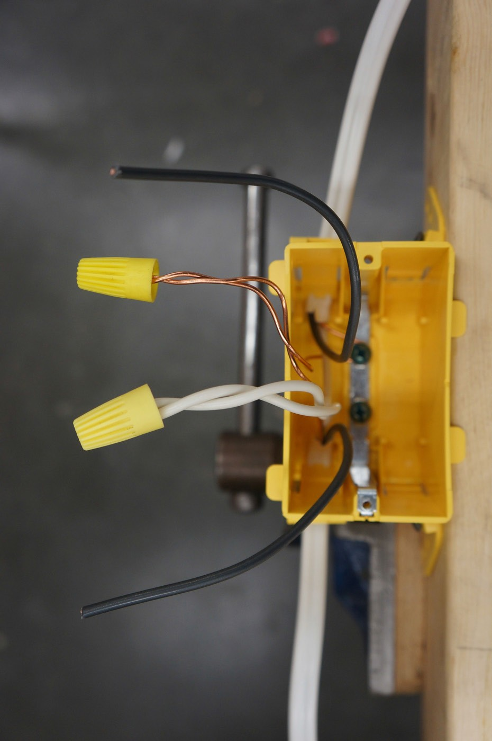

Figure 18—White wires connected in switch box

Light Box
No splices required.

Terminating and Mounting Devices

Outlet Box
The devices are now ready to be installed to the wires.

- Starting at the receptacle, strip the pigtail’s insulation on the neutral (white) and hot (black) wires to �⁄�" (roughly 1 cm) for termination.

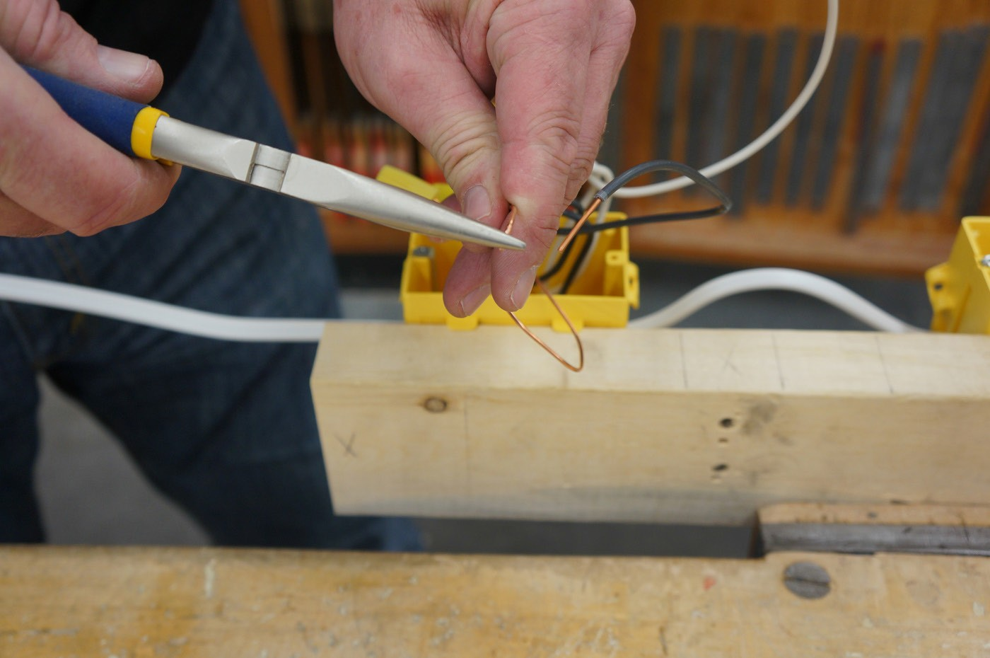

Figure 19—Making a hook

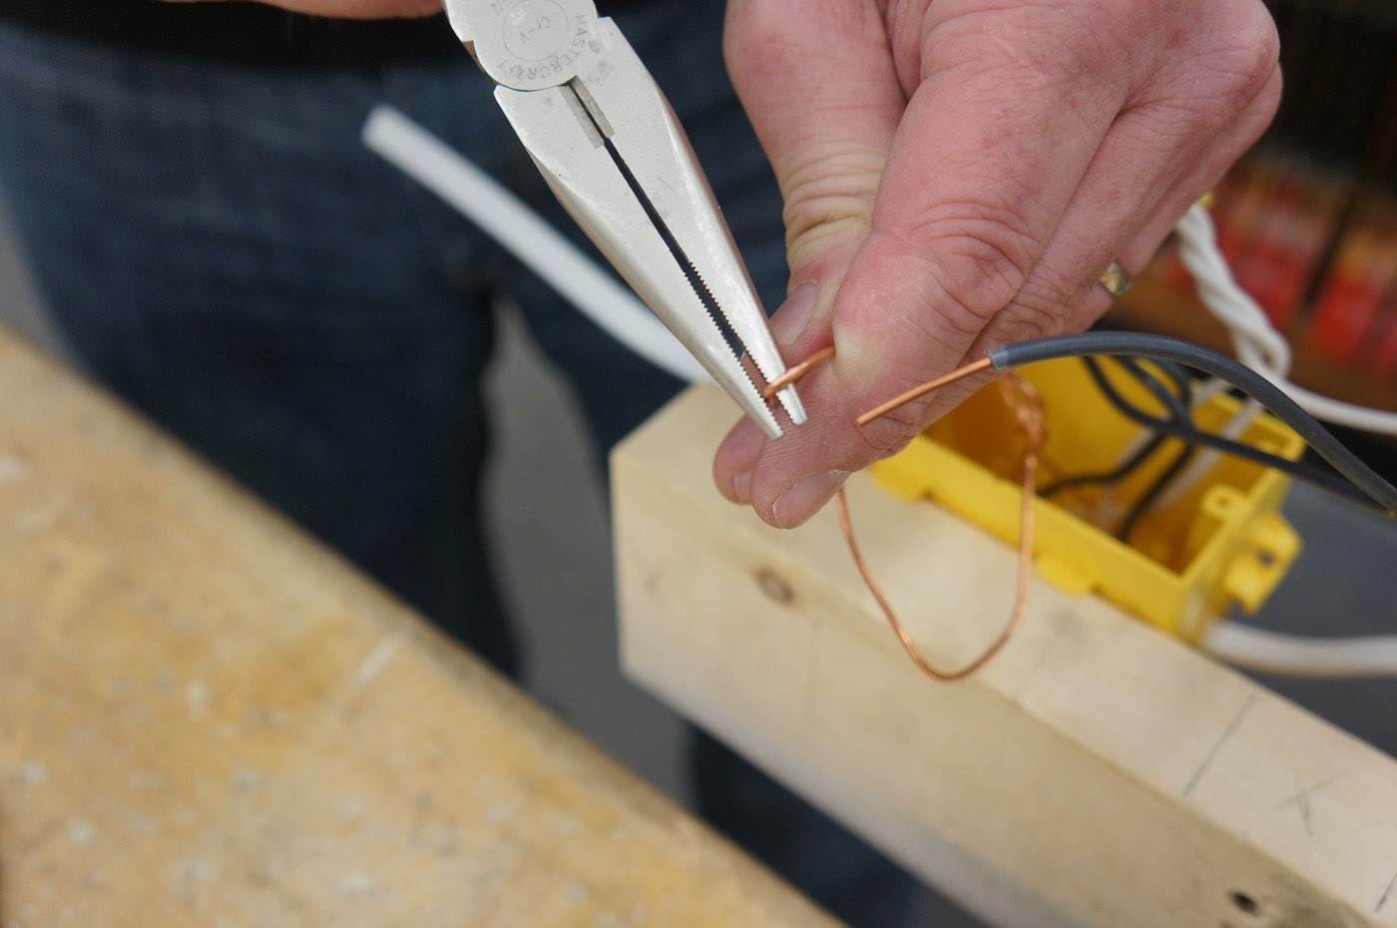

Figure 20—A hook forming

- When terminating wire to devices with terminal screws, making a hook at the end of the conductor allows for a secure connection (Figures 19–22). This type of connection will reduce the chance of a high-resistance fault from a wire coming loose in the future.
- With �⁄�" (roughly 1 cm) of insulation stripped, hold onto the end of the stripped conductor with needle-nose pliers. Hold the wire firmly with the other hand while rotating the pliers to form a hook (Figures 19 and 20). Students might want to practise this skill with scrap
material to perfect their hooks. Many electricians use their pliers to make hooks, and some use wire strippers; all will work. Students may try the different tools to find which one works best for them.

Note: It is important that no insulation touch the terminal screw (too little insulation stripped), as this could cause a high-resistance fault. Also, do not allow bare conductor to run past the end of a device (too much insulation stripped), as it could result in a short
circuit or shock hazard (Figure 21). The hook should fit perfectly under the terminal screw (Figure 23), and the teacher should be very strict about getting students to perfect this skill. The hook should be positioned under the terminal screw so that tightening the screw clockwise will help to close the hook.

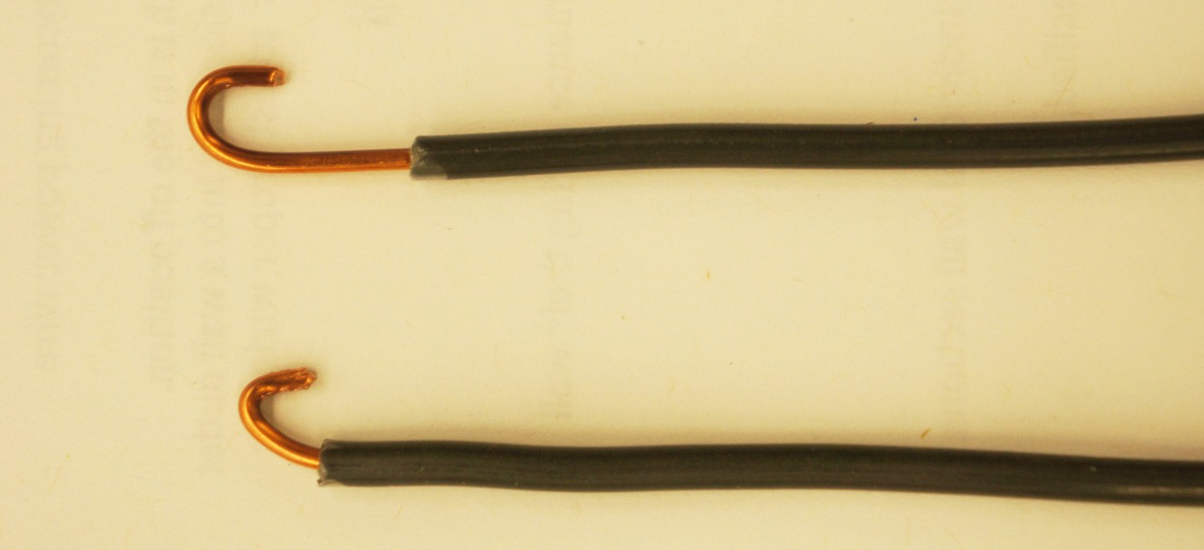

Figure 21—Bad hooks (too little insulation stripped and too much stripped)

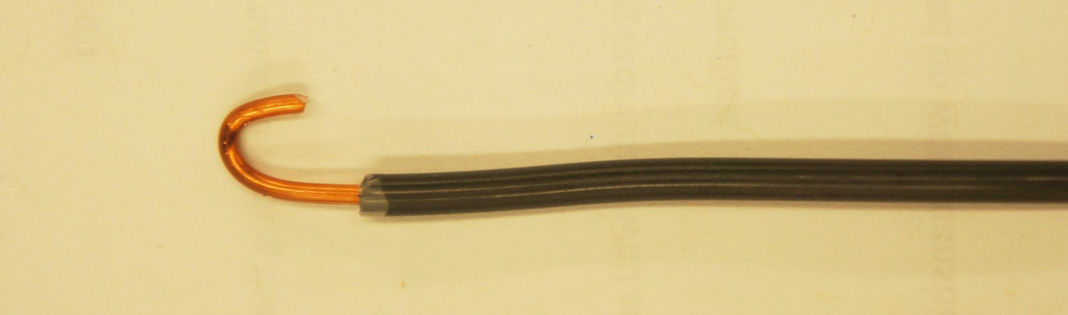
Figure 22—Good hook

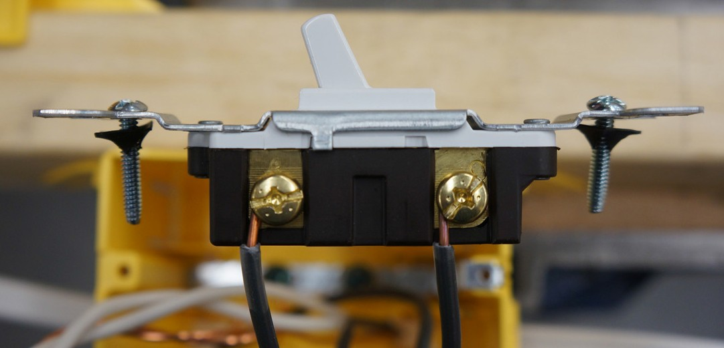
Figure 23—Proper installation under terminal screw

- Make hooks with the ground, white, and black wires. The receptacle will have two silver screw terminals (neutral wire), two brass terminal screws (hot wire), and one green (ground wire) terminal screw. When looking at the receptacle from the front view:
- The green terminal screw should be positioned at the bottom left.
- The silver (neutral) terminal screws should be positioned to the left (longer knife blade shape).
- The brass (hot) terminal screw should be positioned to the right with a smaller knife blade shape.
The receptacle should always be aligned this way when installed.

- Attach the ground wire to the green screw with the hook in proper arrangement and tighten.
- Attach the neutral wire to the proper terminal screw (silver) and tighten.
- Attach the hot wire to the terminal screw (brass) and tighten. The two terminal screws that are not being used may be tightened so they do not protrude.

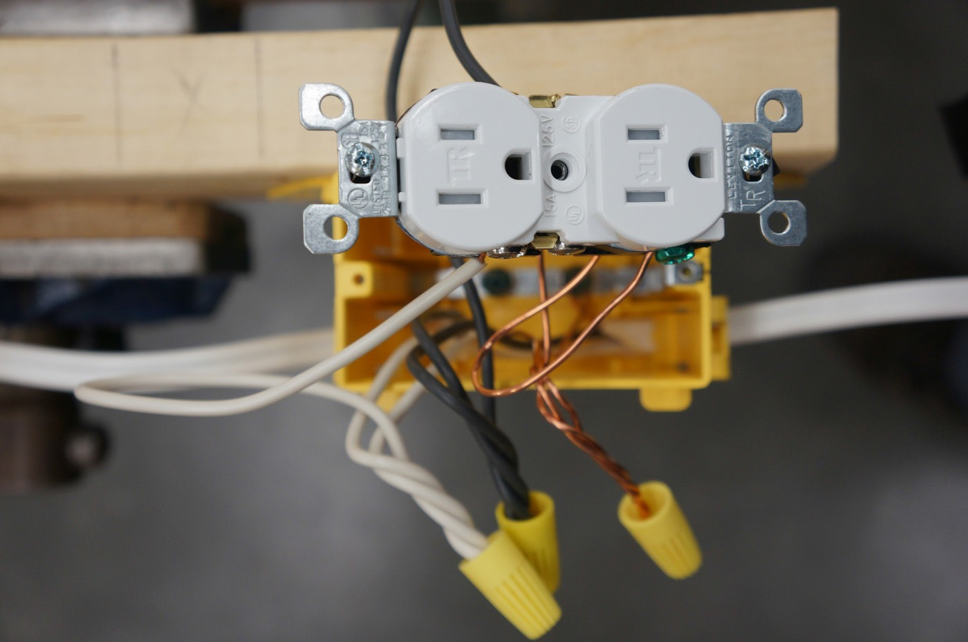

Figure 24—Complete wired receptacle

Switch Box
  - Cut, strip, and make a hook on the two black wires in the switch box (constant power coming from the receptacle) and switch leg (going to the light).
  - There are only two terminals on a single-pole switch. Most switches will have TOP written on the front and On and Off on the toggle, or a small raised dot on the toggle switch which indicates the On (up) position. Another way to configure a single-pole switch is to have the terminal screws to the right when looking at the switch from the front view when installing. The switch will work regardless of which terminal screws the two wires are connected to.
  - Attach the wires to the switch and tighten the terminal screws.

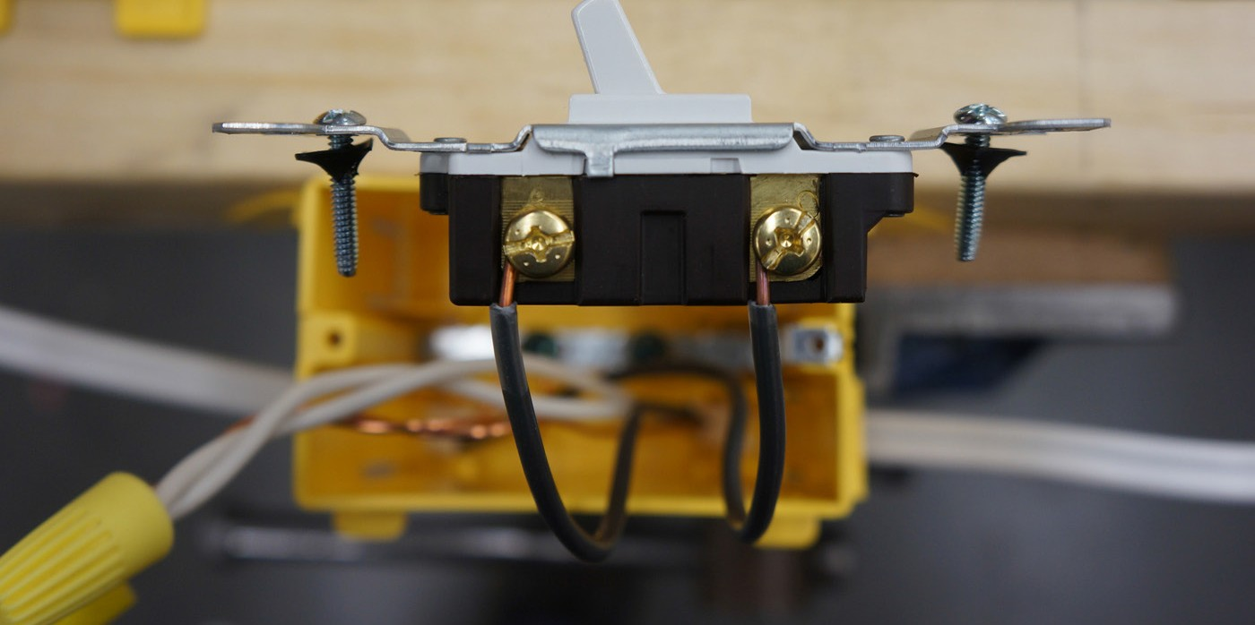
Figure 25—Properly wired switch

Octagon (Light) Box
The last device to be wired is the light.

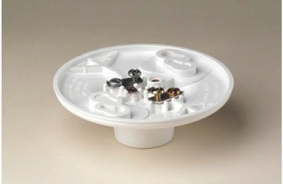

Figure 26—Keyless lamp holder

- Strip the ends of the black and white wires and put a hook on each.
- Connect the white wire to the silver (neutral) terminal screw, and the black wire to the brass (hot) terminal screw.
Since there are only two wires to be connected, no pigtail is needed. If there were two lights, a pigtail would be used at the first box. The two terminal screws not being used should be tightened.

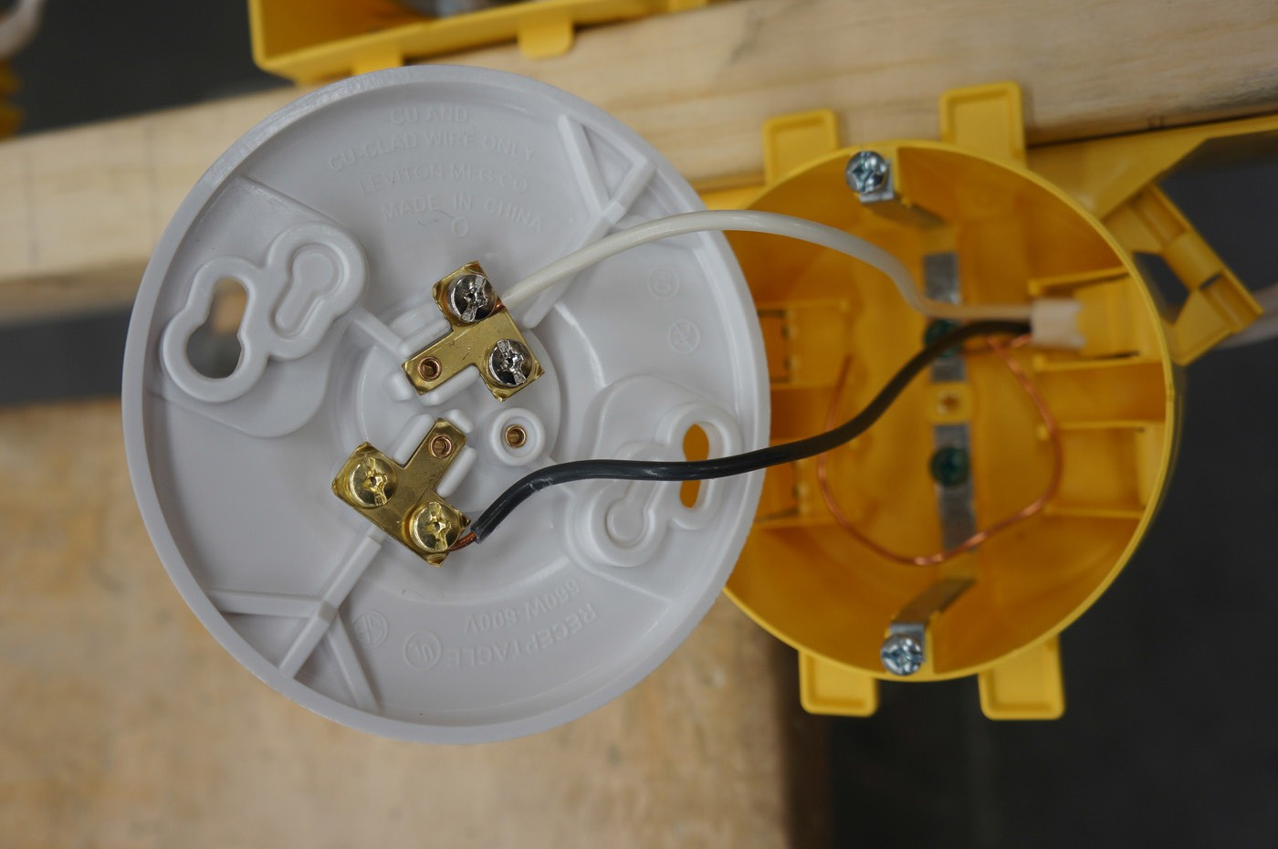
Figure 27—Properly wired lamp holder

Note the importance of properly wiring a lamp or light to the proper terminals (polarity). See Figure 28.

Correct Polarity Reversed Polarity
collar
collar
neutral
hot
light socket
hot
neutral
light socket

Only the button at the bottom of the light socket is hot—a person is much less likely to touch this than the collar.
The entire light fixture collar is hot and easily touched if the light switch is on (particularly as the bulb is being screwed in).

Figure 28—Importance of correct polarity with light fixtures

- The demonstration is now complete. The teacher should question the students to check their understanding. It is advised that the teacher go over the wiring demonstration beforehand, to practise the skills and plan appropriate questions to ask the students during the demonstration.
- Have the students work in pairs to wire the same circuit as in the demonstration.

When complete the teacher should assess the students’ ability and have them redo poor work. DO NOT ENERGIZE THE CIRCUIT. THIS ACTIVITY IS TO PRACTISE WIRING DEVICES.

Evaluation Guidelines
The student will:
- Display knowledge of wiring diagrams
- Display competence with hand tools
- Work safely and responsibly with hand tools
- Understand the terminology in the activity
- Wire devices correctly
- Produce good quality workmanship
- Understand the safety implications of proper wiring methods

Extension Activity
- Have students practise wiring another circuit individually and perfect their technique. Use the same devices but install the feed into the switch.
- Add another light or receptacle to the circuit by adding another box.

- Have students produce a wiring diagram for another configuration of the circuit they propose to wire.
Note: It is not advised to energize any circuits at this time.

Wiring Devices
Electrician

Wiring a Wall Section

Description
The activities that have led up to wiring a wall should have given students the skills and knowledge to culminate with this activity. This activity could be an opportunity to conduct a summative assessment of students’ previous knowledge of theory, safety, code, and wiring methods. Wiring a wall section will introduce students to a few new CEC rules and wiring methods. Having a wall section is obviously a requirement for this activity. The wall section could be full scale or smaller; to make this activity relate to the real world, it’s recommended that the wall section be at least 4' wide by 4' tall. The wall section shown in Figure 1 would be optimal, as it has some real (although scaled down to half size) features such as door and window openings, as well as a corner section, which will help students learn about routing wire and placement of device boxes in relation to these features.

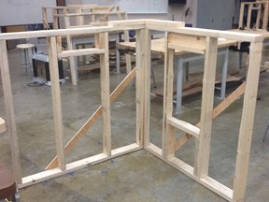
Figure 1—Sample wall section

Building a wall section for a class requires a substantial amount of lumber and time. Optimally, this activity would work well with students having completed the carpentry portion of the course first. This activity is an opportunity for students to wire a wall to code specifications and with the teacher’s supervision, energize and test their circuits. Students will likely work in small groups, depending on the availability of material and the number of walls available. The students should have the opportunity to wire their wall sections individually, to give the teacher a clear picture of each student’s skills and competencies. The wire and boxes may be re-used for each student in order to reduce cost and waste.

This work is licensed under a Creative Commons Attribution-NonCommercial-ShareAlike 4.0 International License unless otherwise indicated. 117

Lesson Outcomes
The student will be able to:
  - Correctly wire a wall section with a receptacle, switch, and light to CEC specifications
  - With supervision, energize and test the circuit
  - Understand the CEC requirements for wiring a wall
  - Know where to place devices in relation to doors and windows

Assumptions
Students will be able to recognize electrical hazards and understand correct safety precautions and procedures. Students will also know:
  - How to wire a basic circuit
  - How to produce a wiring diagram for the circuit
  - How to safely work with hand tools
  - How to use a portable drill

Terminology
Auger bit: a drill bit that usually includes a rotating helical screw blade to act as a screw conveyor to remove the drilled-out material. The rotation of the blade causes the material to move out of the hole being drilled.

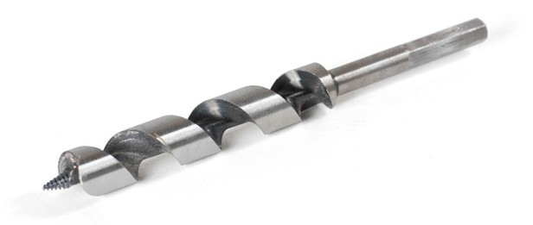
Figure 2—Wood auger bit

Bottom plate: the 2 × 4"s or 2 × 6"s that lie on the subfloor and upon which the vertical studs are installed. Also called the sole plate.
Cable strapping: attaching staples at predetermined distances to comply with Canadian Electrical Code.
Courtesy loop: a length of wire (usually 3–5") that is not strapped before entering a device box. This allows a box to be moved a few inches after wiring, or allows more wire to be pulled into a box for repair of a possible nick of a wire in a box by drywallers who might inadvertently cut a wire when installing drywall. This is not required by code, but it is best practice for residential electrical work. This may save time and money in the event of one of these situations, and may prevent needing to rewire a wall after drywall has been applied (see Figure 13).
Cripple studs: short wood members used above and below window and door openings to support the frame.

Protection plate: a steel or aluminum plate used to cover a stud section where an electrical wire runs. This is only required if the edge of the hole is drilled less than 1¼" (32 mm) from the edge of the stud).

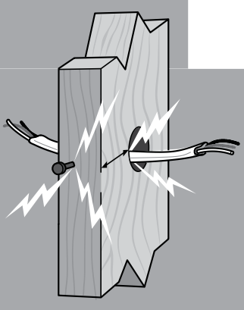

Protect cable when <1¼" to face of framing

<1¼"

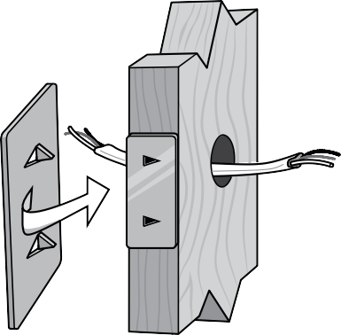Figure 3—Protection plate

Stud: a wooden support member with 2 × 4" nominal dimensions (accurately 1½ × 3½"). Studs are usually spaced 12–16" (30–41 cm) on centre.
Vapour barrier: any material used for damp proofing. Typically, vapour barrier is clear plastic sheathing placed between an insulated wall and a structural wall to control vapour flow within the interior space. The sheathing inhibits the movement of water vapour molecules through the wall. Polyethylene is often used as a vapour barrier, and is available in various thicknesses, e.g., 0.15 mm (6 ml) poly.
Vapour box: moisture resistant barrier surrounding an electrical box. According to the BC Building Code (not the Canadian Electrical Code), if the electrical box is located in an exterior wall or ceiling that requires a vapour barrier, then a vapour box is also required. The enclosure surrounding an electrical box is like a shroud. It consists of a separate plastic or fiberglass box with a wide gasketted flange and seal with a vapour barrier sheet that is normally fixed to the joist or studs.

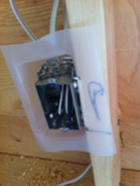
Figure 4—Vapour barrier example

Wire staple: a staple used to secure electrical cable to studs.

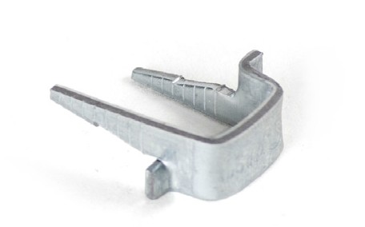

Figure 5—Wire staple

Estimated Time
2–4 hours

Recommended Number of Students
20, based on BC Technology Educators’ Best Practice Guide, small groups of 2–4 per wall, with the opportunity for individual assessment for wiring

Facilities
Technology education shop

Tools
  - Cordless drill or portable power drill
  - ½" to ¾" auger bit
  - Robertson® #1 and #2 screwdrivers
  - Wire strippers
  - Lineman pliers
  - Utility knife
  - Hammer
  - Pencil
  - Tape measure

Optimally, each group will have all hand tools. The cordless or power drill with auger may be shared among the class.

Materials
- Wall section
- 14/2 Loomex cable
- S1 staples
- Wire connectors (yellow)
- Duplex receptacles (one per wall)
- Single-pole switch (one per wall)
- Keyless lamp holder (one per wall)
- 40 W light bulb (one per wall)
- 2 single device boxes and 1 octagon box (per wall)
- 1" #8 wood screws
- 1 power cord (4–6'); 14/3 gauge extension cord with male cord end at one end and bare conductors at the other end. To be used to energize circuit.

Optional
Students could wire a full-scale project such as a shed or small building. It is preferred they practise on a mock-up wall first to understand CEC requirements and wiring methods.

Resources
Electrical Code Simplified, House Wiring Guide, BC Book 1. P.S. Knight Co. Ltd.

Activity

The teacher should demonstrate how to wire a wall section. The students should draw a wiring diagram of a receptacle with incoming power feeding a light switch and a light. The students will have this to refer to before they start their wall sections. It is advised that students complete Wiring Devices before doing this activity.
For the sake of explanation, this activity will be based on the wall section model shown in Figure 1. Teachers may not use the same scale wall section or door and window configuration and should adapt the rules used in this activity to their own wall section.

Marking Out Box Locations
- Place the assembled wall section on the floor or bench with space around for students to see the demonstration clearly.
- Using a tape measure, explain how to lay out the wall for boxes to be attached.
- Show students the symbols for receptacle, switch, and light.
Note: All measurements will represent the bottom of the device boxes.

Receptacle Box
The receptacle will be marked at 6" (15 cm) from the floor at the end of the wall section with the window framed into it.

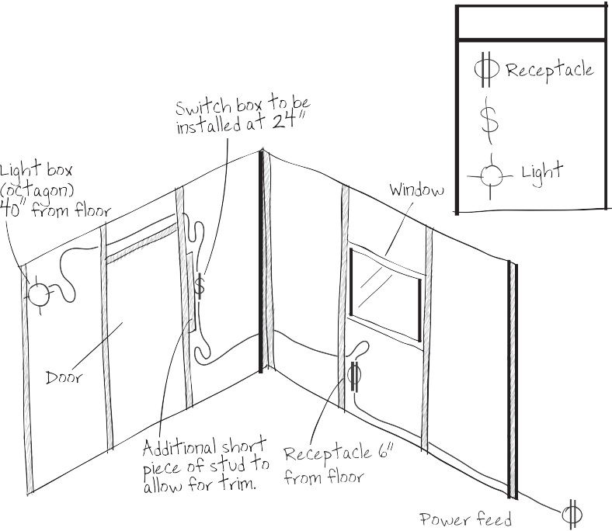
Figure 6—Sketch of wired wall section

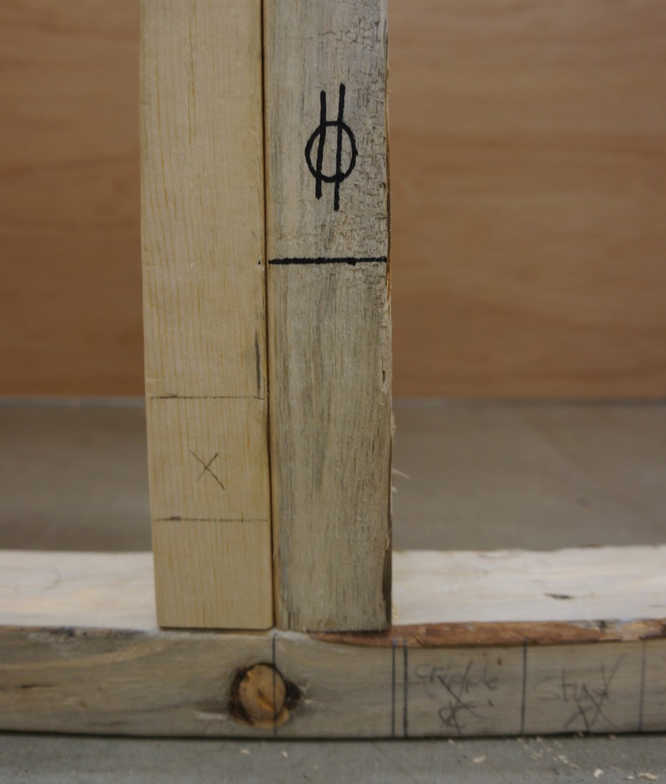

Figure 7—6" (15 cm) mark and a receptacle symbol

Switch Box
The light switch should be marked at 24" (60 cm) from the floor on the wall section with the door framed into it. Mark the switch on the side of the door closest to the corner.

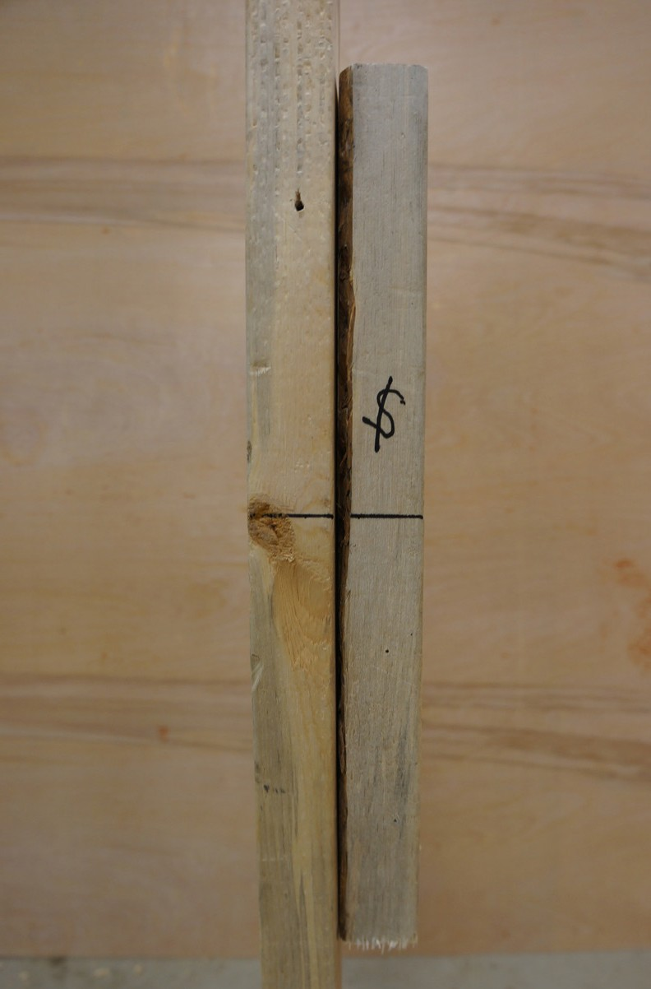

Figure 8—Light switch measurement at 24" and a switch symbol

Light Box
The light box should be marked at 40" (100 cm) from the floor at the end of the wall with the door frame.
Note: These measurements are to the scale of the demonstration wall section. A full-scale wall would be different (receptacles usually at 12" or 30 cm from floor, switches 46–52" or 115–130 cm, and light box locations will vary).

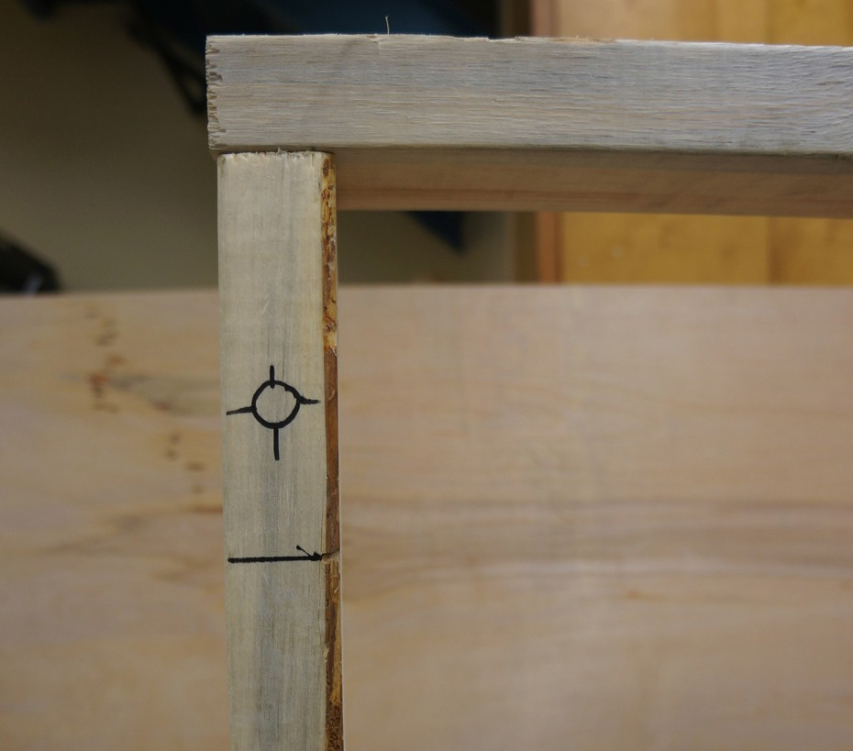
Figure 9—Light box at 40" (100 cm) from the floor with light symbol

Note: A wall section with a window will be an outside wall and according to the building code will require a vapour box. This activity will not use vapour boxes, but the students should be made aware of the building code requirement.

Mount Boxes

Outlet Box
With all devices marked out, attach the receptacle box using 1" (2.5 cm) wood screws. The measurement of 6" (15 cm) should be marked horizontally on the stud as a visual reference to place the bottom of the box.

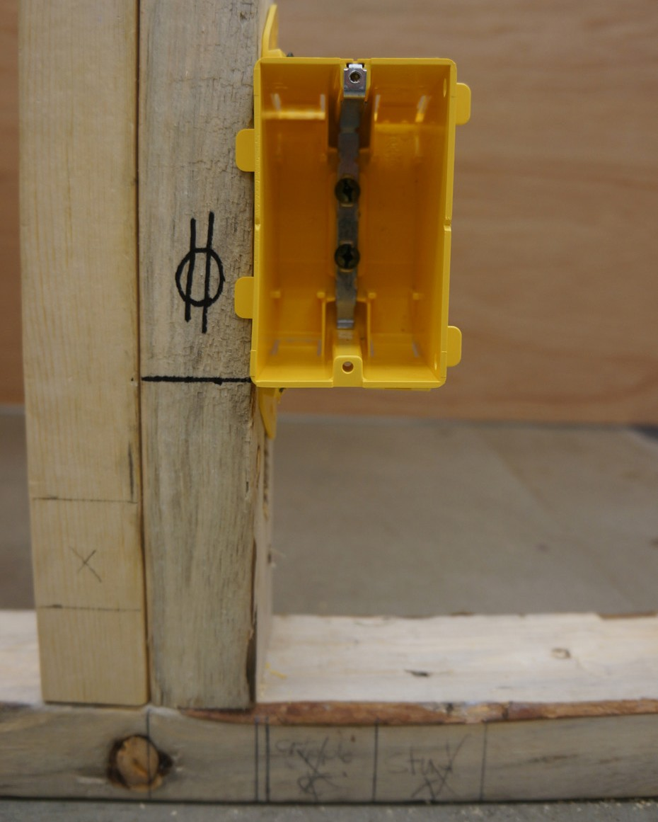

Figure 10—Placement of box in relation to mark on stud

Switch Box
The switch will be placed on the outside of the door frame. An 8–10" (20–25 cm) long piece of stud should be cut and attached at the point where the light switch box will be placed (Figure 10). This is to allow for trim around the door. This is an error that occurs in residential wiring, and it should be noted to students that adding a piece of stud to bring the switch box
further away from the door frame will prevent this problem. Adding a short piece of stud moves the box 3" away from the door frame. If the trim was going to be wider, then the box would have to be moved away further from the door frame.
Note: The teacher will have to explain to students about the placement of a light switch around a door. The door swing must be taken into account so that the door will not cover the switch when being opened. If the door covers the switch, the switch must be outside the swing, or
on the other side of the door frame. For this demonstration it is assumed the door will open to the outside, so it will not affect this application. Attach the light switch box at 24" (60 cm) to the bottom of the box.

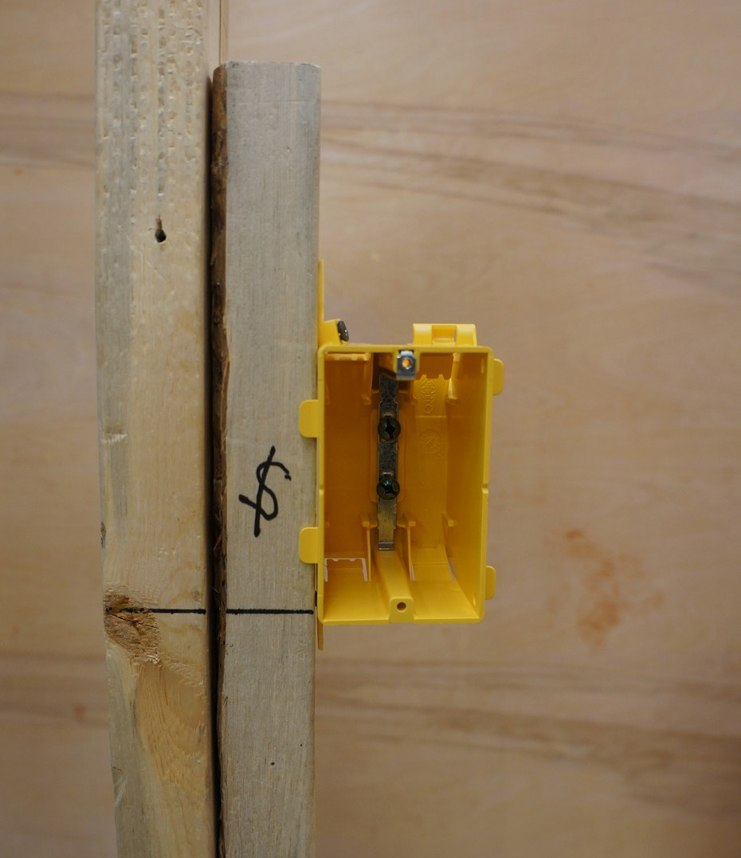
Figure 11—Switch box installed with an extra piece of stud

Light Box
Attach the octagon light box at 40" (100 cm) to the bottom with screws.

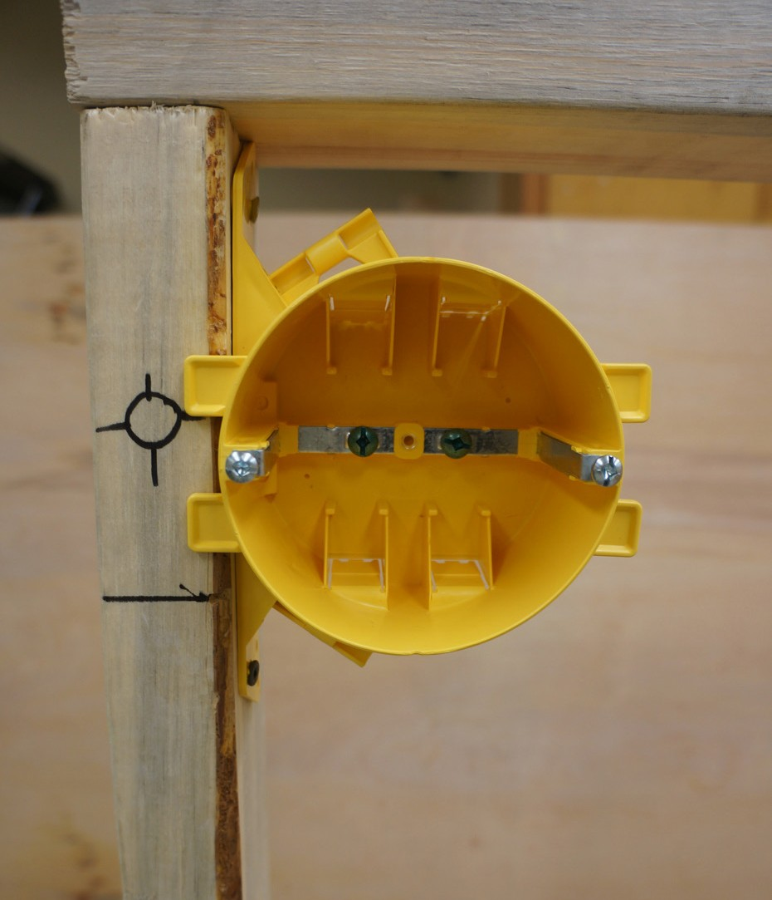

Figure 12—Octagon box attached to stud

Drill Studs
Install the auger bit into a cordless drill or a portable drill. Starting at the window, carefully drill a hole in the centre of the stud, about midway between the window sill and the bottom plate.
Note: All holes must be drilled in the centre of the stud to allow 1¼" (3 cm) clearance on either side of the hole to prevent drywall screws from penetrating the cable.
If the hole does not have 1¼" (3 cm) clearance on both sides, then a protection plate must be used. Continue to drill holes along the cable’s path to the light switch at the same height as the first hole drilled. Two holes will have to be drilled through the cripple studs above the door frame for the cable to reach the light.

Install Cabling
- Bring a short piece of 14/2 cable (24", or 60 cm) into the receptacle box to represent incoming power.
Note: All wiring will be done according to Wiring Devices. The wiring diagram from that activity may be used for reference.
- Allow for a 3–5" (7.5–12.5 cm) courtesy loop (teacher should explain why a courtesy loop is used, see definitions) for incoming power and staple the cable within 12" of the receptacle box.

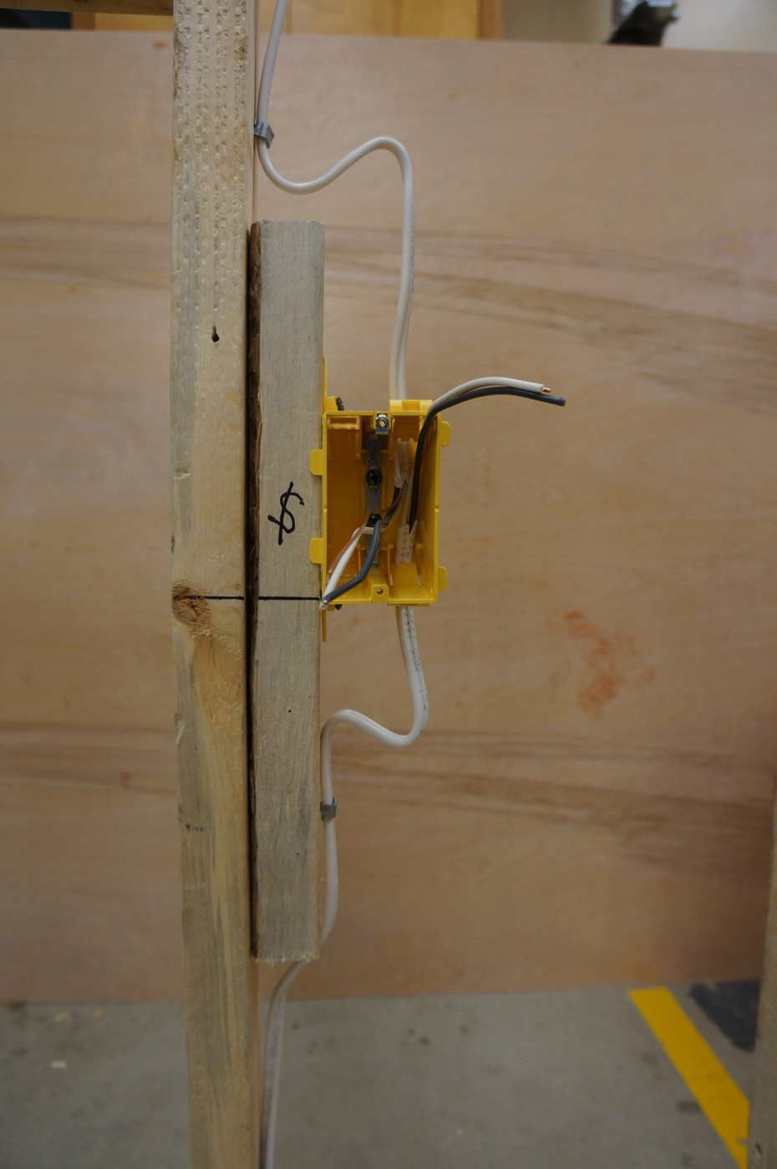

Figure 13—Cable stapled and with courtesy loop

Note: When stapling cable, the staple should not pinch the sheathing of the 14/2 cable. The code for strapping wire is not more than 12" (300 mm) from a box and every 59" (1.5
m) on a run. Cables run through studs are considered sufficiently supported.

- Run the cable from the receptacle box to the switch box. Remember to measure enough cable for courtesy loops. Strap the cable.
- Run the cable from the switch box to the light box. Remember to add a courtesy loop and strap.
- The wiring method is the same as that in Wiring Devices. The students will have their wiring diagrams to refer to when they do their walls.

Grounding the Boxes
The next step is to bond the boxes to ground, starting at the first single device box.

The first single gang box is going to be a receptacle with incoming power, the second single gang box will be a single-pole switch, and the octagon box will be a light.
- Starting at the receptacle box, loosen the grounding screw in the box (counter-clockwise), loop one ground wire around the grounding screw (clockwise) and tighten the screw.
- Make black, white, and bare pigtails wires for splicing outlets. Cut a piece of 14/2 Loomex 6" (15 cm) long and strip off the jacket. Scrap wire could be used for this task. Save the black and white pigtails for later splicing.
- Join the two ground wires along with a pigtail grounding wire, twist, and put a wire connector on them. If the receptacle was the last device in a wiring configuration and there was only one 14/2 cable entering the box, the ground wire could simply loop from the ground screw to the receptacle without making a pigtail.
- Now run the ground wire around the grounding screw in the single-pole switch box. Switches are not connected to the grounding wires, so join the two grounding wires and put on a wire connector.
Note: The switch will be bonded to the ground when the device is secured to the box.

- The octagon box has only one 14/2 cable entering it, so in this case the grounding wire gets wrapped around the grounding screw and pushed into the box.
The grounding is now complete.

Splicing and Pigtailing

Outlet Box
- Match up the white (neutral) wires in the box and cut them to the same length.
- Leave 4" (10 cm) protruding, measured from the front edge of the box.
- Strip the white wires, attach a 4" (10 cm) white pigtail to the other two white wires, twist, and put a wire connector on them.
Note: A pigtail is required by code for the white (neutral) cable with three conductors (14/3, 12/3, etc.), but not for two-wire cables. However, most electricians will use a pigtail for all receptacles and lamp holders, as it will reduce the strain on receptacle and lamp holder termination points and a spliced connection will carry current more reliably.
- Cut and strip the black (hot) conductors in the receptacle box and make a pigtail connection for them as was done for the white wires.

Switch Box
Cut, strip, and twist the two white conductors and join with a wire connector in the switch box.

Light Box
No splices required.

Terminating and Mounting Devices

Outlet Box
The devices are now ready to be installed to the wires.

- Starting at the receptacle, strip the pigtail’s insulation on the neutral (white) and hot (black) wires to 5⁄8" (roughly 1 cm) for termination.
- Make hooks with the ground, white, and black wires. The receptacle will have two silver terminal screws (neutral wire), two brass terminal screws (hot wire), and one green (ground wire) terminal screw. When looking at the receptacle from the front view:
  - The green terminal screw should be positioned at the bottom left.
  - The silver (neutral) terminal screws should be positioned to the left (longer knife blade shape).
  - The brass (hot) terminal screw should be positioned to the right with a smaller knife blade shape.
The receptacle should always be aligned this way when installed.
- Attach the ground wire to the green screw with the hook in proper arrangement and tighten.
- Attach the neutral wire to the proper terminal screw (silver) and tighten.
- Attach the hot wire to the terminal screw (brass) and tighten. The two terminal screws that are not being used may be tightened so they do not protrude.

Switch Box
- Cut, strip, and make a hook on the two black wires in the switch box (constant power coming from the receptacle) and switch leg (going to the light).
There are only two terminals on a single-pole switch. Most switches will have TOP written on the front and On and Off on the toggle, or a small raised dot on the toggle switch that indicates the On (up) position. Another way to configure a single-pole switch is to have the terminal screws to the right when looking at the switch from the front view when installing. The switch will work regardless of which terminal screws the two wires are connected
- Attach the wires to the switch and tighten the terminal screws.

Octagon (Light) Box
The last device to be wired is the light.
- Strip the ends of the black and white wires and put a hook on each.
- Connect the white wire to the silver (neutral) terminal screw and the black wire to the brass (hot) terminal screw.
Since there are only two wires to be connected, no pigtail is needed. If there were two lights, a pigtail would be used at the first box. The two terminal screws not being used should be tightened.
- The teacher should visually inspect the circuit to make sure the wiring is done according to the wiring diagram. Make sure there are no short circuit hazards such as exposed wire or bad wire connections. When inspection is complete, wrap electrical tape around the
terminal screws on the switch and receptacle and secure them to the boxes with the screws on the devices.
- Carefully bend the wires on the keyless lamp holder into the octagon box without putting pressure on the terminal screws, and then secure the fixture to the box.
- Install a bulb.
- Connect the temporary connection from the extension cord to the incoming power wire

without the cord plugged in.
- The last thing to do is energize the circuit. Make sure the light switch is in the OFF position. Make sure all students are clear of devices, and then energize.
- Plug the extension cord into a wall outlet and turn the light switch ON.
- When the light turns on, use the plug tester to test proper wiring on the receptacle.
- After testing, de-energize the circuit.

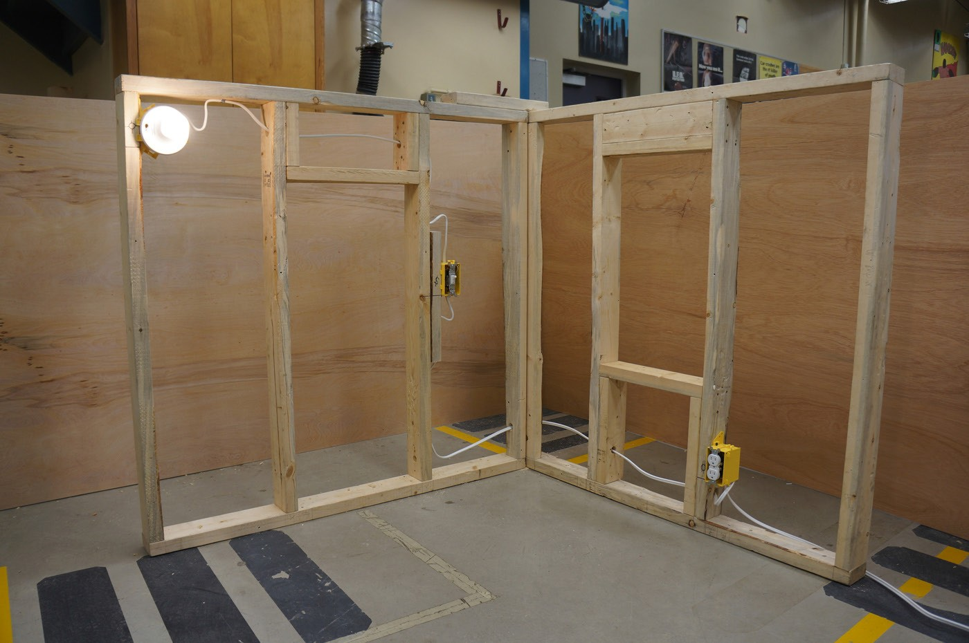
Figure 14—Completed circuit with light on

Check for understanding and disperse the students into groups to commence wiring their wall sections.

Evaluation Guidelines
  - Students work safely and responsibly with tools and equipment.
  - Wiring is done according to demonstration standards.
  - The circuit is checked for safety with the teacher before energizing individual wall sections.
  - Students understand and execute wiring to CEC standards.
  - Devices are placed accurately according to specified dimensions.
  - Wiring and strapping are done neatly.
  - Students should wire the circuit successfully by themselves and be assessed on workmanship and knowledge.

Wiring a Wall Section
Electrician

Fishing a Receptacle Into a Wall Section

Description
Once a house has been built and finished, it’s much more difficult for electricians to install more electrical devices into walls. Many homeowners want to do minor renovations and add receptacles, switches, and lights to their existing electrical installations. Many of those renovations are smaller in scale and don’t require removal of walls and drywall. This is a
situation where electrical workers do installations with minimal construction and disruptions to homeowners. Fishing a switch, light, receptacle, or another electrical device into an existing home is a faster, more economical way to add devices or circuits to a home. The term fishing, when used with regard to electrical work, means to pull cable through inaccessible spaces with a fish tape (Figure 2). A fish tape is a very long metal strip with a hook at the end, which can be used to grab a wire or another fish tape, somewhat like catching fish with a hook on a line. Most often fishing wire is done in a finished drywall wall.
Fishing wires into walls requires the electrician to tap into existing power sources and find the least invasive way to do so. The skill of fishing wire takes time to master. Even then, there are always challenges to overcome. Many small electrical jobs involve only one electrician. Being able to fish a wire without help requires good technique and skill. As will many tasks, practice makes you better. There are many different scenarios for fishing wire in a home. A receptacle might need to be fished vertically through a wall, horizontally into a light fixture, or between floors in a house. A wire fishing job will be made easier by taking the time to investigate the location of the studs and joist framing of the house.

Lesson Outcomes
The student will be able to:
  - Fish a wire into a vertical wall space to add a receptacle
  - Know how to locate studs in a wall
  - Work safely from a stepladder
  - Cut accurately through drywall

Assumptions
All students:
  - Know how to use hand tools safely
  - Know how to strip wire
  - Understand basic branch circuit wiring
  - Have been trained in stepladder use
  - Know how to use a tape measure and torpedo level

This work is licensed under a Creative Commons Attribution-NonCommercial-ShareAlike 4.0 International License unless otherwise indicated. 133

Terminology
Drywall or keyhole saw: a hand saw used to create holes and cutouts in drywall panels.

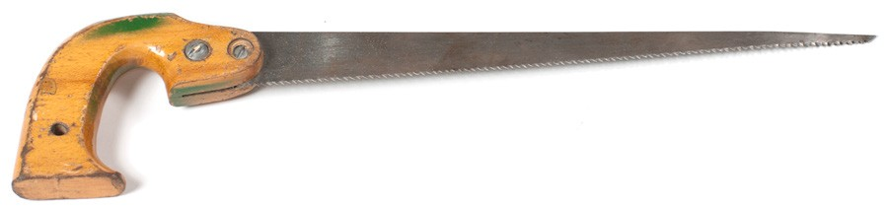
Figure 1—Keyhole saw

Fish tape: a tool for pulling cables through inaccessible spaces. A fish tape is a very long metal strip with a hook at the end, which can be used to grab a wire or another fish tape, somewhat like catching fish with a hook on a line.

Figure 2—Fish tape

Flange: an edge projecting from an object that is used for strength, for guiding, or for attachment to another object.
Joist: a length of timber or steel supporting part of the structure of a building, typically arranged in parallel series to support a floor or ceiling.
Plumb bob: a weight, usually with a pointed tip on the bottom, that is suspended from a string and used as a vertical reference line, or plumb line.

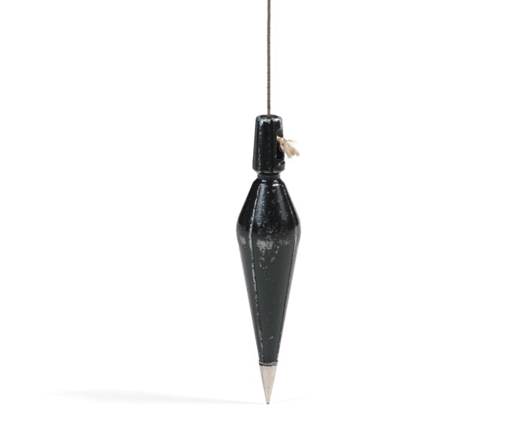
Figure 3—Plumb bob

Rework device boxes: device boxes used for installation into an existing wall. Used in conjunction with device box support clips, they are inexpensive and easy to install.

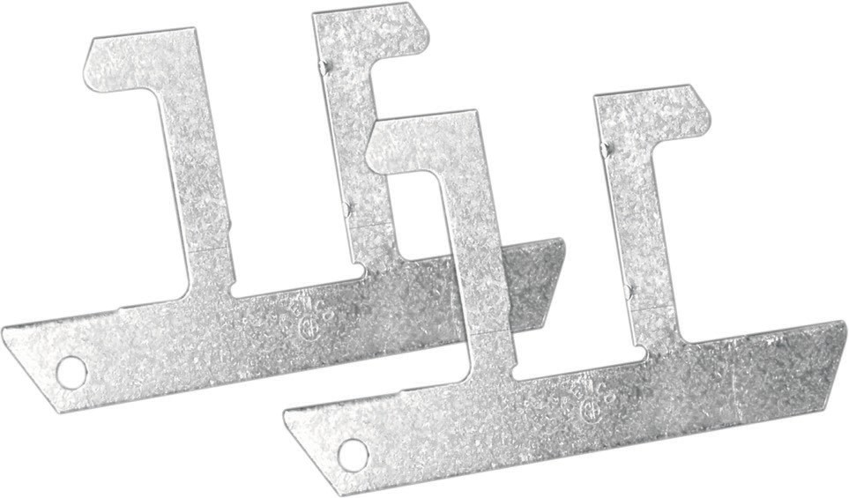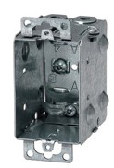

Figure 4—Support clips and rework device box

Note: There are a few different methods for attaching boxes when adding devices. Boxes may be added to a stud or attached to drywall between studs. Each electrician will likely have a preferred method and box style that they use. It’s important for electricians to know how to install boxes
in existing walls using different methods and types of boxes. For this activity, the method will be explained using a specific type of box. If the teacher prefers to use another type of box or would like to introduce a few different methods, the students will benefit from experiencing all of them.

 |  | 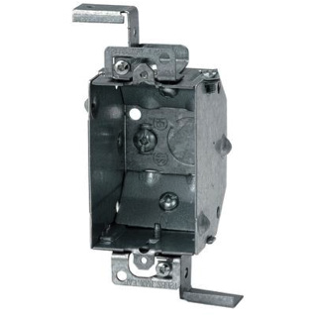
Figure 5—4 × 2⅛ octagon | Figure 6—Finished surface EZ box | Figure 7—Loomex 2¼" rework device box
Stud: an upright support in the wall of a building to which sheathing, drywall, etc., are attached.

Stud finder (also stud detector or stud sensor): a handheld device used to determine the location of wood and metal framing studs in light-frame construction, after the wall surface has been installed. There are different models ranging in price from $20 to $60. Some people do not use stud finders and prefer different methods of finding studs.

Figure 8—Stud finder

Top plate: a member on top of a stud wall on which joists rest to support an additional floor or to form a ceiling.
Torpedo level: an instrument designed to indicate whether a surface is horizontal (level) or vertical (plumb).

Figure 9—Torpedo level

Estimated Time
1–2 hours

Recommended Number of Students
20 maximum, based on BC Technology Educators’ Best Practice Guide. Students can be divided into pairs or groups of four depending on materials available. Students could do this activity in pairs while other students are working on other activities. Pairs could then be rotated through the station.

Facilities
Technology education shop or similar environment

Tools
  - Fish tape
  - Plumb bob
  - Lineman pliers
  - Needle-nose pliers
  - Drywall saw
  - Torpedo level
  - Tape measure
  - Electrical tape
  - Robertson® #1 and #2 screwdrivers
  - 5 or 6' stepladder
  - Wire strippers
  - Utility knife
  - Small flathead screwdriver
  - Pencil
  - Hard hat (for ladder climb)

Materials
To optimize this activity, a section of wall at least 8' tall× 32" wide should be provided. The wall section may be wider to allow more students to cut access holes and to practise using the
stud finder. The wall section must have ½" drywall attached to the front side and some sort of backing on the back (drywall, plywood). Studs should be installed at 16" centres. A false wall could be built and temporarily attached to an existing wall in a shop or outside wall, or a temporary free-standing wall section with supports could be built. Ensure the wall is properly supported and that students will be able to fish wires into the wall. The teacher will have to decide what will work in his or her classroom/shop environment.
Getting students to cut an access hole and climb a ladder to fish the wires is crucial for developing the skills needed for this activity.

Other materials include:
  - 14/2 plastic-sheathed cable, 20' (7 m)
    - Trade name: Loomex
    - CEC name: non-metallic sheathed cable (NMSC)
  - Rework device box with support clips, or teacher’s preferred style of box
  - Duplex receptacle and wall plate

Optional
Use a shorter wall section to perform this activity. If it is not to the dimensions required, it will at least give students some practice in fishing wires into a wall.

Resources

Fishing Electrical Wire Through Walls
http://www.familyhandyman.com/electrical/wiring/fishing-electrical-wire-through-walls/view-all

DIY Running New Electrical Cable
http://www.do-it-yourself-help.com/running_new_cable.html

Activity

- The teacher should demonstrate how to perform this activity, keeping in mind ladder safety. If ladder safety has not been discussed or demonstrated, it should be done before commencing this activity.
- The teacher should show students how to use a stud finder on the sample wall to mark stud locations. The height from the floor to the bottom of the receptacle will be 12" (30 cm), so this is the height at which the studs should be marked on the wall.
- If a stud finder is not used, another method to find the studs is to tap on the drywall in various horizontal locations with the handle of a screwdriver or pliers and listen for sound changes. When tapping on a hollow wall (a wall without insulation), the sound should change when the stud is located.
When the stud is located, make a light mark with a pencil, and then measure 16" horizontally to locate the next stud and mark it. Verify with the stud finder that the next stud has been correctly located.
- Once studs have been located and marked, measure and mark to the centre between the two studs at 12" (30 cm) from the floor.
- Using a stepladder, climb up to a height where the top of the wall may be reached.
Note: Do not stand on the top two steps of the ladder. Make sure students understand the safety issues involved in using ladders.
- Once in a good position to work, there are a few different methods to transfer the centre
of the stud space mark to the top of the wall. The wall in this activity is not a full-width wall, so it should be easy to determine visually where the mark should be placed. This is not always the case when fishing walls, so students should be shown how to transfer the mark by other methods. A good method is to use a plumb bob and hang it down from the top of the wall until it lines up with the centre mark at the bottom. If this method is used, mark the wall space at the top when the plumb bob lines up with the bottom mark. Another method is to measure from a point of reference (such as a corner) to the mark at the bottom, and then transfer that mark to the top of the wall.
- With the drywall saw, cut an access hole in the drywall at the top of the wall just below the top plate. Access should be roughly 3 × 3" (8 × 8 cm).
Note: When cutting pieces out of drywall that will be replaced later, make sure to cut neat square or rectangular shapes for easier repair later.
- Mark out the hole for the receptacle box. Use a tape measure to check that the pencil mark is at 12" (30 cm) above the floor. With a torpedo level, make a 2" (5 cm) horizontal mark to reference with the rework device box. Place the bottom of the box on the mark
with the open side of the box against the wall. Place the torpedo level on the top of the box, ensuring the bottom of the box is on the 12" mark. When the box is level, press the box firmly against the wall so it doesn’t move and trace all four sides of the box onto the drywall.

Note: Do not trace the flanges on the top and bottom of the box. Just trace the rectangular shape of the box.
- When the shape has been traced, cut the drywall with the drywall saw. Begin the cut by gently tapping the tip of the saw into the drywall. Then carefully and accurately start cutting to the outside of the lines until the place of drywall is detached.
- Before mounting the box, loosen the small screws in the flanges at the top and bottom of the box and pull the flanges out to the farthest point toward the open side of the box. Retighten the screws. Adjusting the flanges allows the box to sit level with the drywall.
Without adjusting the flanges the box will sit past the level of the drywall. This procedure must be done before putting the box into the wall.

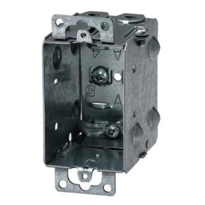
Figure 10—2½" deep Loomex device box

- It is time to fit the box. There are screw hole plates at the top and bottom of the box, used to attach a faceplate to the box with screws. The drywall will need to be notched slightly with the drywall saw to account for where the screw hole plates are positioned. Once all cuts are complete, gently push the box into the cut out section. When the box is pushed all the way in, it should sit level with the drywall. If the box extends past the drywall, trim the cutout with the saw until the box fits correctly. When the box is fitted correctly, remove it from the wall.
- Now fish the cable into the wall. Climb the ladder and insert the fish tape into the upper access point. Feed the tape down the wall and have a student try to capture the tape at the receptacle cutout. It might take some practice to align the tape with the bottom cutout.
Patience and communication between the two people is important. If the fish tape travels
to the floor it will need to be brought back up slowly to the cutout opening. Occasionally the person at the bottom will need to make a hook with a scrap piece of wire to capture the fish tape. When the person at the receptacle cutout secures the fish tape, pull about 2' (60 cm) of tape through the opening.
- The teacher should change positions with the student at the receptacle cutout so the teacher may demonstrate how to attach wire to the fish tape.

- Measure enough cable to allow for 1' (30 cm) of extra cable at the receptacle and 2–3' (60–90 cm) at the top access point. Strip 8–10" (20–30 cm) of sheathing from the 14/2 cable. Strip about 2" (5 cm) of insulation from the conductors. Run all three cables through the fish tape hook and bend them back on each other to form a strong hook. Hook only the stripped portion of the cables. The attached wires should be no larger than the 14/2 cable sheathing width when complete; make sure the wires are not bunched up. Wrap electrical tape over the bent wires to prevent them from becoming disconnected.
A good connection between the wires and the fish tape is needed so the cable does not get caught up when pulling the cable up, and so that it does not become disconnected from the fish tape. Many walls have insulation, pipes, and other obstructions in them, so a small and sturdy connection between wire and fish tape is best. Ensure the electrical tape wrapped around the fish tape has no sharp or blunt edges; this could be a point for the connection to get caught up when drawing the cable through the wall. It’s well worth the effort to ensure a good joint between the fish tape and wire is made so the fish tape does not come off.
- Have the student at the top of the ladder gently pull up the fish tape while the teacher feeds the cable into the opening. Continue until the cable comes out at the top access
point. Leave enough cable to allow 8–10" (20–30 cm) of wire for wiring the receptacle. The student at the top of the ladder can cut off (with pliers) the cable connection close to the fish tape. Cut the cable, not the fish tape. Make a loop of cable at the top and put a wrap of electrical tape around it to ensure it does not fall back down through the access point.
- At the receptacle opening, remove the tab from the device box to allow the cable to be brought into the box. Strip 8" (20 cm) of the outer sheath from the cable without damaging the conductor insulation. Insert the stripped end of the cable into the box. Make sure the sheathing enters the box and is secured in place with no more than ½" (1 cm) of sheathing in the box. Run the bonding wire clockwise around the bonding screw and tighten.
- Insert one of the box support clips into the receptacle opening with the two open wings facing outward. Hold one of the wings so the clip does not fall into the opening. With your other hand, place the box into the opening. When moving the box into position, hold the wing of the clip so it stays in place. When the box is in place, bend over the wing of the clip so it sits inside the box. Use needle-nose pliers to squeeze the clip so it sits tightly inside the box. The next clip will be harder to place. Start by pushing one end in first. The other end of the clip will not fit into the opening because it is too long. Using a small flat screwdriver, gently tap the long vertical point of the clip until it moves through the drywall and past the box into position. Squeeze the wings into position in the same way as on the other side.

Figure 11—Rework device box supports

- Install the receptacle, making sure it sits level with the drywall. Install the receptacle plate.
- Remove the receptacle, box, clips, and wire. The clips should be able to be straightened and used again, and the wire may be used again as well.
- The teacher may choose whether to use the same access points for all students or to cut different accesses for each group, depending on resources.
- Check for understanding and start students on the activity.

Evaluation Guidelines
The student:
  - Works safely and responsibly
  - Works safely on a ladder
  - Performs the activity competently
  - Uses tools appropriately
  - Produces quality workmanship

Extension Activity
  - Students could attempt to do this activity without the help of a partner.
  - The teacher could add insulation bats into a section of wall to make the fishing activity more challenging.

Assemble an Extension Cord

Description
Extension cords are part of any job site. All construction sites require many trades to operate portable equipment. This is a job for an industrial extension cord that can stand up to the immense wear and tear of the work site. Outdoor-rated extension cords have a heavier insulation jacket rated for rugged use to better protect against mechanical damage and wet environments. The ends of the cords also take abuse, and if the cable or cord end gets damaged it may need to be replaced. Knowing how to change an extension cord end properly and safely is a basic skill for electricians. If an extension cord end is improperly grounded, is wired poorly, or has frayed or loose wires, it is a very serious shock or electrocution hazard that could result in injury or death.

- Power cord  - Rubber housing  - Wiring module  - Power cord lamps  - Power cord clamp screws  - Assembly screw (3)  - Terminal screw (3)  Green terminal (ground wire) Silver terminal (white wire) Brass terminal (black wire)  - Key guide on wiring module (to be aligned with key on housing) | 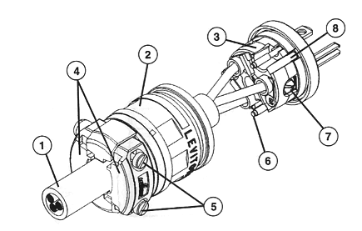
 | Male End
 | 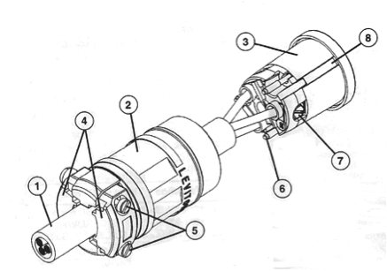
 | Female End

Figure 1—Male and female ends of an extension cord

This work is licensed under a Creative Commons Attribution-NonCommercial-ShareAlike 4.0 International License unless otherwise indicated. 143

Lesson Outcomes
The student will be able to:
  - Safely and properly change three-prong male and female cord end
  - Understand the safety implications of improperly wired extension cords
  - Use hand tools appropriately

Assumptions
The student:
  - Knows how to use hand tools safely
  - Understands basic electricity concepts
  - Knows how to strip wire

Terminology
Female cord end: a socket that receives the male end of an electrical device or extension cord.
Male cord end: a two- or three-prong plug that fits into a wall receptacle. A three-prong plug is preferred as it contains a ground wire pin.

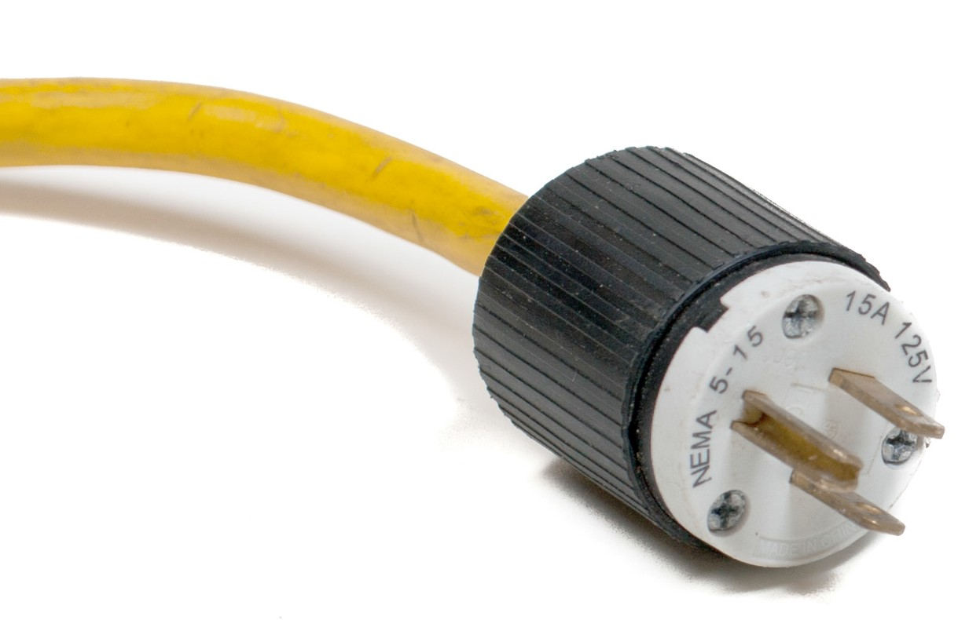

Figure 2—Male end of an extension cord

Plug tester: a device used to verify that an AC wall outlet (or extension cord) is wired properly.

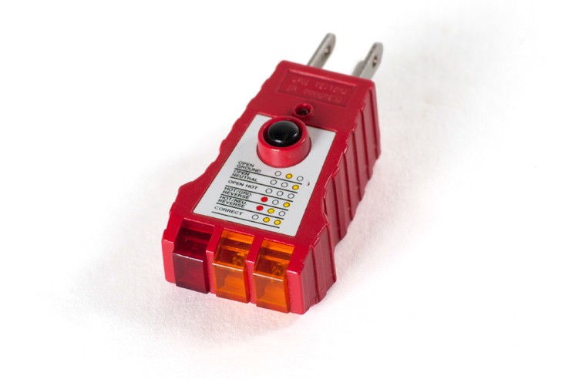

Figure 3—Plug (receptacle) tester

Power cord/extension cord (trade name, cabtire): the wire count on cabtire is based on the number of insulated wires inside the jacket. All wires inside the jacket are insulated. Therefore, a three-wire cabtire contains a black, a white, and a green wire. The number preceding the count is the wire’s size or gauge (e.g., 14/3 or 16/3).
Stranded wire: a group of conductor strands bundled or twisted together and insulated to make a stranded wire. Used when wires need to be more pliable, such as extension cords. If solid conductors were used, the extension cord would be stiff and the conductors would break when flexed.

Estimated Time
1 hour

Recommended Number of Students
20, based on BC Technology Educators’ Best Practice Guide

Facilities
Technology education shop with benches

Tools
- Side cutters
- Wire strippers
- Utility knife
- Robertson® #1, Phillips® #2, and slot screwdrivers

Materials
Male and female 3-wire industrial cord ends and 14/3 cabtire. Type and lengths are to be determined by the teacher according to available materials.

Optional
There are several styles of extension cord ends. In most (particularly those of better quality), the cable goes straight into a clamping device under the terminal screw. In other types, the cable is looped under the terminal screw. Students will benefit from using both designs.

Resources

Replacing the Male Plug on an Extension Cord or Power Cord
http://www.hammerzone.com/archives/elect/accessories/ext_cord/end1/replace.htm

Activity

- Cut the male end from an existing extension cord. Cut the wire close to the cord end so wire is not wasted.
- To install a male cord end, remove roughly 1" of the insulating jacket from the extension cord. To do this, strip the cabtire jacket by making two cuts, with the side cutters, to the jacket at the end of the cabtire cord. Then grip the two equal halves and pull with equal force. The jacket will peel like a banana. Then cut the jacket from the cabtire using the side cutters. Packing paper between the conductors may also require neat trimming. It is safer not to use a knife so the conductors are not cut.
- Loosen the male socket outer housing with the appropriate screwdriver. The socket will usually have three screws, but this depends on the manufacturer. Remove the outer housing. Loosen the clamp screws on the outer housing and slide it over the cabtire.
- Use the appropriate screwdriver to loosen the terminal screws and remove the cut conductors (only if doing a repair demonstration).
- Strip about ¾" of insulation from the black, white, and green conductors. The stranded wire inside should then be twisted (clockwise) to ensure the strands will have no frays when they are inserted into the terminals. Do not over-twist or the strands will not push into the terminals.
Note: The length of conductors to be stripped should be the same as on the wires being removed; different styles of male ends will require wire stripped to different lengths.
Generally about ⅜".
- The terminals should be colour-coded the same as a receptacle: green for ground, silver for white, and gold or bronze for the black conductor. Insert the conductors into the terminals ensuring all strands enter the clamping device. It may be easier to insert all wires into the terminals before tightening any terminal screws. Tighten the terminal screws until snug.
Note: If the terminals do not have a clamping device for the conductors, a hook or loop must be formed. If forming a loop, be careful not to have frayed wire protruding from under the terminal screws. After tightening the terminal screws, gently wiggle the conductors to make sure they are secure under the terminal.
- Slide the outer housing up to the terminal cord end and tighten the three screws. Tighten the clamp screws.
- The outer jacket must be clamped under the outer housing. If conductors are visible, the cord end must be taken apart and then reconnected with shorter wire lengths. If water can penetrate inside the housing because of improper installation or there are loose or stray strands of conductor, there could be a shock hazard.
- The end may now be energized and tested for proper operation. Use the plug tester for testing.
- Check for understanding and have students commence with the activity.

Evaluation Guidelines
- Students work appropriately and safely with hand tools.
- No exposed conductors protrude from the housing.
- The extension cord works properly when completed.
- Students understand safety concerns resulting from damaged or improperly wired extension cords.

Extension Activity
Students wire the female end of an extension cord.

Assemble an Extension Cord
Electrician

